

**Vermont Health Benefit Exchange (HBE)**

Business Architecture Design for HBE

**TACTICAL STEERING COMMITTEE APPROVALS**

**VT HBE Approving Authority:**

<Signature> <Date>

<Printed Name> <Position Title>

**Department of Vermont Health Access Approving Authority:**

<Signature> <Date>

<Printed Name> <Position Title>

**Department of Information and Innovation Chief Information Officer**

<Signature> <Date>

<Printed Name> <Position Title>

**Department of Financial Regulation Approving Authority:**

<Signature> <Date>

<Printed Name> <Position Title>

# REVISION HISTORY

|  |  |  |  |
| --- | --- | --- | --- |
| Version | Date | Organization/Point of Contact | Description of Changes |
| 0.1 | 08/06/2012 | Paul Knollman | Initial Draft – Document Outline |
|  |  |  |  |
|  |  |  |  |
|  |  |  |  |

# Table of Contents

REVISION HISTORY 3

Table of Contents 4

Table of Figures 7

1. Introduction 1

2. HBE Business Architecture Summary 1

3. Plan Management 3

3.1. Establish Insurer and Plan Initial Certification and Agreement 3

3.2. Monitor Insurer and Plan Certification Compliance 5

3.3. Establish Insurer and Plan Renewal and Recertification 6

3.4. Maintain Operational Data 6

3.5. Process Change in Plan Enrollment Availability 9

3.6. Review Rate Increase Justifications 10

3.7. Business Process Support Model 10

4. Eligibility and Enrollment 11

4.1. Vermonter Eligibility and Enrollment 12

4.1.1. Prepare / Update Vermonter Eligibility Application 12

4.1.2. Verify Vermonter Eligibility Application Information 13

4.1.3. Determine Vermonter Eligibility 16

4.1.4. Enroll Vermonter in Qualified Health Plan 17

4.1.5. Disenroll Vermonter from Qualified Health Plan 19

4.1.6. Renew Vermonter Eligibility and Enrollment 20

4.1.7. Appeal Exchange Eligibility Decision 21

4.2. Business Process Support Model 22

4.3. Vermonter Responsibility Exemption 23

4.3.1. Prepare/Update Vermonter Exemption Application 24

4.3.2. Vermonter Exemption Application Information 24

4.3.3. Determine Vermonter Exemption Eligibility 27

4.3.4. Renew Vermonter Exemption Eligibility 28

4.3.5. Appeal Exchange Eligibility Decision 29

4.4. Business Process Model 30

4.4.1. SHOP Employer Eligibility Enrollment 31

4.4.1.1. Prepare / Update Employer Eligibility Application 32

4.4.1.2. Verify Employer Eligibility Application Information 33

4.4.1.3. Determine Employer Eligibility for Participation 34

4.4.1.4. Determine Employer Contribution 35

4.4.1.5. Terminate Employer Participation 36

4.4.1.6. Renew Employer Participation 37

4.4.1.7. Appeal SHOP Eligibility Decision 39

4.4.2. Business Process Support Model 39

4.4.3. SHOP Employee Eligibility Enrollment 40

4.4.3.1. Prepare / Update Employee Eligibility Application 41

4.4.3.2. Verify Employee Eligibility Application Information 42

4.4.3.3. Determine Employee Eligibility 43

4.4.3.4. Enroll Employee in Qualified Health Plan 44

4.4.3.5. Disenroll Employee from QHP Business Services 45

4.4.3.6. Renew Employee Eligibility & Enrollment Business Services 47

4.4.4. Business Process Support Model 48

4.5. Financial Management 49

4.5.1. APTCs and CSRs Data Reporting 49

4.5.2. APTC and CSR Issuer payments 49

4.5.3. Premium payment history reporting 50

4.5.3.1. Advance Payments of Premium Tax Credits and Cost Sharing Reductions 50

4.5.4. Insurer Payment Transfers 51

4.5.4.1. Insurer Invoice/Payment Discrepancy Resolution 51

4.5.4.2. Plan Assessment 52

4.5.4.3. Premium Payment to Insurers 54

4.5.4.4. Calculate/Receive Reinsurance Contributions 55

4.5.4.5. Verify Reinsurance Contributions 56

4.5.4.6. Reinsurance and General Fund Payments 57

4.5.4.7. Risk Adjustment Payments and Calculations 58

4.5.5. Data Collection 59

4.5.5.1. Non-Exchange Data Collection Plan Assessment 60

4.5.5.2. Claims/Encounter Data Collection 61

4.5.6. Premium Processing 62

4.5.6.1. SHOP Premium Collection 62

4.5.6.2. Vermonter Premium Collection 63

4.5.6.3. Employer Premium Discrepancy Resolution 64

4.5.6.4. Vermonter Premium Discrepancy Resolution 66

4.5.7. Risk Spreading Calculations 67

4.5.7.1. Reinsurance Payment Calculation 67

4.5.7.2. Risk Adjustment Calculation 69

4.5.7.3. Risk Corridors Calculation 70

4.5.8. Business Process Support Model 71

4.6. Customer Service 75

4.6.1. Manage Inbound Communication 76

4.6.2. Manage Customer Requests 76

4.6.3. Manage Self Service Support 77

4.6.4. Administrative Tasks Management 78

4.7. Business Process Support Model 79

4.8. Communications 80

4.9. Oversight and Reporting 80

Appendix A 81

Appendix B 82

**Table of Tables**

Table 16 - Master Interface Table 82

Table 17 - Glossary 86

Table 18 - References 86

# Table of Figures

Figure 6 - HIX Functional Model 1

Figure 7 - HIX Level 0 Capability View 2

Figure 8 - Establish Insurer and Plan Initial Certification and Agreement 4

Figure 9 - Monitor Insurer and Plan Certification Compliance 5

Figure 10 - Establish Insurer and Plan Renewal and Recertification 6

Figure 11 - Maintain Operational Data (1 of 2) 7

Figure 12 - Maintain Operational Data (2 of 2) 8

Figure 13 - Process Change in Plan Enrollment Availability 9

Figure 14 - Review Rate Increase Justifications 10

Figure 15 - Plan Management Business Process Support Model 11

Figure 16 - Prepare / Update Vermonter Eligibility Application 13

Figure 17 - Prepare Verify Vermonter Eligibility Application Information (1 of 4) 14

Figure 18 - Prepare Verify Vermonter Eligibility Application Information (2 of 4) 14

Figure 19 - Prepare Verify Vermonter Eligibility Application Information (3 of 4) 15

Figure 20 - Prepare Verify Vermonter Eligibility Application Information (4 of 4) 15

Figure 21 - Determine Vermonter Eligibility (1 of 2) 16

Figure 22 - Determine Vermonter Eligibility (2 of 2) 17

Figure 23 - Prepare Enroll Vermonter in Qualified Health Plan (1 of 2) 18

Figure 24 - Prepare Enroll Vermonter in Qualified Health Plan (2 of 2) 18

Figure 25 - Disenroll Vermonter from Qualified Health Plan 19

Figure 26 - Renew Vermonter Eligibility and Enrollment 20

Figure 27 - Appeal Exchange Eligibility Decision 21

Figure 28 – E&E Vermonter Business Process Support Model 22

Figure 29 - Prepare/Update Vermonter Exemption Application 23

Figure 30 - Vermonter Exemption Application Information (1 of 3) 24

Figure 31 - Vermonter Exemption Application Information (2 of 3) 25

Figure 32 - Vermonter Exemption Application Information (3 of 3) 26

Figure 33 - Determine Vermonter Exemption Eligibility 27

Figure 34 - Renew Vermonter Exemption Eligibility 28

Figure 35 - Appeal Exchange Eligibility Decision 29

Figure 36 - E&E Vermonter Responsibility Exemption Business Process 30

Figure 37 - Prepare / Update Employer Eligibility Application 31

Figure 38 - Verify Employer Eligibility Application Information 32

Figure 39 - Determine Employer Eligibility for Participation 33

Figure 40 - Determine Employer Contribution (1 of 2) 34

Figure 41 - Determine Employer Contribution (2 of 2) 35

Figure 42 - Terminate Employer Participation 36

Figure 43 - Renew Employer Participation 37

Figure 44 - Appeal SHOP Eligibility Decision 38

Figure 45 – E&E SHOP Employer Business Process Support Model 39

Figure 46 - Prepare/Update Employee Eligibility Application 40

Figure 47 - Verify Employee Eligibility Application Information 41

Figure 48 - Determine Employee Eligibility 43

Figure 49 - Enroll SHOP Employee in QHP (1 of 2) 44

Figure 50 - Enroll SHOP Employee in QHP (2 of 2) 45

Figure 51 - Disenroll Employee from QHP Business Services (1 of 2) 46

Figure 52 - Disenroll Employee from QHP Business Services (2 of 2) 46

Figure 53 - Renew Employee Eligibility & Enrollment Business Services 47

Figure 54 – E&E SHOP Employee Business Process Support Model 48

Figure 55 – BP-FM:01 APTC and CSR Issuer Payments 50

Figure 56 – BP-FM:07 Issuer Invoice/ Payment Discrepancy Resolution 52

Figure 57 – BP-FM:13 – Plan Assessment for State Exchanges 53

Figure 58 – BP-FM:14 – Aggregated Premium Payment to Issuers and User Fee Collection 54

Figure 59 – BP-FM:15 – Reinsurance Contributions 55

Figure 60 – BP-FM:16 – Reinsurance Contribution Verification 56

Figure 61 – BP-FM:17 – Reinsurance Financial Transfers 57

Figure 62 – BP-FM:18 – Risk Adjustment Payment 59

Figure 63 – BP-FM:08 – Non-Exchange Enrollee/ Rate Data Collection 60

Figure 64 – BP-FM:09 Claims/ Encounter Data Collection 61

Figure 65 – BP-FM:03 – SHOP Premium Collection 63

Figure 66 – BP-FM:04 – State Option to Collect Premiums in The Health Benefits Exchange 64

Figure 67 – BP-FM:05 – Employer Premium Discrepancy Resolution 65

Figure 68 – BP-FM:06 – Vermonter Premium Discrepancy Resolution 66

Figure 69 – BP-FM:10 – Reinsurance Payment Calculation 68

Figure 70 – BP-FM:11 – Risk Adjustment Calculation 69

Figure 71 – BP-FM:12 – Risk Corridors 70

Figure 72 – APTC and CSR Business Process Support Model 71

Figure 73 – Insurer Payment Transfer Business Process Support Model 72

Figure 74 – Data Collection Business Process Support Model 73

Figure 75 – Premium Processing Business Process Support Model 74

Figure 76 – Risk Spreading Calculations Business Process Support Model 75

Figure 77 - Manage Inbound Communication 76

Figure 78 - Manage Customer Request 77

Figure 79 - Manage Self Service Support 78

Figure 80 - Administrative Tasks Management 79

Figure 81 - Customer Service Business Process Support Model 80

# Introduction

The Business Architecture aligns business strategies and objectives with IT. It outlines the business case for IT transformation and provides a business-centric view of the enterprise from a functional perspective. The Business Architecture is comprised of business capabilities, business processes, and a business process support model. The details of the Vermont Business Architecture are defined this document.

# HBE Business Architecture Summary

The overall design is based on the business blue prints provided by CMS. CMS is participating in a collaborative business analysis effort to generate business architecture blueprints for use in communicating Exchange operations to stakeholders, and as the foundation for system design and development activities.

A business architecture blueprint consists of detailed definitions of business processes, business services, and data necessary to support the implementation of the services for each of The Health Benefits Exchange business areas. Blueprints provide a foundation for beginning detailed requirements analysis, as well as data and technical standards definition activities.

Following figure shows the high level functional model for the HBE. Some models reference HIX, since this is the term used by CMS.



**Insurance**

**Provider Portal**

**Citizen Portal**



**Verification & eligibility screening**

Search



**SHOP**

**Exchange**

**Small**

**Businesses**



**Small Business Employee**

**Small Business Employer**



**Subsidy Calculation**

**Premium Calculation**

**Navigator Assistance**

**Insurance Company**

**Case Management**

**Enrollment and Plan Management**

**Payment and enrollment Data**

**Verification with Government Agencies**

**General**

**Ledger**

**Invoicing** and Payroll Deduction info



**Payment Collection**



Health Insurance Exchange Functional Model

**Reporting & Monitoring**

Figure 6 - HBE Functional Model

The Health Benefits Exchange will help consumers and small businesses apply for public and private health insurance and other related benefits. Vermonter citizens and small business employees will access The Health Benefits Exchange via the Citizen Portal. In order to determine eligibility and verify the eligibility information provided by individuals, HBE will need to connect to a variety of systems. These systems include those internal to The State of Vermont, and external systems including those at CMS, The Social Security Administration, The Department of Homeland Security, The Internal Revenue Service (IRS), The Vermont Department of Financial Regulation Insurance Division (DFR) and The Vermont Department of Motor Vehicles (DMV). HBE will also integrate with insurers and the insurer’s provider networks. Due to these complex integration requirements, HBE will standardize the processes and the data objects involved to ensure ease of maintenance and reusability.

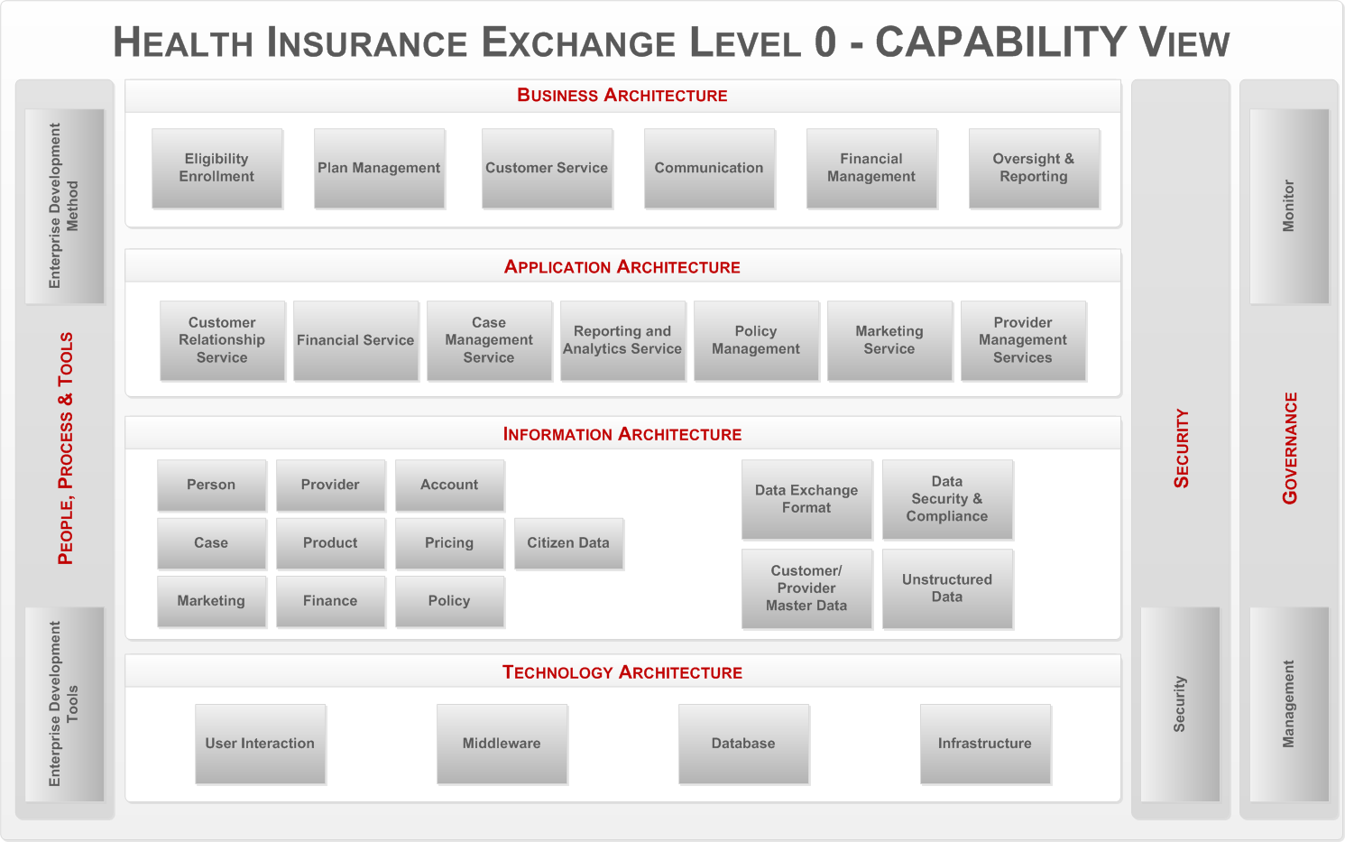

Figure 7 - HBE Level 0 Capability View

As shown in the HBE Level 0 Capability View model above, in the Business Architecture domain there are six business areas or business capabilities defined by CMS. These six business areas are as follows:

* Plan Management
* Eligibility Enrollment
* Financial Management
* Customer Service
* Communication
* Oversight and Reporting

The corresponding CMS blueprint documents define the details of each. In the following subsections each business area is described and decomposed. These were reviewed by Vermont’s core business team and stakeholders and further refined from the core CMS blue print to include Vermont’s own additional requirements.



# Plan Management

This section addresses the business architecture design for the Plan Management business area. The Plan Management business area consists of the following processes:

* Establish Insurer and Plan Initial Certification and Agreement
* Monitor Insurer and Plan Certification Compliance
* Establish Insurer and Plan Renewal and Recertification
* Maintain Operational Data
* Process Change in Plan Enrollment Availability
* Review Rate Increase Justifications

The following is the series of Level 1 Business Capability Models, one for each business process. The business process in focus for a particular model is depicted in a darkened gray box. The rest of the model is associated with that specific business process. In the Business Services area the Supporting Business Services (SBS) are indicated with a red tab to distinguish them from the Core Business Services (CBS).



## Establish Insurer and Plan Initial Certification and Agreement

The following figure is the Business Capability Model for the Plan Management business area, business process “Establish Insurer and Plan Initial Certification and Agreement.”

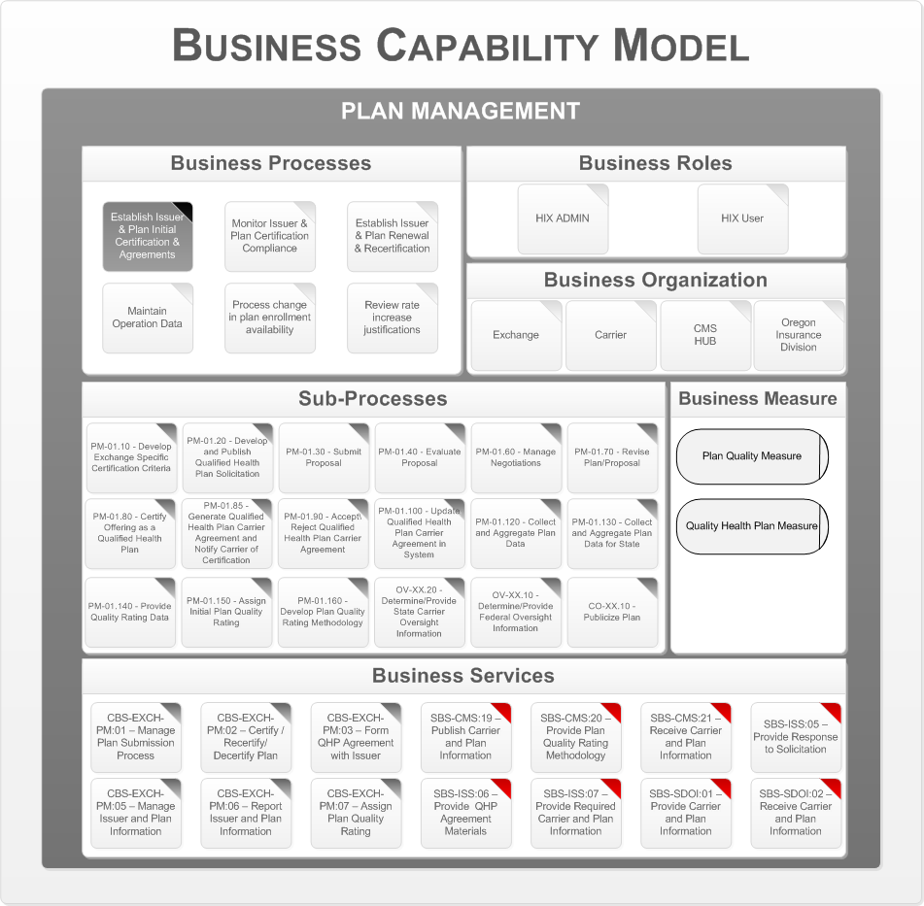

Figure 8 - Establish Insurer and Plan Initial Certification and Agreement

This business process is performed in order to accomplish the initial certification and agreement for a QHP provided by an Insurer. Components of this process may also be reused for recertification.

The following are the key business organizations that interact during this process:

* Department of Vermont Health Access
* CMS HUB
* Insurers
* VT Department of Financial Regulation Insurance Division

There are two type of business services realized, one is Core Business Services and the second is Supporting Business Services. Core Business Servicesidentify the functionality performed by The Health Benefits Exchange in carrying out core business processes. Core Business Services include partially automated business process workflows involving interactions with Exchange operations staff and stakeholders, as well as fully automated business rules processing. Supporting Business Services identify the interactions with stakeholders participating in the business process. Supporting Business Services enable stakeholders to share information with the central actor HBE and provide other services in support of exchange operations.

Appendix A – Reference Section lists the CMS Blue Print Documents that contains details on the Business Processes, Business Sub Processes, and Business Services.

## Monitor Insurer and Plan Certification Compliance

The following figure shows the Business Architecture Model for the business process “Monitor Insurer and Plan Certification Compliance”.

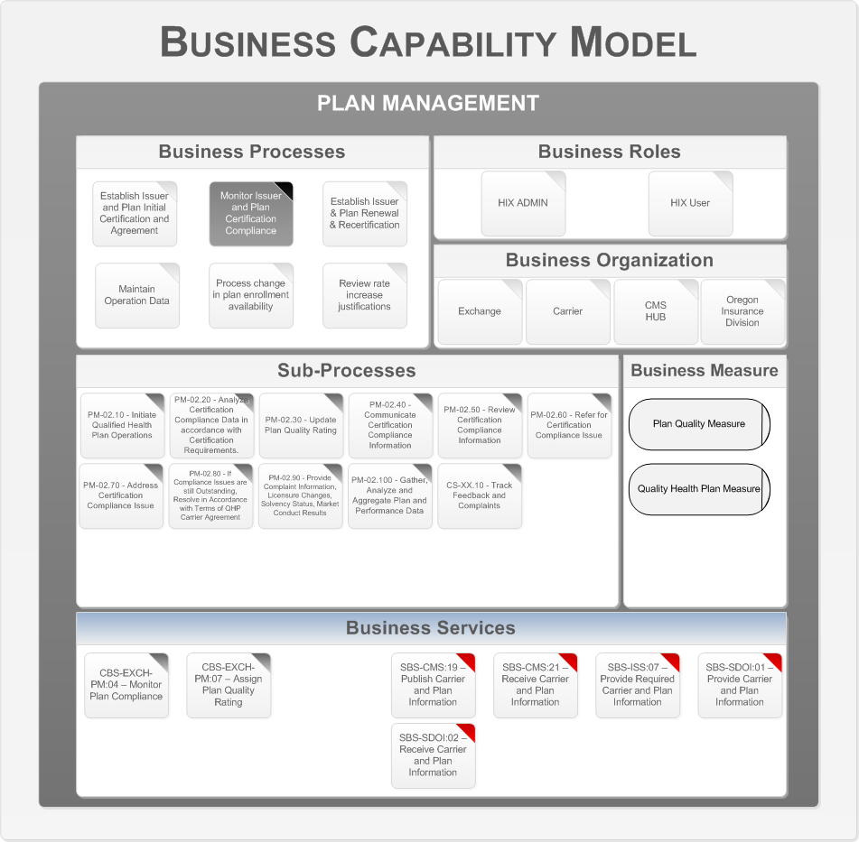

Figure 9 - Monitor Insurer and Plan Certification Compliance

This process consists of administrative activities performed in order to monitor plan performance and certification compliance. Plan quality ratings are also updated as part of this process.

The following are the key business organizations that interact during this process:

* Department of Vermont Health Access
* CMS HUB
* Insurers
* VT Department of Financial Regulation Insurance Division

Appendix A – Reference Section lists the CMS Blue Print Documents that contains details on the Business Processes, Business Sub Processes, and Business Services.

## Establish Insurer and Plan Renewal and Recertification

The following figure shows the Business Architecture Model for the business process “Establish Insurer and Plan Renewal and Recertification”.

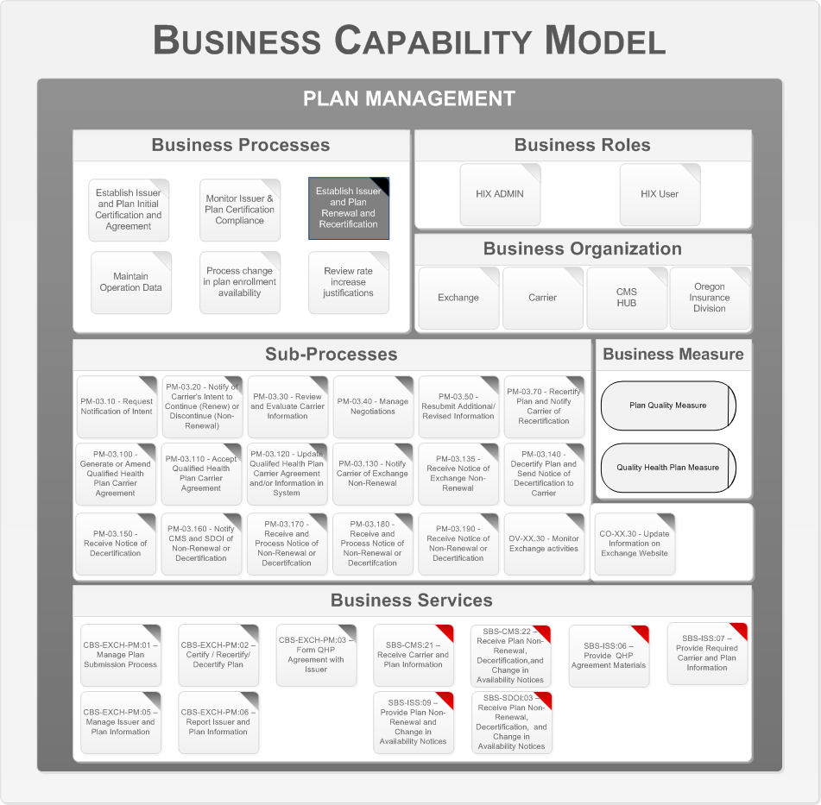

Figure 10 - Establish Insurer and Plan Renewal and Recertification

This process is performed after the initial certification process for QHPs. The process includes activities associated with the recertification of a qualified health plan, and could potentially result in decertification of the qualified health plan.

The following are the key business organizations that interact during this process:

* Department of Vermont Health Access
* CMS HUB
* Insurers
* VT Department of Financial Regulation Insurance Division

Appendix A – Reference Section lists the CMS Blue Print Documents that contains details on the Business Processes, Business Sub Processes, and Business Services.

## Maintain Operational Data

The following diagrams represent the Business Architecture Model for the business process “Maintain Operational Data”. There are two figures shown for readability purposes due to the large number of sub-processes. These two figures are one Business Capability Model.

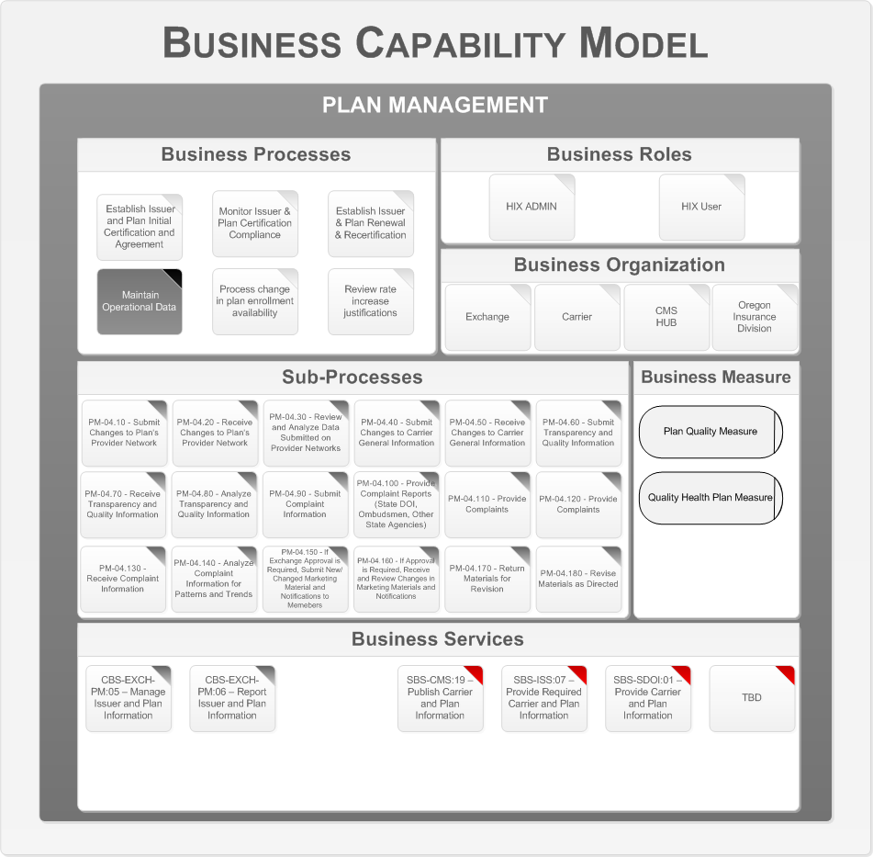

Figure 11 - Maintain Operational Data (1 of 2)

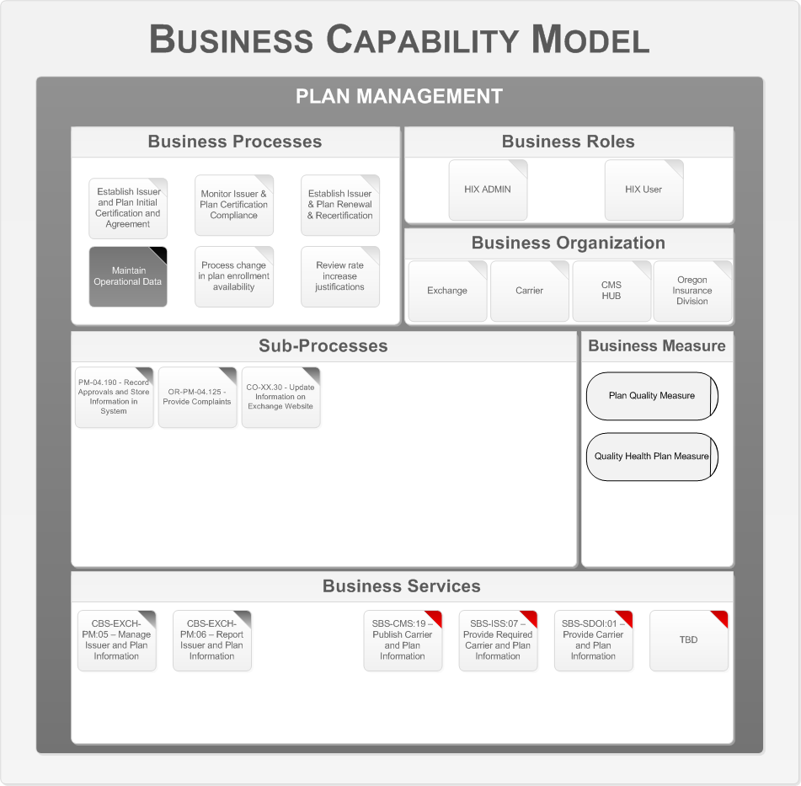

Figure 12 - Maintain Operational Data (2 of 2)

This process is be performed to maintain the currency of the operational data received from Insurers, to analyze changes in the data, and to take appropriate actions based on changes in the data. The data may include: Insurer network data, Insurer general information, transparency data, quality information, complaint data (from multiple sources), and marketing materials and notifications to members.

The following are the key business organizations that interact during this process:

* Department of Vermont Health Access
* CMS HUB
* Insurers
* VT Department of Financial Regulation Insurance Division

Appendix A – Reference Section lists the CMS Blue Print Documents that contains details on the Business Processes, Business Sub Processes, and Business Services.

## Process Change in Plan Enrollment Availability

The following figure shows the business architecture model for the business process “Process Change in Plan Enrollment Availability”.

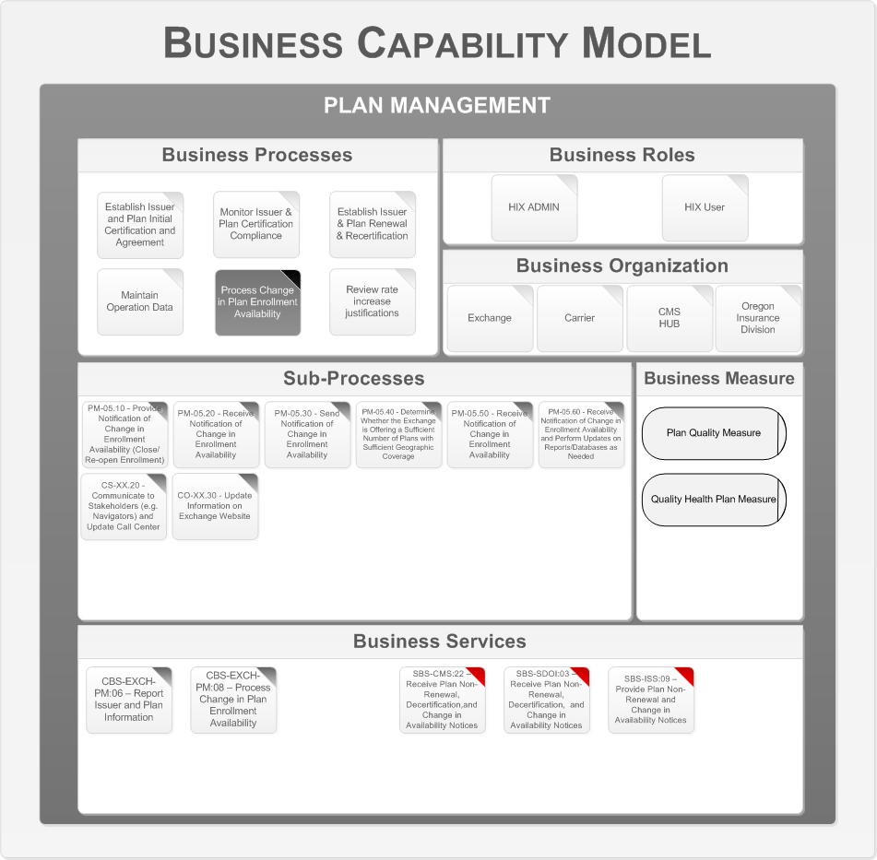

Figure 13 - Process Change in Plan Enrollment Availability

This process is performed when an Insurer either closes or re-opens enrollment for a QHP during a plan year. The Insurer may close enrollment of a QHP under certain conditions specified in section 2702 of the Public Health Service Act, for example when they reach service capacity limits.

The following are the key business organizations that interact during this process:

* Department of Vermont Health Access
* CMS HUB
* Insurers
* VT Department of Financial Regulation Insurance Division

Appendix A – Reference Section lists the CMS Blue Print Documents that contains details on the Business Processes, Business Sub Processes, and Business Services.

## Review Rate Increase Justifications

The following figure shows the business architecture model for the business process “Review Rate Increase Justifications”.

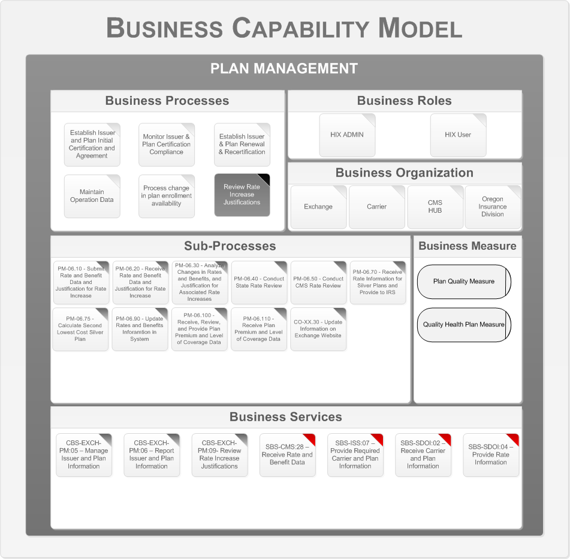

Figure 14 - Review Rate Increase Justifications

This process will be performed to receive and review justifications for rate increases. The Health Benefits Exchange review also utilizes information received from the State and/or CMS rate review processes.

The following are the key business organizations that interact during this process.

* Department of Vermont Health Access
* CMS HUB
* Insurers
* VT Department of Financial Regulation Insurance Division

Appendix A – Reference Section lists the CMS Blue Print Documents that contains details on the Business Processes, Business Sub Processes, and Business Services.

## Business Process Support Model

The next step is to map the business services to application services and define the key business data objects. This is described by the Business Process Support Model. The following diagram shows the Business Process Support Model for the Plan Management business process.

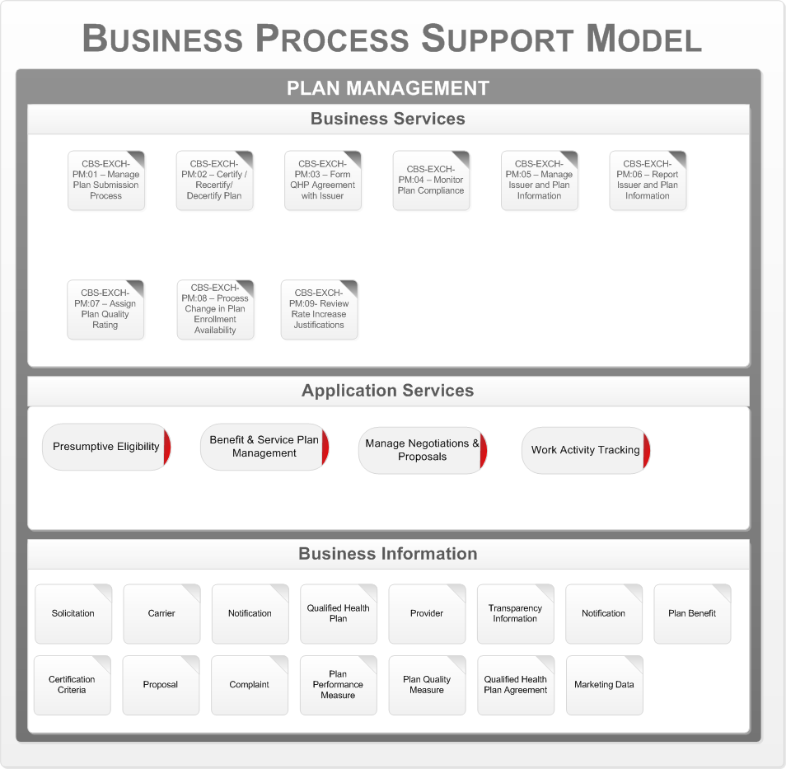

Figure 15 - Plan Management Business Process Support Model

The core business services for the Plan Management processes are mapped to 4 application services, these are:

* Presumptive Eligibility Service
* Benefit and Service Plan Management
* Manage Negotiations and Proposal
* Work Activity Tracking

Appendix A – Reference Section lists the CMS Blue Print Documents that contains details on the Business Processes, Business Sub Processes, and Business Services.

# Eligibility and Enrollment

This section addresses the business architecture design for the Eligibility and Enrollment business area. The Eligibility & Enrollment business area comprises a collection of business processes that facilitate application acceptance, eligibility determination and enrollment, renewal, and eligibility appeal activities. These activities support individual eligibility and enrollment, exemptions from the individual responsibility requirement, and the ability for small employers and their employees to participate in SHOP.

The Eligibility and Enrollment business area is classified into 4 key sub-business areas:

* Vermonter Eligibility Enrollment
* Vermonter Responsibility Exemption
* SHOP Employer Eligibility Enrollment
* SHOP Employee Eligibility Enrollment

The following section describes the details of each sub-business area, and presents the corresponding business capability models for each business process.



## Vermonter Eligibility and Enrollment

Vermonter Eligibility and Enrollment encompasses all The Health Benefits Exchange functions required to accept applications; verify individual and household information; determine eligibility for enrollment in a qualified health plan—and, if applicable, determine eligibility for Medicaid, CHIP; and support an individual’s selection of and enrollment in a QHP. It also includes functions to process changes to eligibility during the coverage year, renew eligibility and enrollment, disenrollment from a QHP, and accept and process appeals of eligibility decisions.

He details of the business architecture for the Vermonter Eligibility and Enrollment business area follow. This business area consists of the following processes:

* Prepare / Update Vermonter Eligibility Application
* Verify Vermonter Eligibility Application Information
* Determine Vermonter Eligibility
* Enroll Vermonter in Qualified Health Plan
* Disenroll Vermonter from Qualified Health Plan
* Renew Vermonter Eligibility and Enrollment
* Appeal Exchange Eligibility Decision

The following is the series of Level 1 Business Capability Models, one for each business process. The business process in focus for a particular model is depicted in a darkened gray box. The rest of the model is associated with that specific business process. In the Business Services area the Supporting Business Services are indicated with a red tab to distinguish them from the Core Business Services.

### Prepare / Update Vermonter Eligibility Application

The following figure is the Business Capability Model for the Eligibility and Enrollment Vermonter business area, business process “Prepare / Update Vermonter Eligibility Application.”

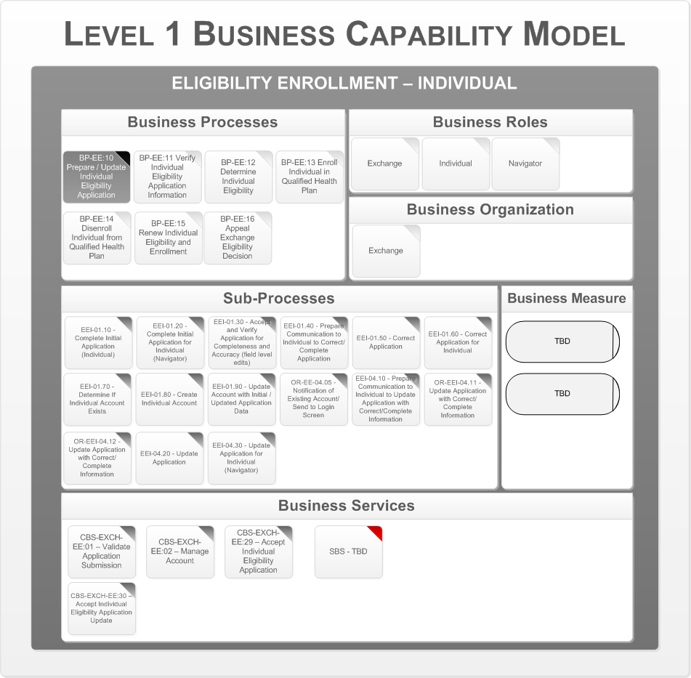

Figure 16 - Prepare / Update Vermonter Eligibility Application

This process collects initial and updated application information from an individual necessary to determine eligibility for enrollment in a qualified health plan, APTC, CSR, Medicaid, CHIP and the Basic Health Program. The application information includes details about each member of the household. The following are the key business organizations that interact during this process:

* The Health Benefits Exchange

Appendix A – Reference Section lists the CMS Blue Print Documents that contains details on the Business Processes, Business Sub Processes, and Business Services.

### Verify Vermonter Eligibility Application Information

The following diagrams represent the Business Capability Model for the Eligibility and Enrollment Vermonter business area, business process “Verify Vermonter Eligibility Application Information.”

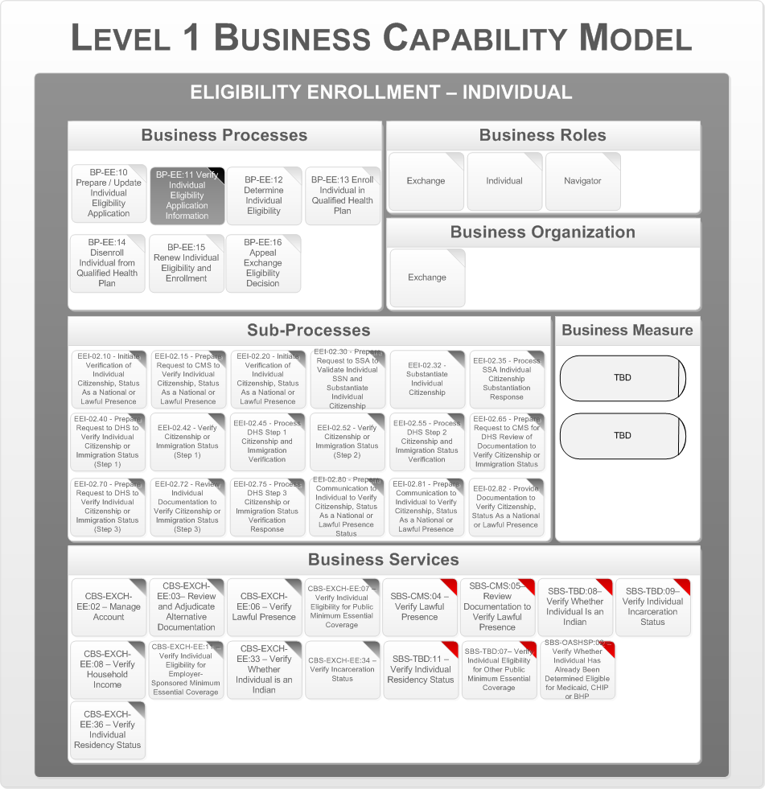

Figure 17 - Prepare Verify Vermonter Eligibility Application Information (1 of 4)

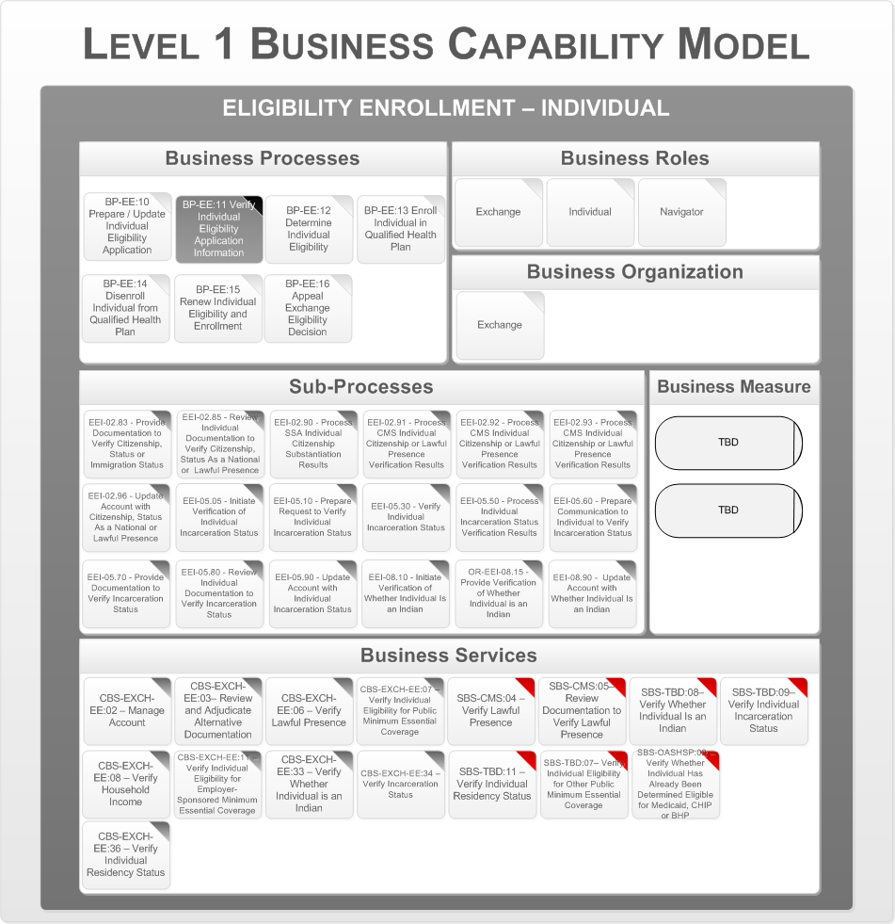

Figure 18 - Prepare Verify Vermonter Eligibility Application Information (2 of 4)

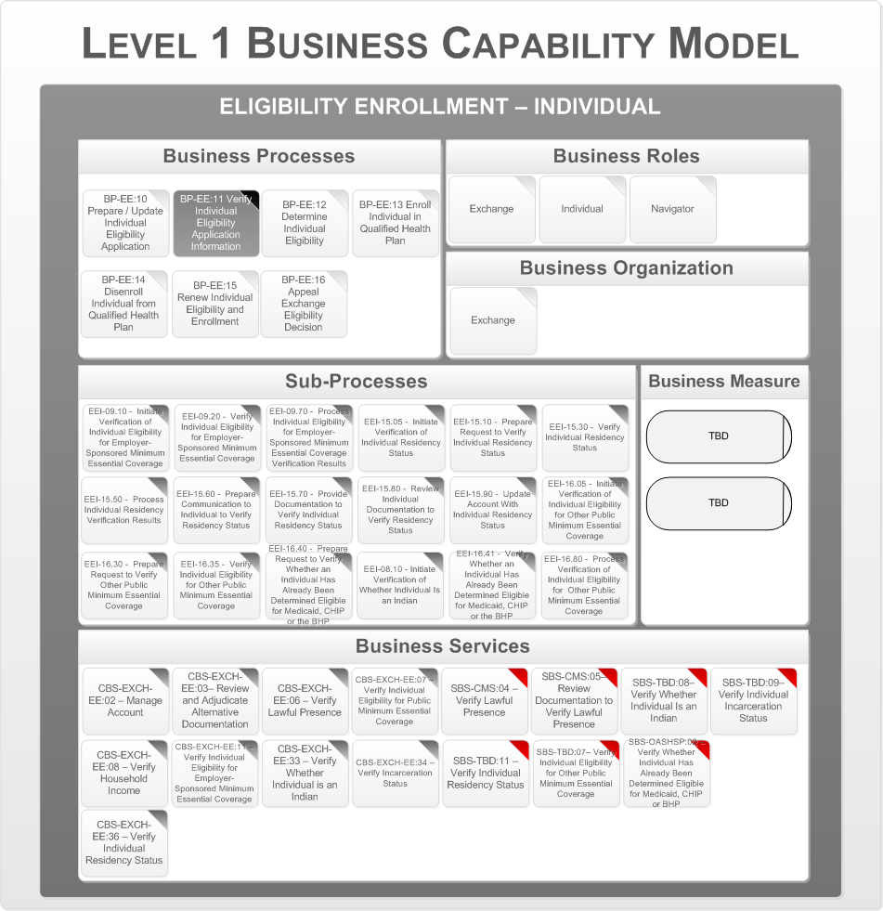

Figure 19 - Prepare Verify Vermonter Eligibility Application Information (3 of 4)

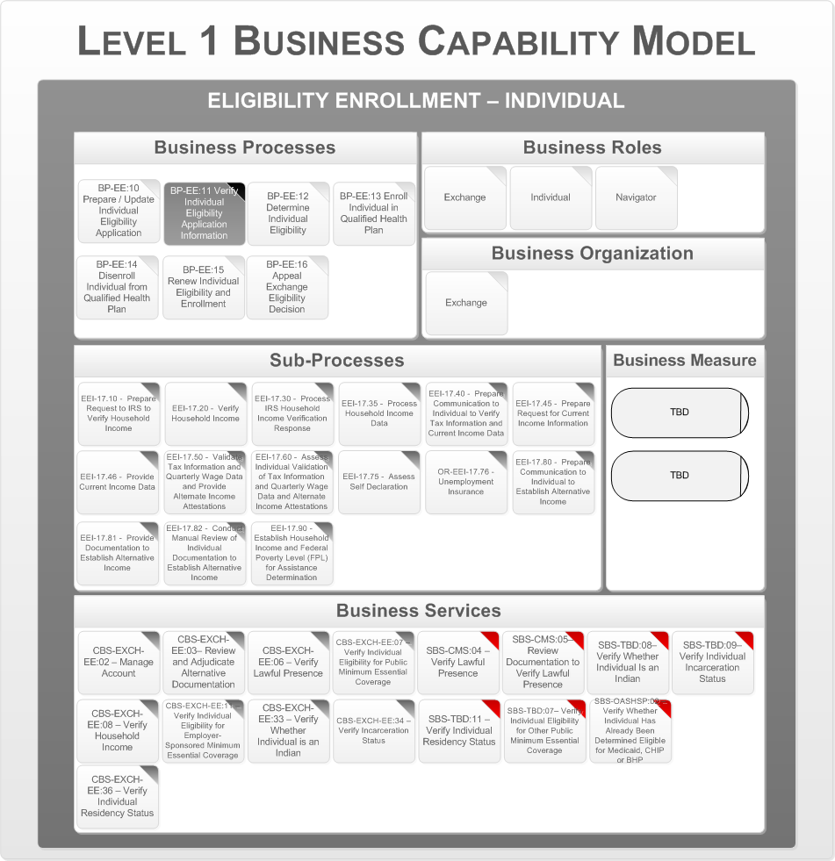

Figure 20 - Prepare Verify Vermonter Eligibility Application Information (4 of 4)

This process verifies the information provided on the application with data needed to determine eligibility. This process includes verifying the applicant’s citizenship, immigration status, incarceration status, and other relevant checks. The following are the key business organizations that interact during this process:

* The Health Benefits Exchange

Appendix A – Reference Section lists the CMS Blue Print Documents that contains details on the Business Processes, Business Sub Processes, and Business Services.

### Determine Vermonter Eligibility

The following diagrams represent the Business Capability Model for the Eligibility and Enrollment Vermonter business area, business process “Determine Vermonter Eligibility.”

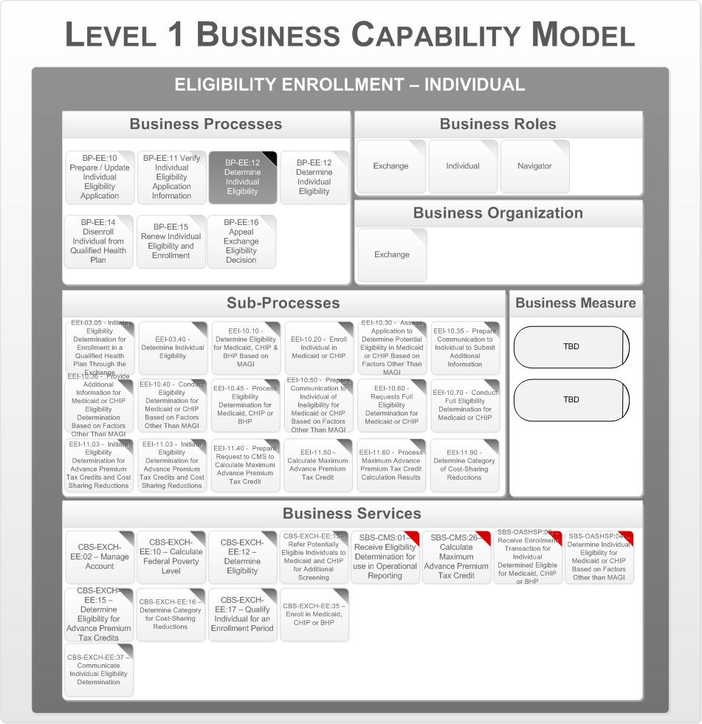

Figure 21 - Determine Vermonter Eligibility (1 of 2)

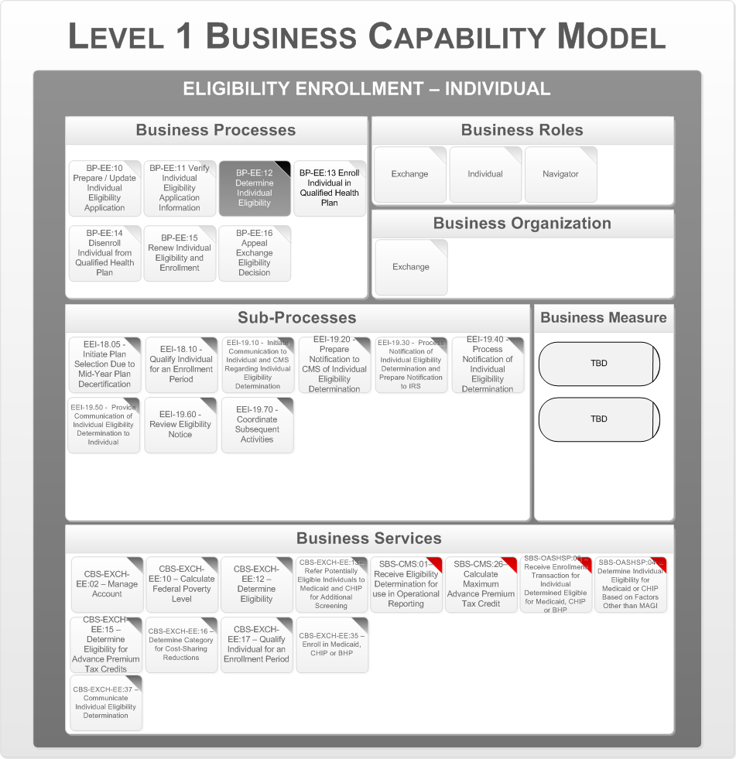

Figure 22 - Determine Vermonter Eligibility (2 of 2)

This process determines the individual’s eligibility for enrollment in a qualified health plan, and if applicable, APTC, CSR, and Medicaid, CHIP, and the Basic Health Program. This process may include evaluating eligibility based on MAGI and household size. The following are the key business organizations that interact during this process:

* The Health Benefits Exchange

Appendix A – Reference Section lists the CMS Blue Print Documents that contains details on the Business Processes, Business Sub Processes, and Business Services.

### Enroll Vermonter in Qualified Health Plan

The following diagrams represent the Business Capability Model for the Eligibility and Enrollment Vermonter business area, business process “Enroll Vermonter in Qualified Health Plan.”

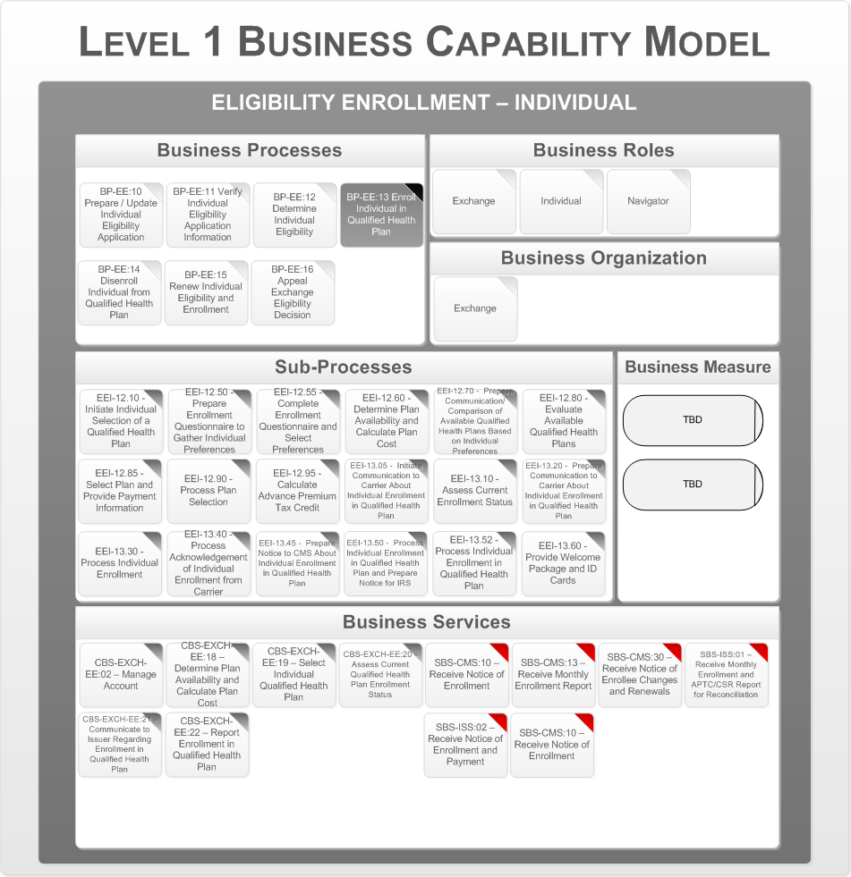

Figure 23 - Prepare Enroll Vermonter in Qualified Health Plan (1 of 2)

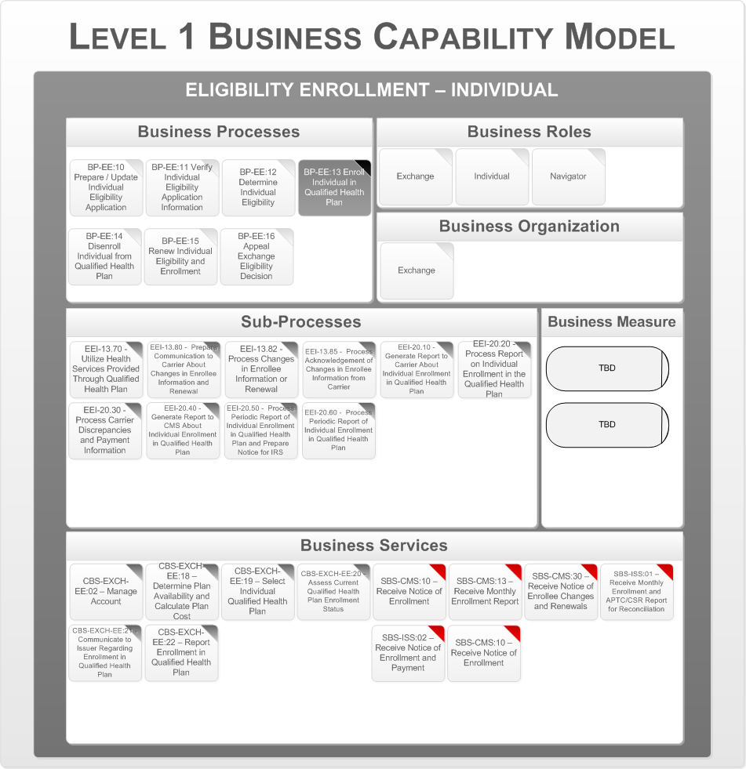

Figure 24 - Prepare Enroll Vermonter in Qualified Health Plan (2 of 2)

This process facilitates an eligible individual’s selection of a qualified health plan and subsequent enrollment in the plan. It assesses whether an individual meets the requirements for an enrollment period, and if so, generates plan choice information that is customized to the individual's eligibility and personal preferences. Enrollment activities include notifying the issuer of the selected qualified health plan of the individual enrollment, facilitating payment of the first month's premium, notifying CMS to facilitate payments of APTC and CSR, and processing the issuer's response to The Health Benefits Exchange enrollment transaction. The following are the key business organizations that interact during this process:

* The Health Benefits Exchange

Appendix A – Reference Section lists the CMS Blue Print Documents that contains details on the Business Processes, Business Sub Processes, and Business Services.

### Disenroll Vermonter from Qualified Health Plan

The following figure is the Business Capability Model for the Eligibility and Enrollment Vermonter business area, business process “Disenroll Vermonter from Qualified Health Plan.”

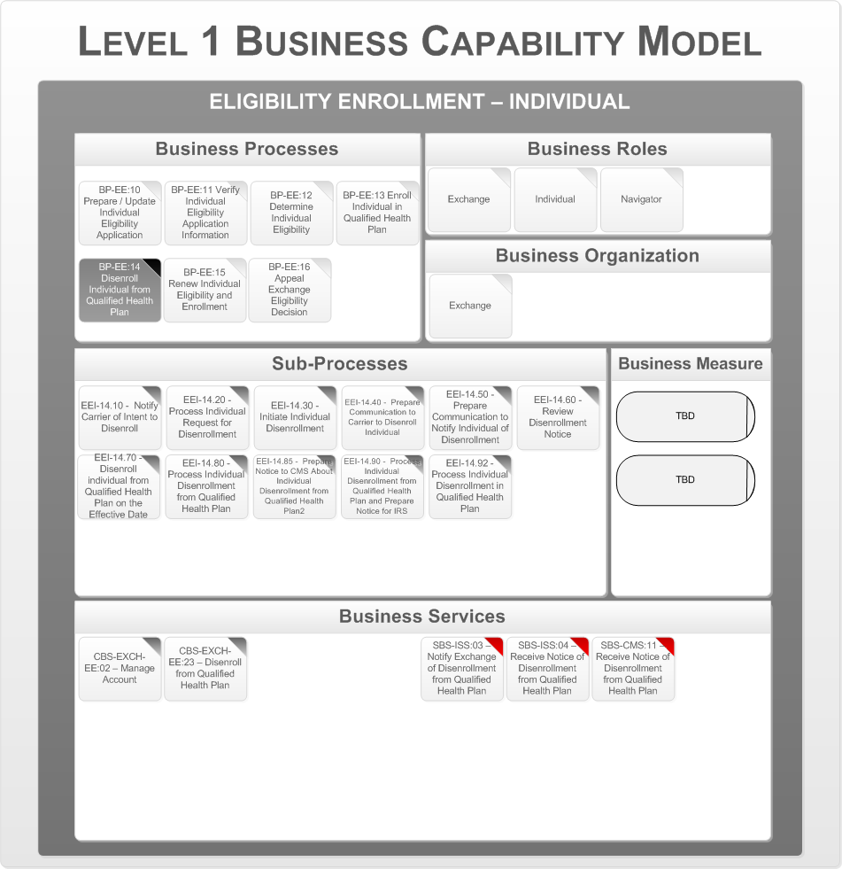

Figure 25 - Disenroll Vermonter from Qualified Health Plan

This process collects initial and updated application information from an individual necessary to determine eligibility for enrollment in a qualified health plan, APTC, CSR, and Medicaid, CHIP, and the Basic Health Program. Application information includes details about each member of the household. The following are the key business organizations that interact during this process:

* The Health Benefits Exchange

Appendix A – Reference Section lists the CMS Blue Print Documents that contains details on the Business Processes, Business Sub Processes, and Business Services.

### Renew Vermonter Eligibility and Enrollment

The following figure is the Business Capability Model for the Eligibility and Enrollment Vermonter business area, business process “Renew Vermonter Eligibility and Enrollment.”

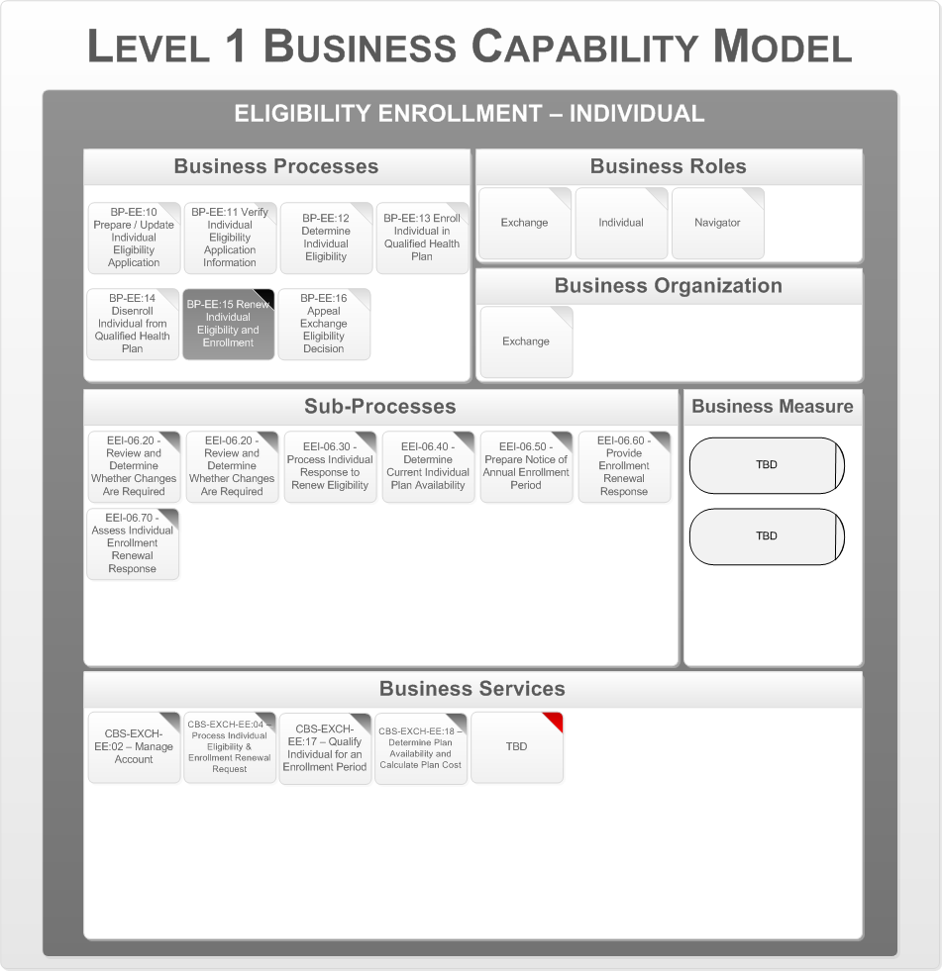

Figure 26 - Renew Vermonter Eligibility and Enrollment

This process handles the renewal of an individual’s eligibility and enrollment, including re-determining the individual's eligibility for enrollment in a qualified health plan, APTC, CSR, and Medicaid, CHIP, and the Basic Health Program. The following are the key business organizations that interact during this process:

* The Health Benefits Exchange

Appendix A – Reference Section lists the CMS Blue Print Documents that contains details on the Business Processes, Business Sub Processes, and Business Services.

### Appeal Exchange Eligibility Decision

The following figure is the Business Capability Model for the Eligibility and Enrollment Vermonter business area, business process “Appeal Exchange Eligibility Decision.”

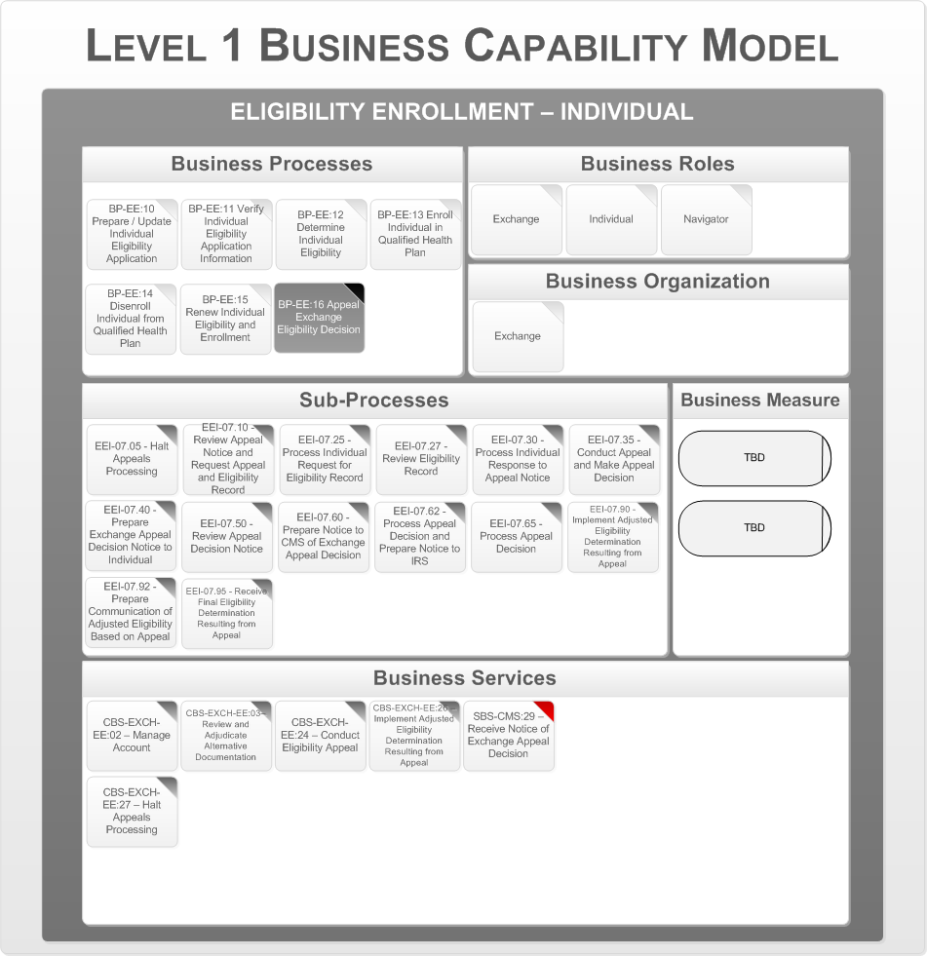

Figure 27 - Appeal Exchange Eligibility Decision

This process identifies key activities involved in appeals of eligibility determinations made by The Health Benefits Exchange, and includes providing notices to individuals, receiving appeal requests, adjudicating appeals, and implementing appeal decisions. The following are the key business organizations that interact during this process:

* The Health Benefits Exchange

Appendix A – Reference Section lists the CMS Blue Print Documents that contains details on the Business Processes, Business Sub Processes, and Business Services.

## Business Process Support Model

The next step is to map the business services to application services and define the key business data objects. This is described by the Business Process Support Model. The following diagram shows the Business Process Support Model for the “Eligibility and Enrollment for Vermonter” business area.

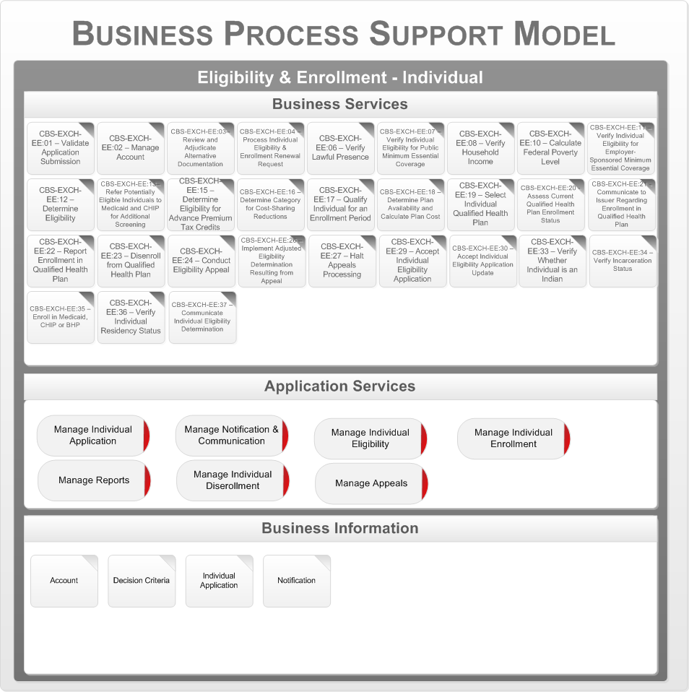

Figure 28 – E&E Vermonter Business Process Support Model

The core business services for “Vermonter Eligibility and Enrollment” are mapped to the five application services:

* Manage Vermonter Application
* Manage Notification and Communication
* Manage Vermonter Eligibility
* Manage Vermonter Enrollment
* Manage Reports
* Manage Vermonter Disenrollment
* Manage Appeals

## Vermonter Responsibility Exemption

Vermonter Responsibility Exemption encompasses all Exchange functions required to accept applications, verify relevant individual and household information, and determine eligibility for an exemption from the individual responsibility requirement. It also includes functions to renew exemptions and accept and process appeals of exemption determinations.

### Prepare/Update Vermonter Exemption Application

The following figure is the Business Capability Model for the Eligibility and Enrollment Vermonter Responsibility Exemption business area, business process “Prepare/Update Vermonter Exemption Application.”

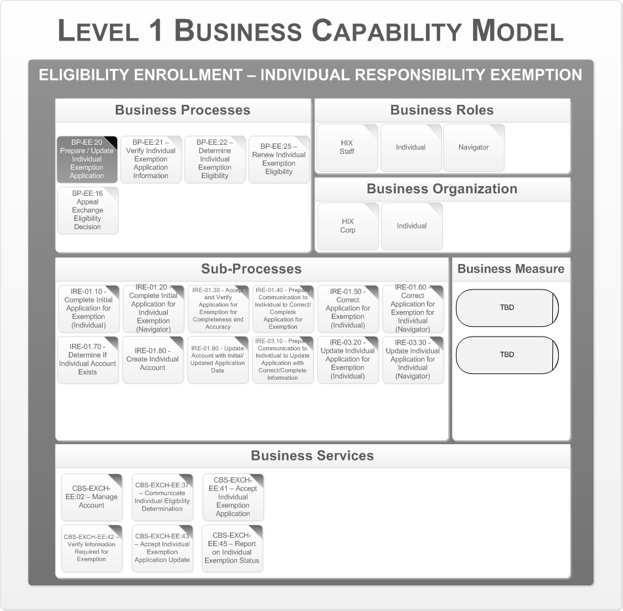

Figure 29 - Prepare/Update Vermonter Exemption Application

This process collects initial and updated application information from an individual necessary to determine eligibility for individual exemptions from the individual responsibility requirement. The following are the key business organizations that interact during this process:

* Department of Vermont Health Access
* Vermonter

Appendix A – Reference Section lists the CMS Blue Print Documents that contains details on the Business Processes, Business Sub Processes, and Business Services.

### Vermonter Exemption Application Information

The following figure is the Business Capability Model for the Eligibility and Enrollment Vermonter Responsibility Exemption business area, business process “Vermonter Exemption Application Information”.

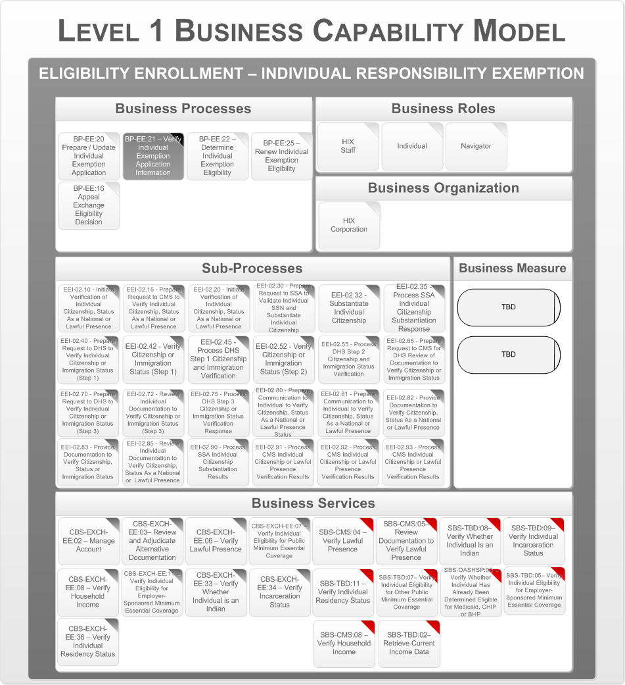

Figure 30 - Vermonter Exemption Application Information (1 of 3)

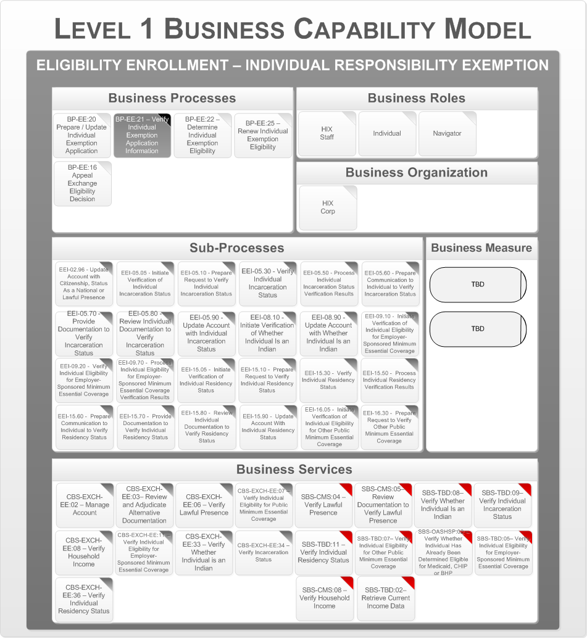

Figure 31 - Vermonter Exemption Application Information (2 of 3)

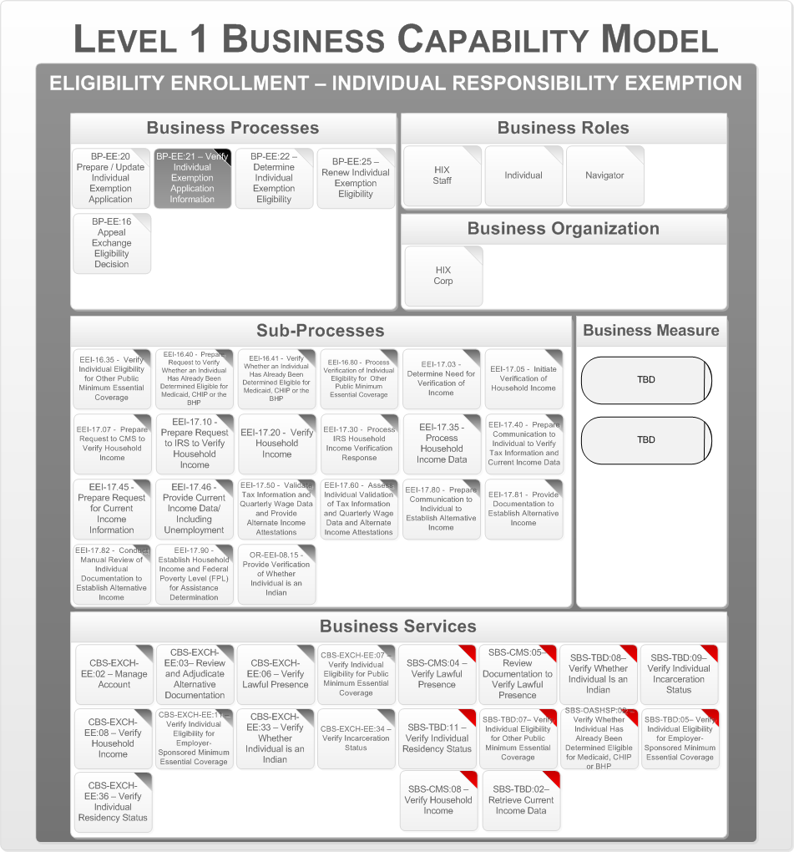

Figure 32 - Vermonter Exemption Application Information (3 of 3)

This process verifies the information provided on the application with trusted data sources, and acquires other authoritative data needed to determine eligibility. This process varies depending on the reason for the exemption requested by an individual. The following are the key business organizations that interact during this process:

* Department of Vermont Health Access

Appendix A – Reference Section lists the CMS Blue Print Documents that contains details on the Business Processes, Business Sub Processes, and Business Services.

### Determine Vermonter Exemption Eligibility

The following figure is the Business Capability Model for the Eligibility and Enrollment Vermonter Responsibility Exemption business area, business process “Determine Vermonter Exemption Eligibility”.

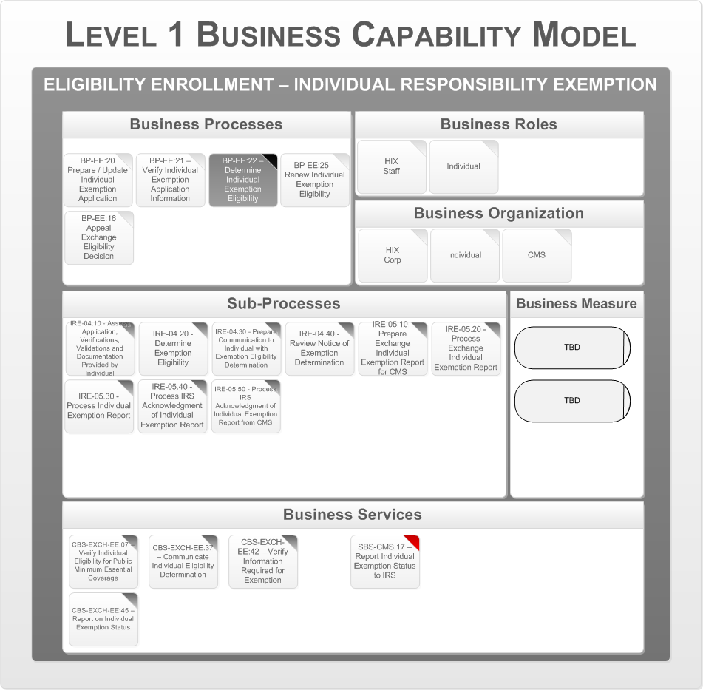

Figure 33 - Determine Vermonter Exemption Eligibility

This process determines eligibility for exemptions from the individual responsibility requirement. The following are the key business organizations that interact during this process:

* Department of Vermont Health Access
* Vermonter
* CMS

Appendix A – Reference Section lists the CMS Blue Print Documents that contains details on the Business Processes, Business Sub Processes, and Business Services.

### Renew Vermonter Exemption Eligibility

The following figure is the Business Capability Model for the Eligibility and Enrollment Vermonter Responsibility Exemption business area, business process “Renew Vermonter Exemption Eligibility”.

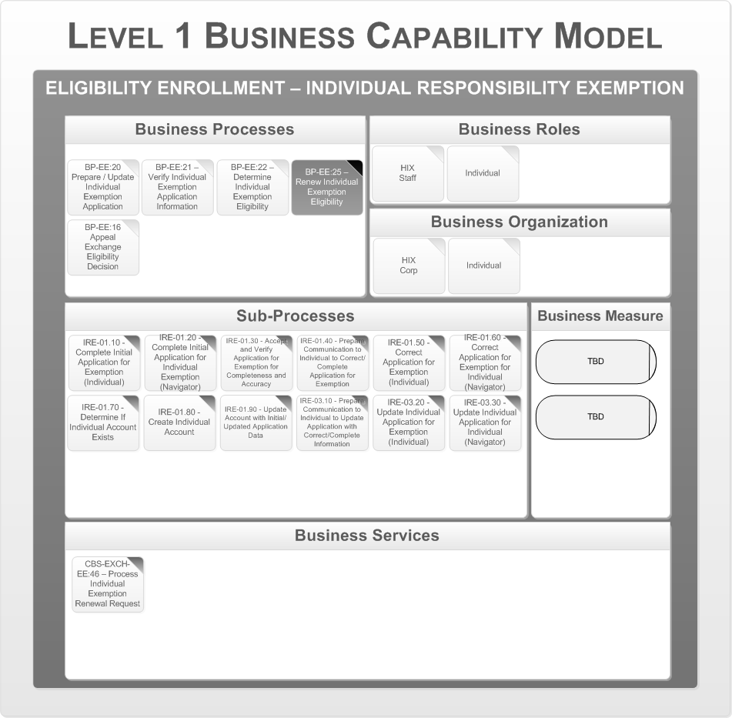

Figure 34 - Renew Vermonter Exemption Eligibility

This process handles the renewal of an individual’s exemption from the individual responsibility requirement. Certain exemptions may not require renewal.HBE Corporation. The following are the key business organizations that interact during this process:

* Vermonter

Appendix A – Reference Section lists the CMS Blue Print Documents that contains details on the Business Processes, Business Sub Processes, and Business Services.

### Appeal Exchange Eligibility Decision

The following figure is the Business Capability Model for the Eligibility and Enrollment Vermonter Responsibility Exemption business area, business process “Appeal Exchange Eligibility Decision”.

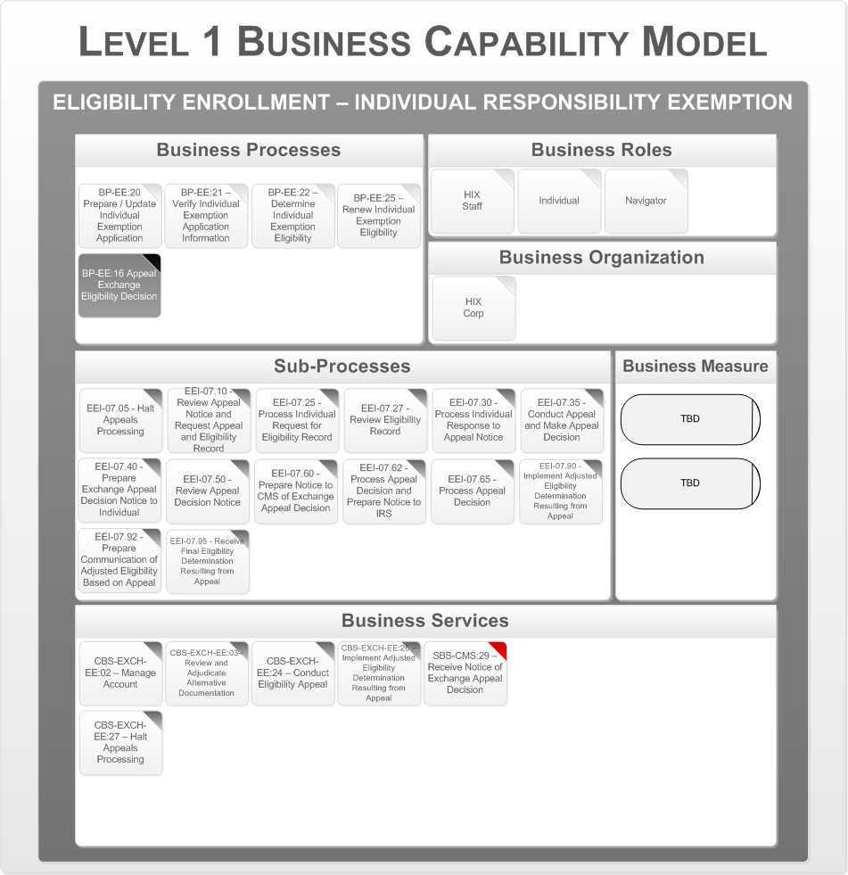

Figure 35 - Appeal Exchange Eligibility Decision

This process identifies key activities involved in appeals of eligibility determinations made by The Health Benefits Exchange, and includes providing notices to individuals, receiving appeal requests, adjudicating appeals, and implementing appeal decisions. The following are the key business organizations that interact during this process:

* Department of Vermont Health Access

Appendix A – Reference Section lists the CMS Blue Print Documents that contains details on the Business Processes, Business Sub Processes, and Business Services.

## Business Process Model

The next step is to map the business services to application services and define the key business data objects. This is described by the Business Process Support Model. The following diagram shows the Business Process Support Model for the “Eligibility and Enrollment for Vermonter Responsibility Exemption” business area.

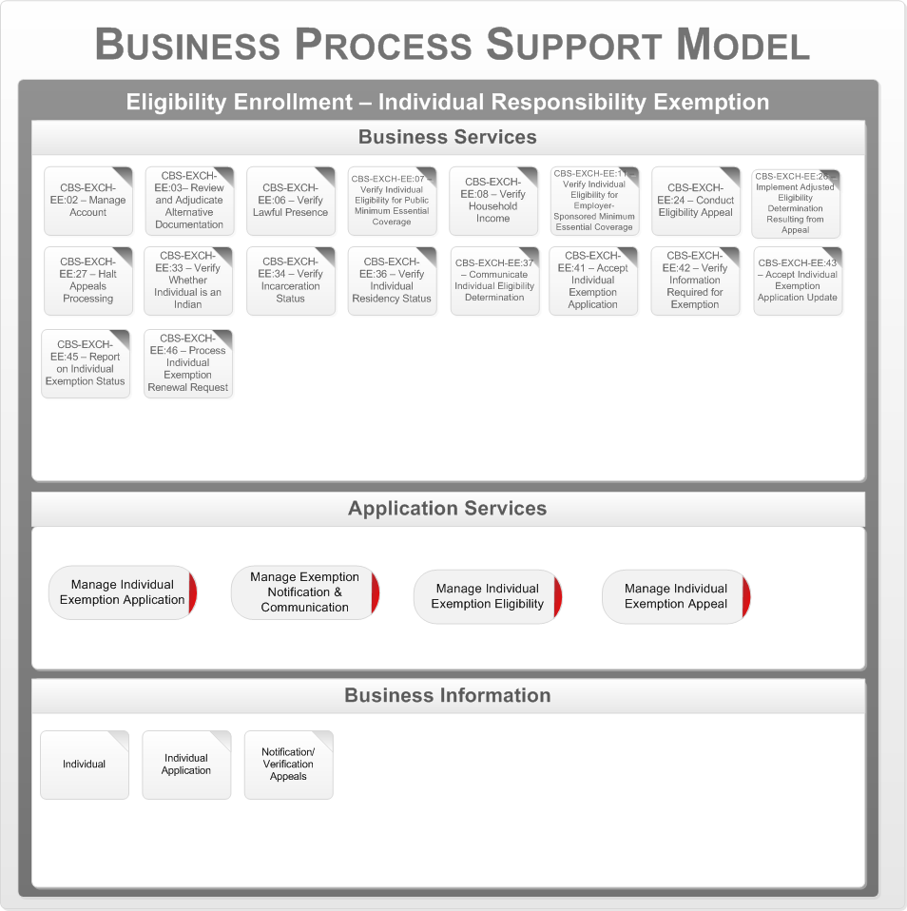

Figure 36 - E&E Vermonter Responsibility Exemption Business Process

Support Model

The core business services for “Eligibility and Enrollment Responsbility Exemption” are mapped to the five application services:

* Manage Vermonter Exemption Application
* Manage Exemption Notification and Communication
* Manage Vermonter Exemption Eligibility
* Manage Vermonter Exemption Appeal

### SHOP Employer Eligibility Enrollment

SHOP Employer Eligibility and Enrollment encompasses all Exchange functions required to accept employer applications, verify relevant information, determine eligibility for an employer to participate in the SHOP Exchange, and support an employer’s facilitation of an employee’s selection of a QHP through the SHOP Exchange. It also includes functions to renew eligibility and enrollment, discontinue participation in the SHOP Exchange, and accept and process appeals of eligibility decisions.

This subsection addresses the business architecture for the SHOP Employer Eligibility and Enrollment business area. This area consists of the following processes:

* + - Prepare / Update Employer Eligibility Application
    - Verify Employer Eligibility Application Information
    - Determine Employer Eligibility for Participation
    - Determine Employer Contribution
    - Terminate Employer Participation
    - Renew Employer Participation
    - Appeal Small Business Health Options Program (SHOP) Eligibility Decision

The following is the series of Level 1 Business Capability Models, one for each business process. The business process in focus for a particular model is depicted in a darkened gray box. The rest of the model is associated with that specific business process. In the Business Services area the Supporting Business Services are indicated with a red tab to distinguish them from the Core Business Services.

#### Prepare / Update Employer Eligibility Application

The following figure is the Business Capability Model for the Eligibility and Enrollment SHOP Employer business area, business process “Prepare / Update Employer Eligibility Application.”

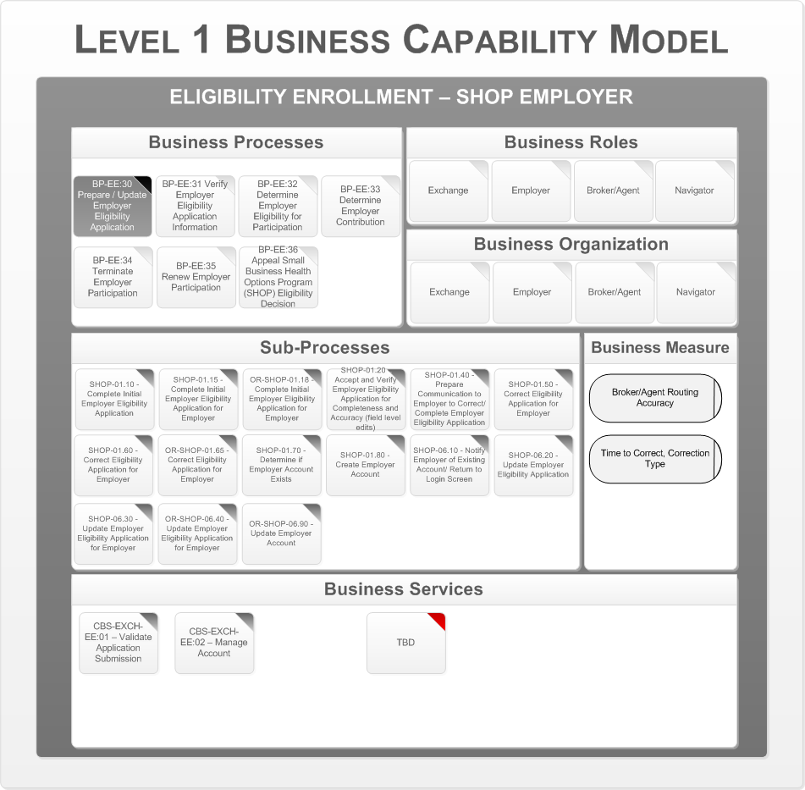

Figure 37 - Prepare / Update Employer Eligibility Application

This process collects initial and updated application information from an employer necessary to determine eligibility for participation in a SHOP Exchange. Application information includes the employer’s name and address, employer identifier, and a roster of employees with work addresses. Employers must also provide an attestation that all full-time employees are offered coverage. The following are the key business organizations that interact during this process:

* The Health Benefits Exchange
* Employer
* Broker/Agent
* Navigator

Appendix A – Reference Section lists the CMS Blue Print Documents that contains details on the Business Processes, Business Sub Processes, and Business Services.

#### Verify Employer Eligibility Application Information

The following figure is the Business Capability Model for the Eligibility and Enrollment SHOP Employer business area, business process “Verify Employer Eligibility Application Information.”

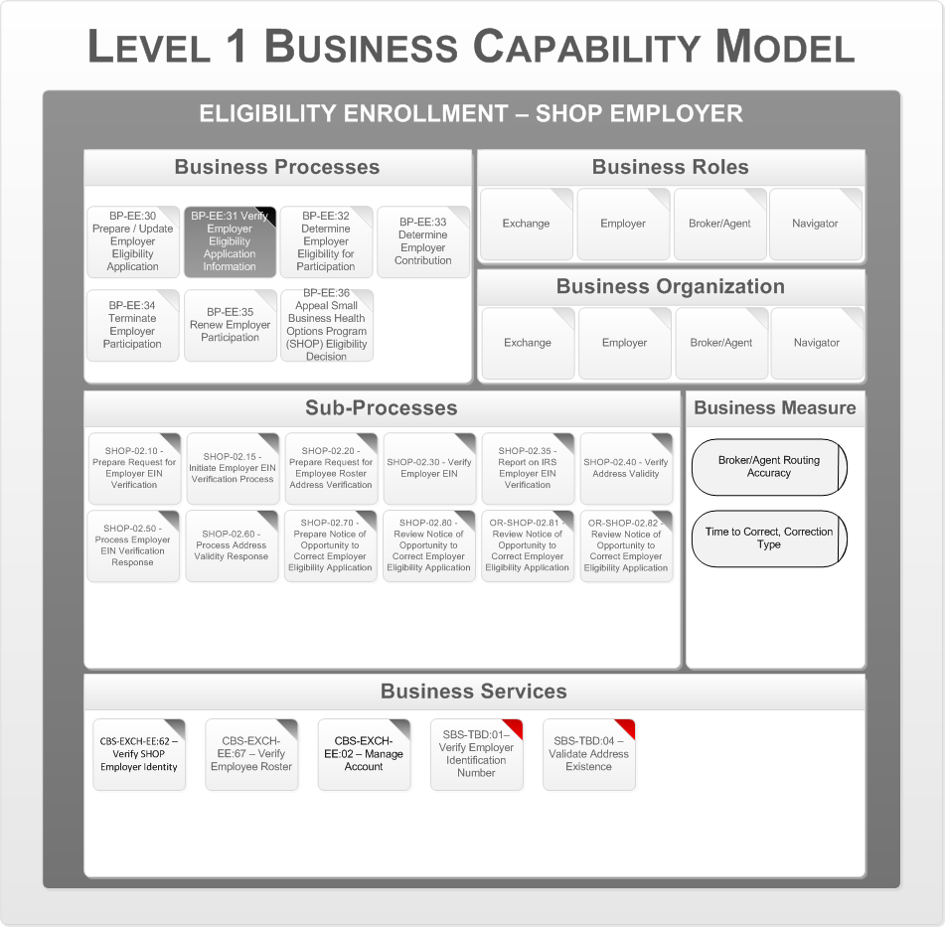

Figure 38 - Verify Employer Eligibility Application Information

This process Verifies existence of the employer’s Federal Employer Identification Number (EIN) and validity of the addresses contained in the employee roster.

* The Health Benefits Exchange
* Employer
* Broker/Agent
* Navigator

Appendix A – Reference Section lists the CMS Blue Print Documents that contains details on the Business Processes, Business Sub Processes, and Business Services.

#### Determine Employer Eligibility for Participation

The following figure is the Business Capability Model for the Eligibility and Enrollment SHOP Employer business area, business process “Determine Employer Eligibility for Participation.”

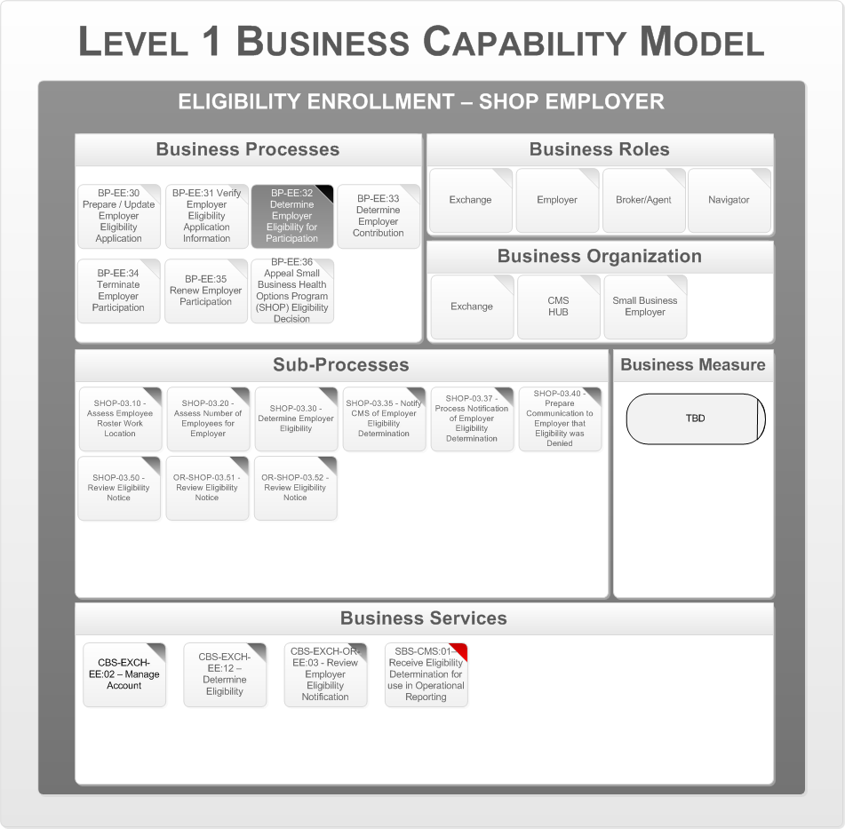

Figure 39 - Determine Employer Eligibility for Participation

This process determines the employer’s eligibility for participation in a SHOP Exchange. The following are the key business organizations that interact during this process:

* The Health Benefits Exchange
* Employer
* CMS (HUB)

Appendix A – Reference Section lists the CMS Blue Print Documents that contains details on the Business Processes, Business Sub Processes, and Business Services.

#### Determine Employer Contribution

The following diagrams represent the Business Capability Model for the Eligibility and Enrollment SHOP Employer business area, business process “Determine Employer Contribution.”

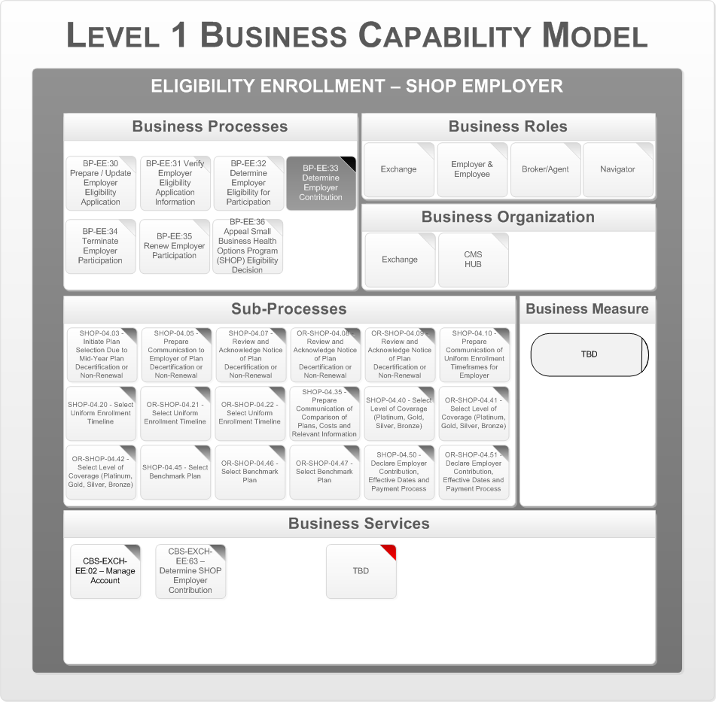

Figure 40 - Determine Employer Contribution (1 of 2)

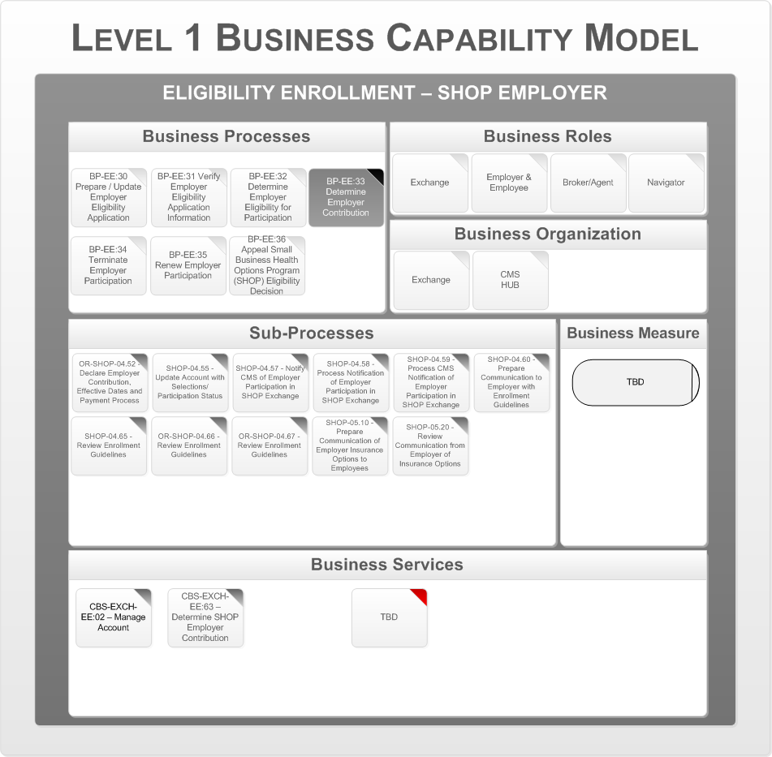

Figure 41 - Determine Employer Contribution (2 of 2)

This process facilitates plan selection options for the employees in accordance with the selected uniform enrollment timeframe. The employer also declares its contribution toward the cost of coverage and whether it elects to contribute through pretax payments. The employer communicates to the employee regarding the availability of coverage through the SHOP Exchange and guidelines for selecting and enrolling in a QHP. The following are the key business organizations that interact during this process:

* The Health Benefits Exchange
* CMS (HUB)

Appendix A – Reference Section lists the CMS Blue Print Documents that contains details on the Business Processes, Business Sub Processes, and Business Services.

#### Terminate Employer Participation

The following figure is the Business Capability Model for the Eligibility and Enrollment SHOP Employer business area, business process “Terminate Employer Participation.”

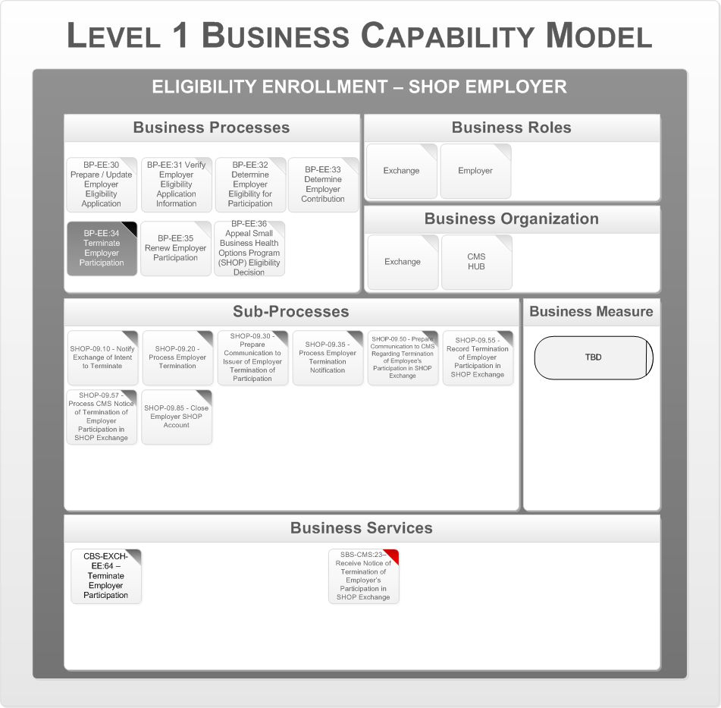

Figure 42 - Terminate Employer Participation

This process terminates an employer’s participation in a SHOP Exchange initiated by the employer, or by The Health Benefits Exchange if the employer is found to be negligent. Employees enrolled in QHPs are notified of their options. The issuer and CMS are also notified. The following are the key business organizations that interact during this process:

* The Health Benefits Exchange
* CMS (HUB)

Appendix A – Reference Section lists the CMS Blue Print Documents that contains details on the Business Processes, Business Sub Processes, and Business Services.

#### Renew Employer Participation

The following figure is the Business Capability Model for the Eligibility and Enrollment SHOP Employer business area, business process “Renew Employer Participation.”

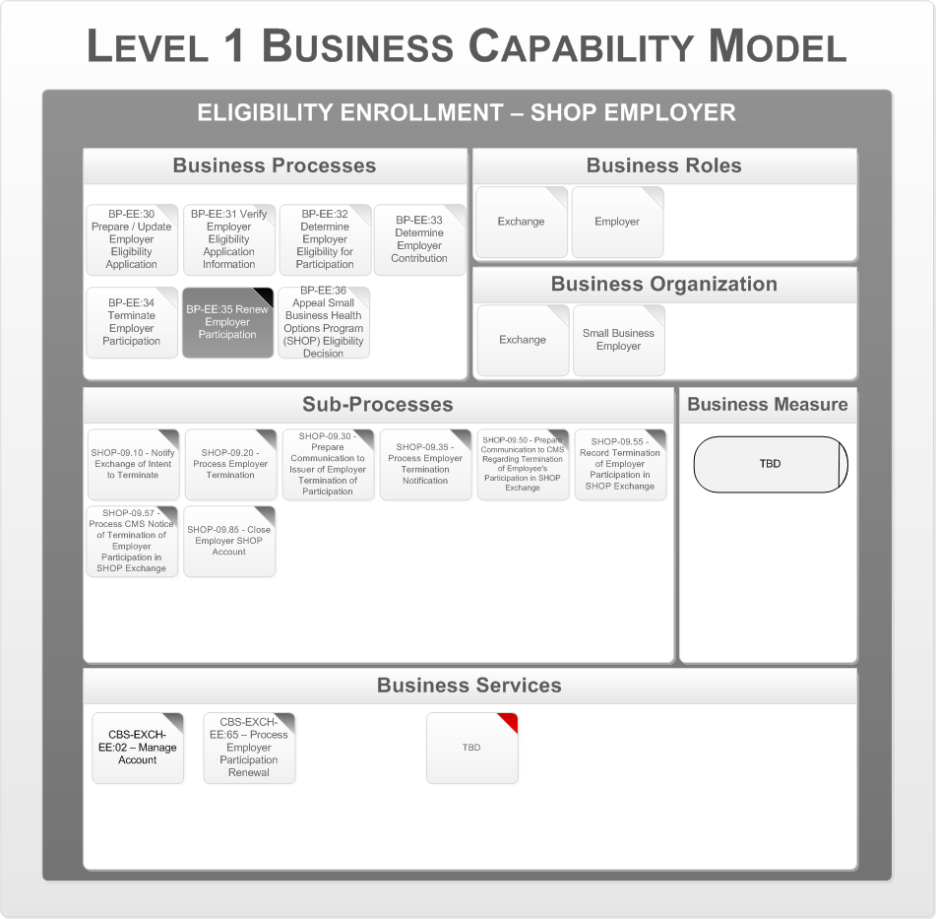

Figure 43 - Renew Employer Participation

This process handles the redetermination of eligibility for participation in the SHOP Exchange. The following are the key business organizations that interact during this process:

* The Health Benefits Exchange
* Employer

Appendix A – Reference Section lists the CMS Blue Print Documents that contains details on the Business Processes, Business Sub Processes, and Business Services.

#### Appeal SHOP Eligibility Decision

The following figure is the Business Capability Model for the Eligibility and Enrollment SHOP Employer business area, business process “Appeal SHOP Eligibility Decision.”

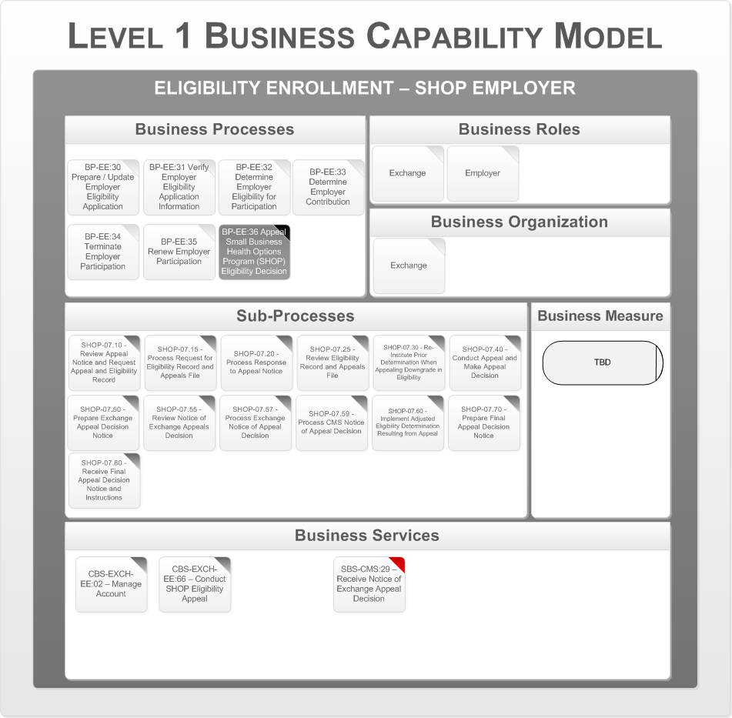

Figure 44 - Appeal SHOP Eligibility Decision

This process identifies key activities involved in appeals of eligibility determinations made by The Health Benefits Exchange, including providing notices to employees and employers, receiving appeal requests, adjudicating appeals, and implementing appeal decisions.

The following are the key business organizations that interact during this process:

* The Health Benefits Exchange

Appendix A – Reference Section lists the CMS Blue Print Documents that contains details on the Business Processes, Business Sub Processes, and Business Services.

### Business Process Support Model

The next step is to map the business services to application services and define the key business data objects. This is described by the Business Process Support Model. The following diagram shows the Business Process Support Model for the “Eligibility and Enrollment for SHOP” Employer business area.

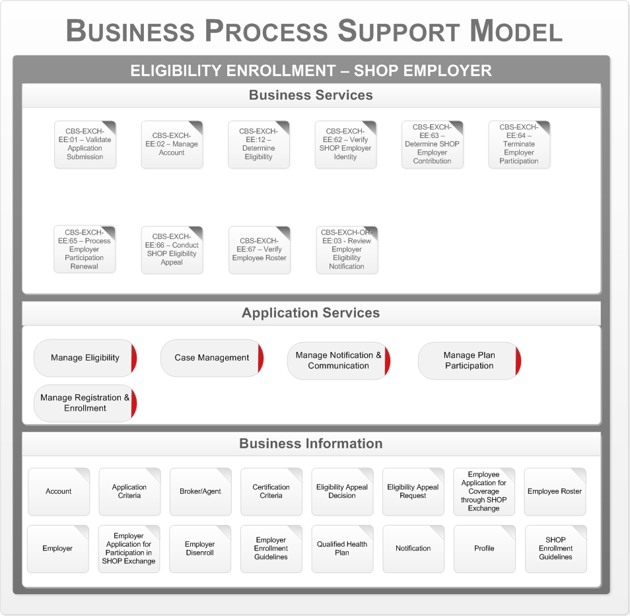

Figure 45 – E&E SHOP Employer Business Process Support Model

The core business services for “SHOP Employer Eligibility and Enrollment” are mapped to the five application services:

* Manage Eligibility
* Case Management
* Manage Notification and Communication
* Manage Plan Participation
* Manage Registration & Enrollment

### SHOP Employee Eligibility Enrollment

SHOP Employee Eligibility and Enrollmentencompasses all Exchange functions required to accept employee applications, verify relevant information, determine eligibility for employee enrollment in a QHP through the SHOP Exchange, and support an employee’s selection of, and enrollment in, a QHP through the SHOP Exchange. It also includes functions to renew eligibility and enrollment, disenroll from a QHP, and accept and process appeals of eligibility decisions.

This section addresses the business architecture design for the SHOP Employee Eligibility and Enrollment business area. This area consists of the following processes:

* + - Prepare / Update Employee Eligibility Application
    - Verify Employee Eligibility Application Information
    - Determine Employee Eligibility
    - Enroll Employee in Qualified Health Plan
    - Disenroll Employee from Qualified Health Plan Business Services
    - Renew Employee Eligibility & Enrollment Business Services

The following is the series of Level 1 Business Capability Models, one for each business process. The business process in focus for a particular model is depicted in a darkened gray box. The rest of the model is associated with that specific business process. In the Business Services area the Supporting Business Services are indicated with a red tab to distinguish them from the Core Business Services.

#### Prepare / Update Employee Eligibility Application

The following figure is the Business Capability Model for the Eligibility and Enrollment SHOP Employer business area, business process “Prepare/Update Employee Eligibility Application.”

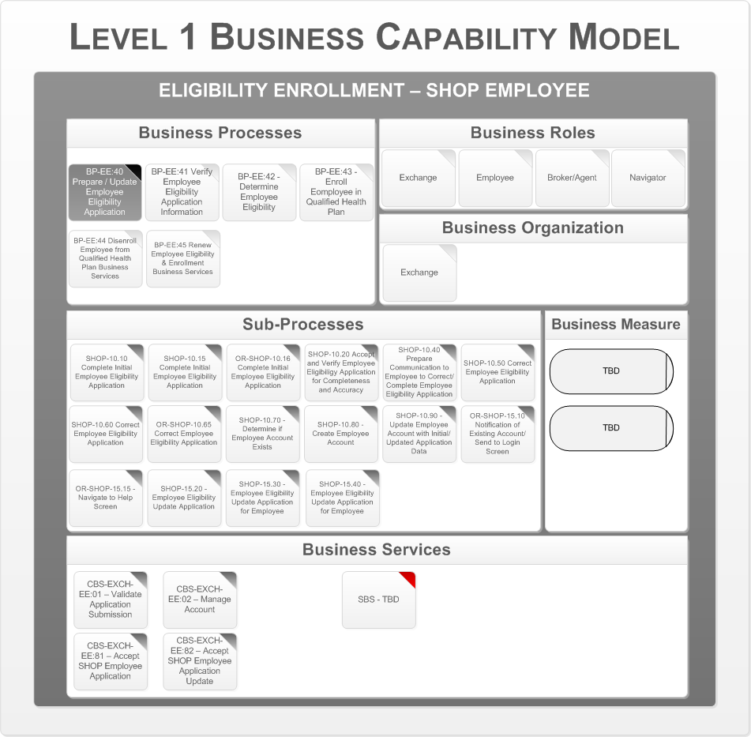

Figure 46 - Prepare/Update Employee Eligibility Application

This process collects initial and updated application information from an employee necessary to determine eligibility for enrollment through a SHOP Exchange. The following are the key business organizations that interact during this process:

* The Health Benefits Exchange

Appendix A – Reference Section lists the CMS Blue Print Documents that contains details on the Business Processes, Business Sub Processes, and Business Services.

#### Verify Employee Eligibility Application Information

The following figure is the Business Capability Model for the Eligibility and Enrollment SHOP Employer business area, business process “Verify Employee Eligibility Application Information.”

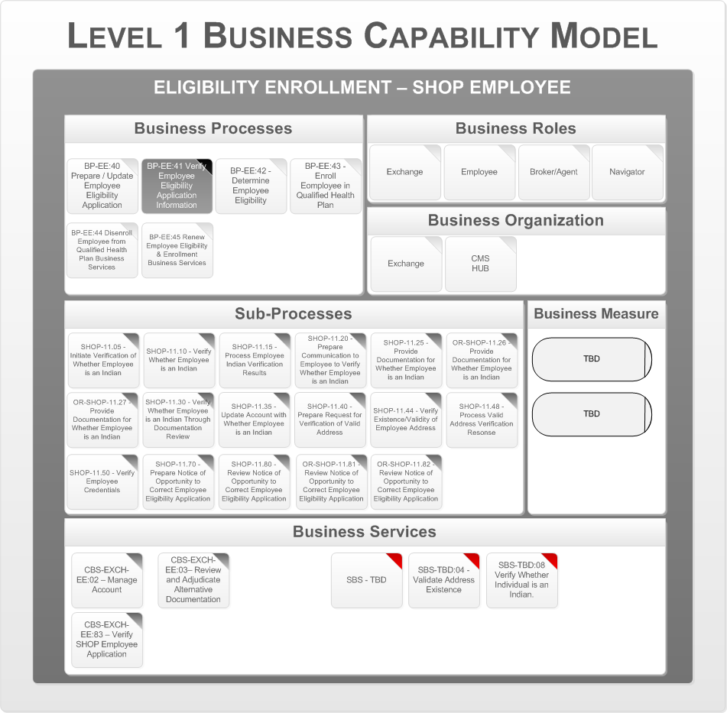

Figure 47 - Verify Employee Eligibility Application Information

This process verifies existence of the employee’s home and work addresses with trusted data sources and validates the identifier associating the employee with the employer. The following are the key business organizations that interact during this process:

* The Health Benefits Exchange
* CMS (HUB)

Appendix A contains detail on sub-processes and identified services descriptions.

#### Determine Employee Eligibility

The following figure is the Business Capability Model for the Eligibility and Enrollment SHOP Employer business area, business process “Determine Employee Eligibility.”

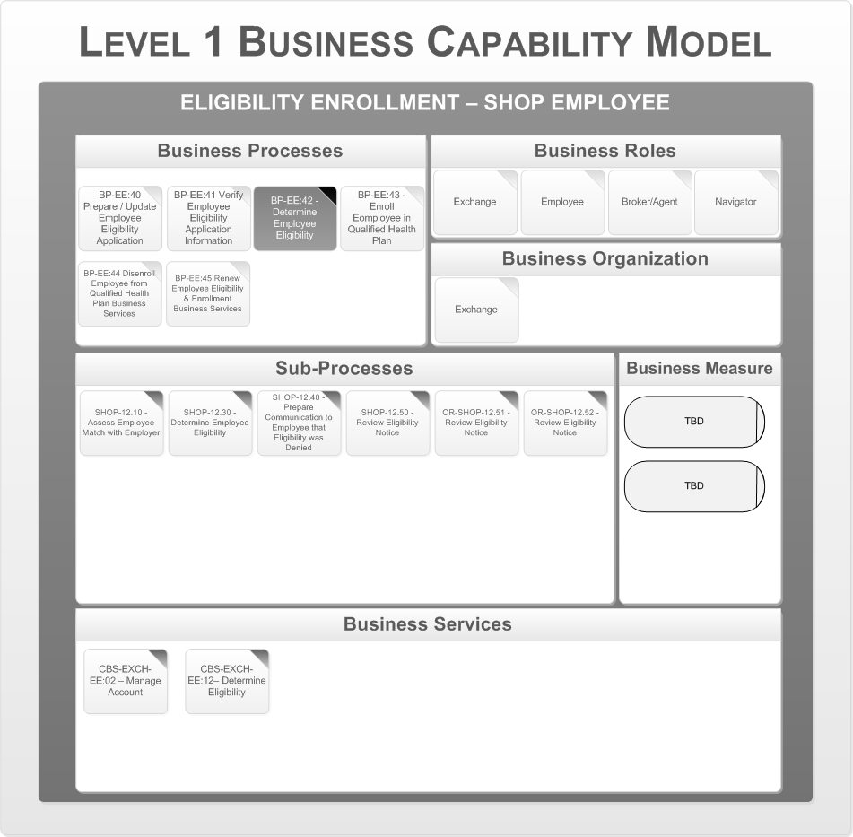

Figure 48 - Determine Employee Eligibility

This process determines the employee’s eligibility for enrollment in a SHOP Exchange. The following are the key business organizations that interact during this process:

* The Health Benefits Exchange

Appendix A – Reference Section lists the CMS Blue Print Documents that contains details on the Business Processes, Business Sub Processes, and Business Services.

#### Enroll Employee in Qualified Health Plan

The following diagrams represent the Business Capability Model for the Eligibility and Enrollment SHOP Employer business area, business process “Enroll Employee in Qualified Health Plan.”

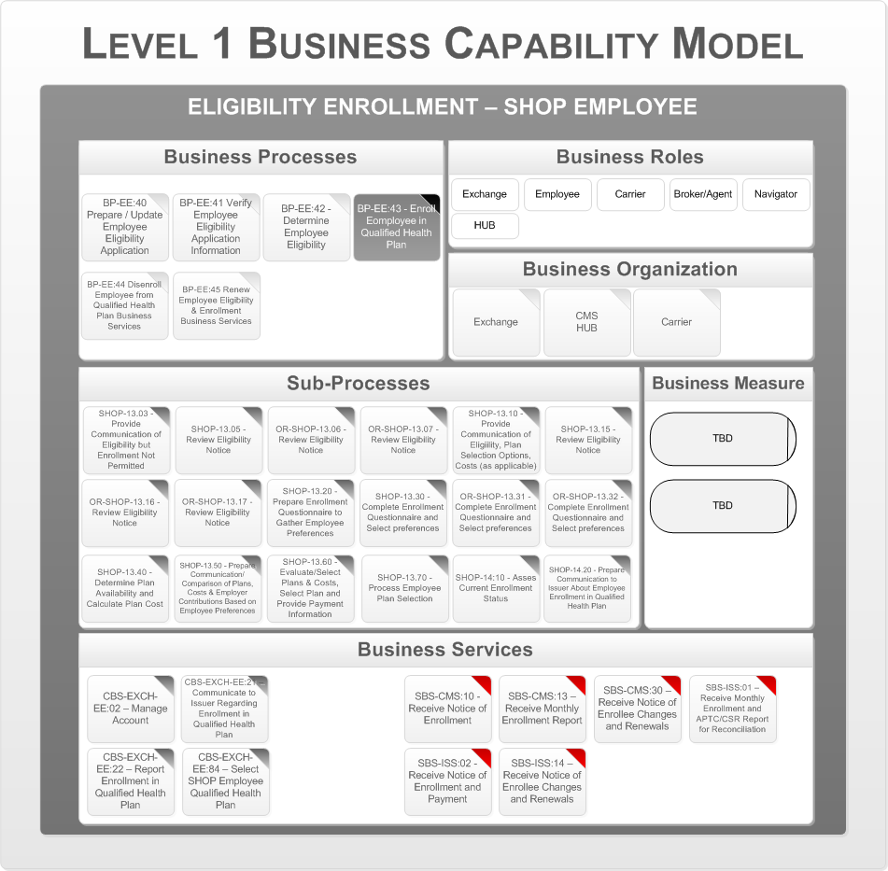

Figure 49 - Enroll SHOP Employee in QHP (1 of 2)

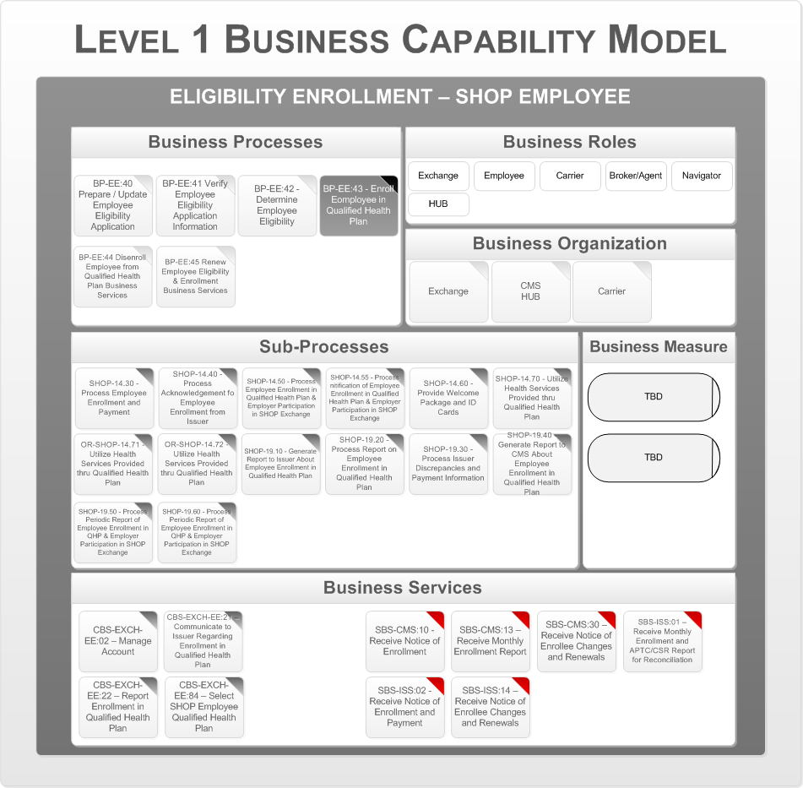

Figure 50 - Enroll SHOP Employee in QHP (2 of 2)

This process assesses whether an employee meets the requirements for an enrollment period, and if so, generates plan choice information. Enrollment activities may include notifying the issuer of the employee’s selected qualified health plan, facilitating payment of the first month's premium, and processing the issuer's response to The Health Benefits Exchange enrollment transaction. The Health Benefits Exchange notifies CMS of the employee’s enrollment in a QHP. The following are the key business organizations that interact during this process:

* The Health Benefits Exchange
* CMS (HUB)
* Insurer

Appendix A – Reference Section lists the CMS Blue Print Documents that contains details on the Business Processes, Business Sub Processes, and Business Services.

#### Disenroll Employee from QHP Business Services

The following diagrams represent the Business Capability Model for the Eligibility and Enrollment SHOP Employer business area, business process “Disenroll Employee from QHP Business Services.”

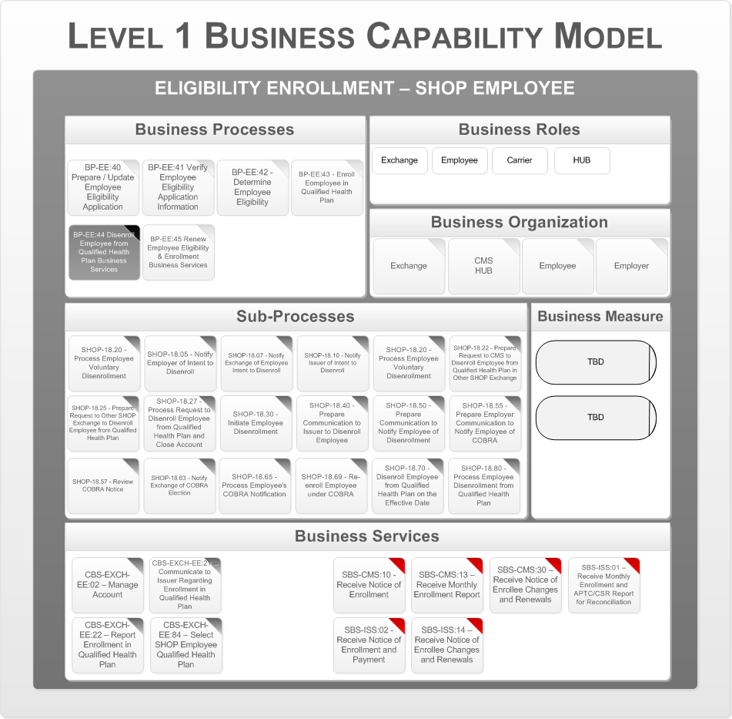

Figure 51 - Disenroll Employee from QHP Business Services (1 of 2)

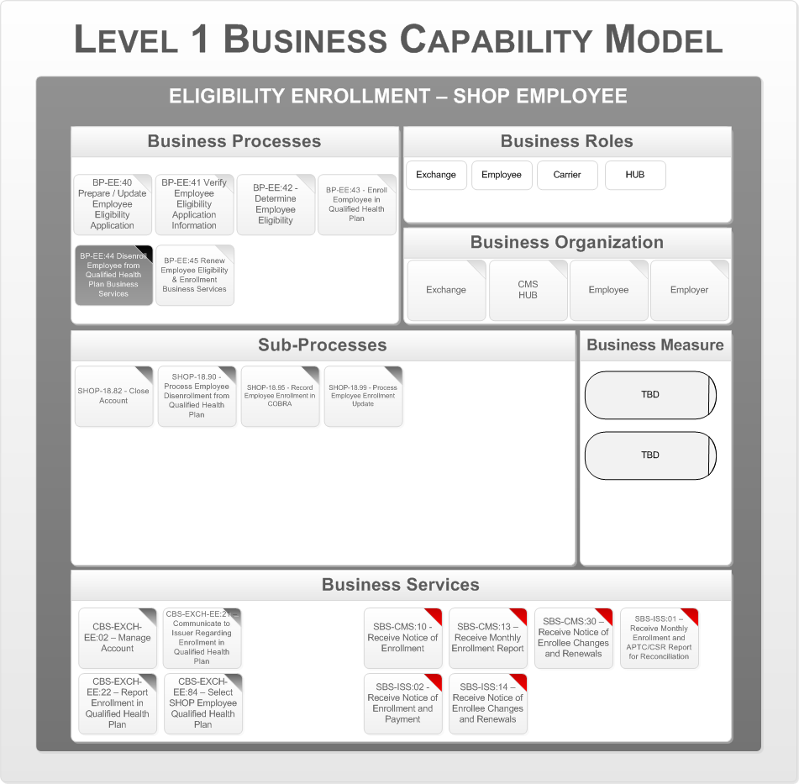

Figure 52 - Disenroll Employee from QHP Business Services (2 of 2)

This process disenrolls an employee from a QHP. This process involves notifying interested parties of the disenrollment. The Health Benefits Exchange notifies CMS of the employee’s disenrollment from a QHP. The following are the key business organizations that interact during this process:

* The Health Benefits Exchange
* CMS (HUB)
* Employer
* Employee

Appendix A – Reference Section lists the CMS Blue Print Documents that contains details on the Business Processes, Business Sub Processes, and Business Services.

#### Renew Employee Eligibility & Enrollment Business Services

The following figure is the Business Capability Model for the Eligibility and Enrollment SHOP Employer business area, business process “Renew Employee Eligibility & Enrollment Business Services.”

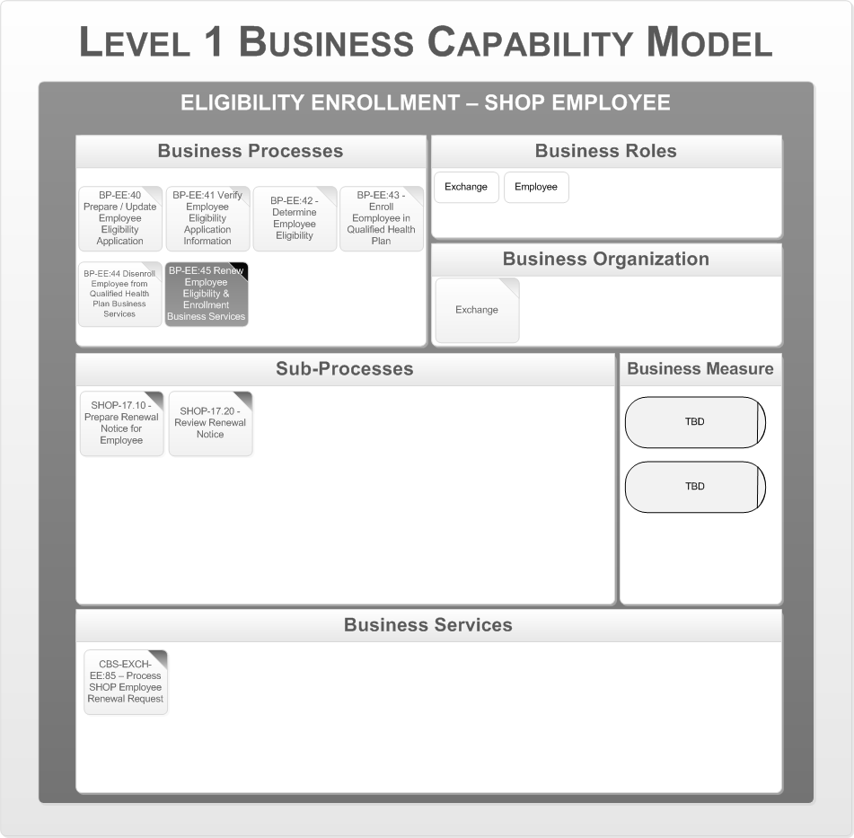

Figure 53 - Renew Employee Eligibility & Enrollment Business Services

This process handles the renewal of an employee’s eligibility and enrollment in a qualified health plan. The Health Benefits Exchange notifies CMS of the employee’s enrollment in a QHP. The following are the key business organizations that interact during this process:

* The Health Benefits Exchange
* CMS (HUB)
* Insurer

Appendix A – Reference Section lists the CMS Blue Print Documents that contains details on the Business Processes, Business Sub Processes, and Business Services.

### Business Process Support Model

The next step is to map the business services to application services and define the key business data objects. This is described by the Business Process Support Model. The following diagram shows the Business Process Support Model for the “Eligibility and Enrollment for SHOP Employee” business area.

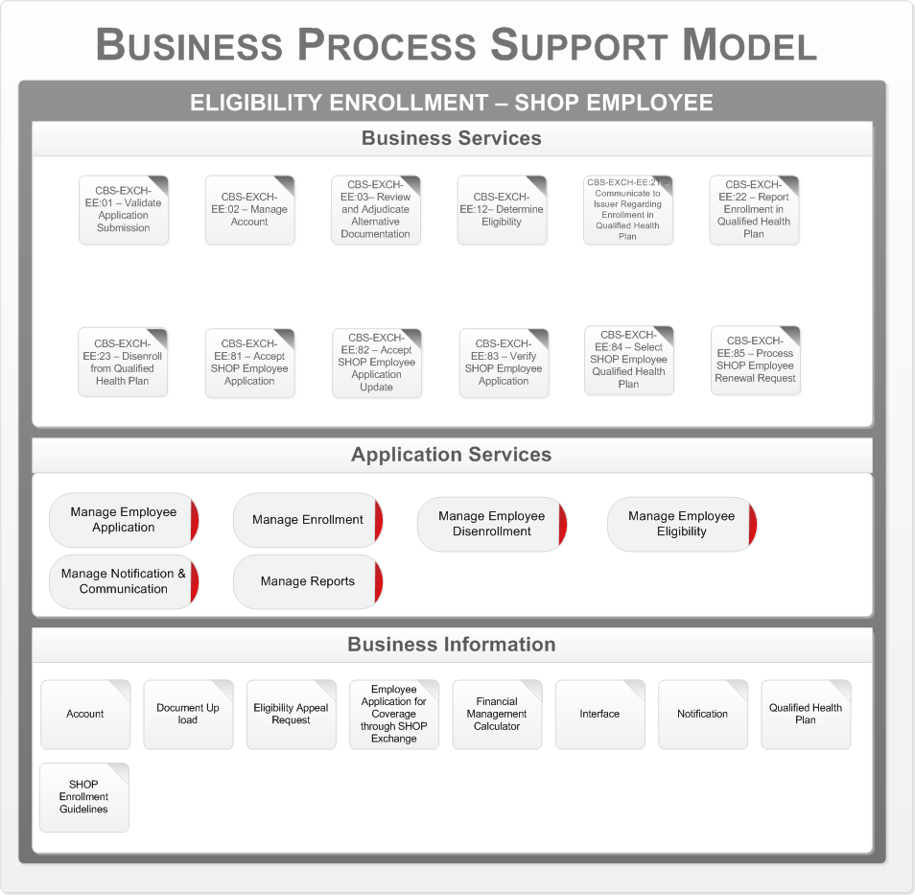

Figure 54 – E&E SHOP Employee Business Process Support Model

The core business services for the SHOP Employee Eligibility and Enrollment are mapped to the six application services:

* Manage Employee Application
* Manage Enrollment
* Manage Employee Disenrollment
* Manage Employee Eligibility
* Manage Notification & Communication
* Manage Reports

## Financial Management

This section addresses the business architecture design for the Financial Management business area. The Financial Management business area comprises a collection of business processes that facilitate the financial operation of The Health Benefits Exchange (e.g., health plan premium processing), the administration of Issuer Risk Spreading programs, advance payments of the premium tax credit, and payments for cost sharing reductions.

The Financial Management business area consists of the following sub-business areas:

* Advance Payments of the Premium Tax Credit and Cost Sharing Reduction
* Insurer Payment Transfers
* Data Collection
* Premium Processing
* Risk Spreading Calculations

The following describes the details of the each sub-business area, and presents the corresponding business capability models for each business process.

### APTCs and CSRs Data Reporting

This process handles the financial transactions associated with advance payments of the premium tax credit and cost sharing reductions. This involves notifying CMS of individual enrollments and the Second Lowest Cost Silver Plan (SLCSP) for a household. This also captures CMS's remittance of payments to Issuers.

The process has two major parts: APTC and CSR Issuer payments, and premium payment history reporting.

### APTC and CSR Issuer payments

The Health Benefits Exchange will provide monthly reports on all individuals enrolled in QHPs for the upcoming month along with the amounts of APTCs and CSRs associated with Vermonters. CMS will aggregate payments at the Issuer level and prepare reports to inform the Issuer of amounts of payments they will receive and attribute the amounts to Vermonters; and CMS will also inform The Health Benefits Exchange of the amounts of APTCs and CSRs paid to all QHP Issuers in The Health Benefits Exchange and attribute those amounts to Vermonters.

### Premium payment history reporting

The Health Benefits Exchange will receive premium payment history reports from Issuers, and provide the reports to CMS.

This section addresses the business architecture design for the APTC and CSR business area. This area consists of the following process:

* Advance Payments of Premium Tax Credits and Cost Sharing Reductions

#### Advance Payments of Premium Tax Credits and Cost Sharing Reductions

The following figure is the Business Capability Model for the Financial Management business area, business process “APTCs and CSRs Data Reporting”

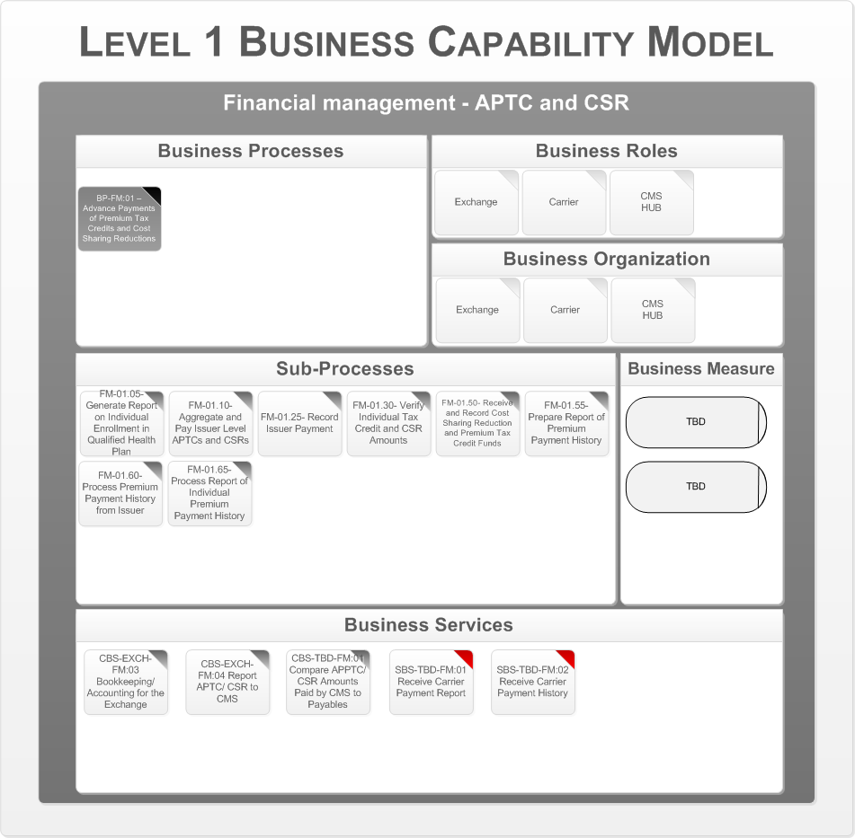

Figure 55 – BP-FM:01 APTC and CSR Issuer Payments

This process encompasses The Health Benefits Exchange functions required for reporting Exchange enrollment data to CMS for the purpose of calculating advance payments of the premium tax credits and payments of cost sharing reductions on behalf of eligible Exchange enrollees. The following are the key business organizations that interact during this process:

* The Health Benefits Exchange
* CMS (HUB)
* Insurer

Appendix A – Reference Section lists the CMS Blue Print Documents that contains details on the Business Processes, Business Sub Processes, and Business Services.

### Insurer Payment Transfers

This process encompasses all The Health Benefits Exchange functions required to receive premiums from Vermonters and Employers, aggregate premium receipts and distribute these to Issuers, and resolve invoice discrepancies with Vermonters and Employers.

This section addresses the business architecture design for the Insurer Payment Transfer business area. This area consists of the following processes:

* + - Insurer Invoice/Payment Discrepancy Resolution
    - Plan Assessment
    - Premium Payment to Insurers
    - Calculate/Receive Reinsurance Contributions
    - Verify Reinsurance Contributions
    - Reinsurance and General Fund Payments
    - Risk Adjustment Payments and Calculations

The following is the series of Level 1 Business Capability Models, one for each business process. The business process in focus for a particular model is depicted in a darkened gray box. The rest of the model is associated with that specific business process. In the Business Services area the Supporting Business Services are indicated with a red tab to distinguish them from the Core Business Services.

#### Insurer Invoice/Payment Discrepancy Resolution

The following figure is the Business Capability Model for the Financial Management – Insurer Payment Transfer business area, business process “Insurer Invoice/Payment Discrepancy Resolution.”

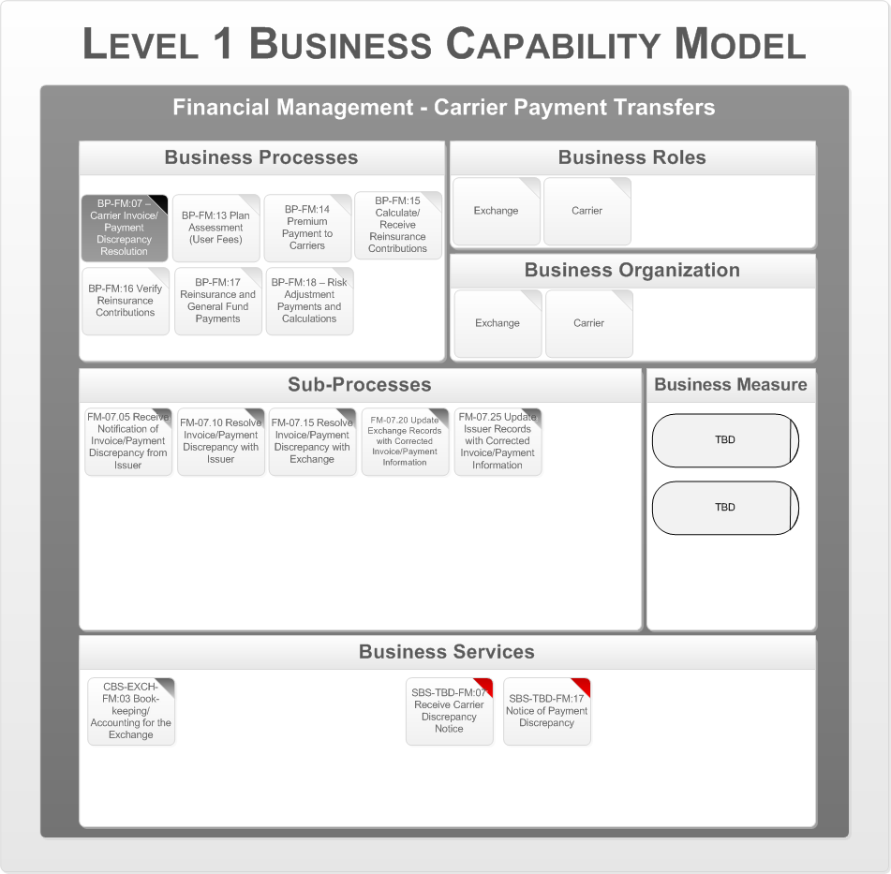

Figure 56 – BP-FM:07 Issuer Invoice/ Payment Discrepancy Resolution

This process resolves Issuer invoice or payment discrepancies in the SHOP and Vermonter Premium Aggregation as well as the User Fee processes. When an Issuer receives an aggregated premium payment from an Exchange (either the SHOP or Vermonter Exchange), the Issuer may identify either a premium payment discrepancy or a user fee invoice discrepancy. The Issuer will work with The Health Benefits Exchange to resolve the discrepancy. Based on the resolution, The Health Benefits Exchange may update Exchange records with updated information to resolve the payment or invoice discrepancy. Similarly, the Issuer may update their records if it is determined they were incorrect. The following are the key business organizations that interact during this process:

* + The Health Benefits Exchange
  + Insurer

Appendix A – Reference Section lists the CMS Blue Print Documents that contains details on the Business Processes, Business Sub Processes, and Business Services.

#### Plan Assessment

The following figure is the Business Capability Model for the Financial Management – Insurer Payment Transfer business area, business process “Plan Assessment.”

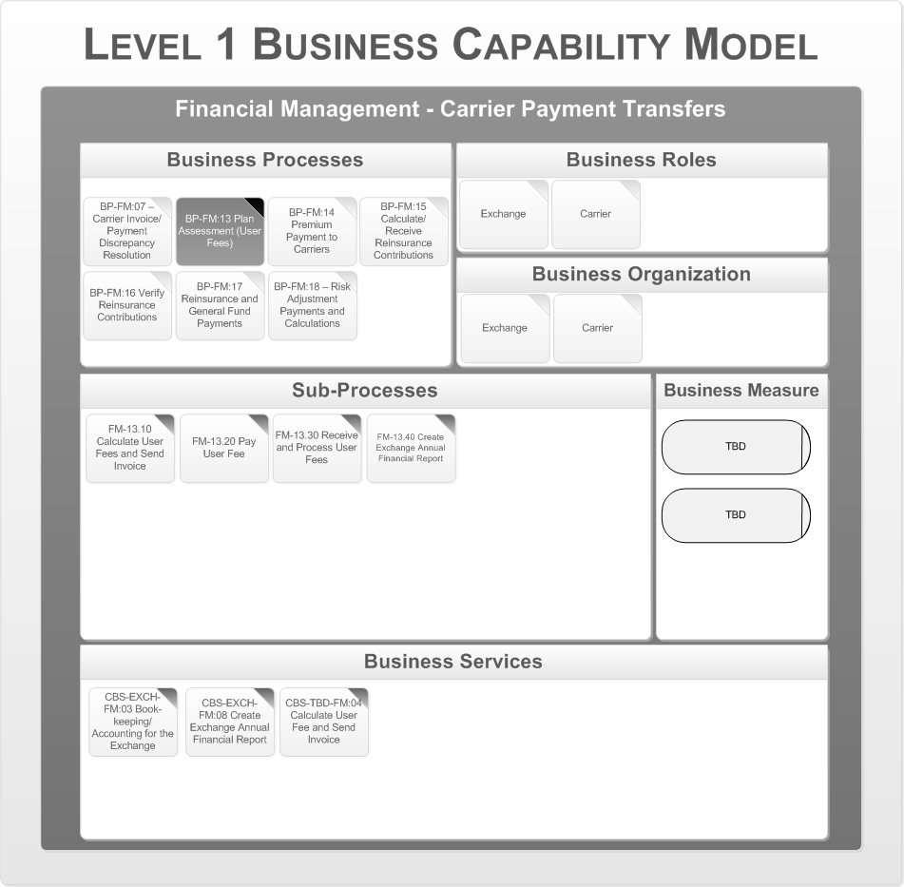

Figure 57 – BP-FM:13 – Plan Assessment for State Exchanges

Beginning in 2014, this optional process charges user fees to participating health insurance Issuers to generate funding to support Exchange operations in States that elect to charge user fees. Each State will determine the user fee formula. The Health Benefits Exchange will then calculate the user fee due for Exchange operations, notify the Issuers, and process Issuer payments. The Health Benefits Exchange also prepares The Health Benefits Exchange Annual Financial Report as required by the State or other authority. **Note:** This process will not be utilized if The Health Benefits Exchange elects to deduct user fees from premiums as outlined in BP-FM:14.

The following are the key business organizations that interact during this process:

* + The Health Benefits Exchange
  + Insurer

Appendix A – Reference Section lists the CMS Blue Print Documents that contains details on the Business Processes, Business Sub Processes, and Business Services.

#### Premium Payment to Insurers

The following figure is the Business Capability Model for the Financial Management – Insurer Payment Transfer business area, business process “Premium Payment to Insurers.”

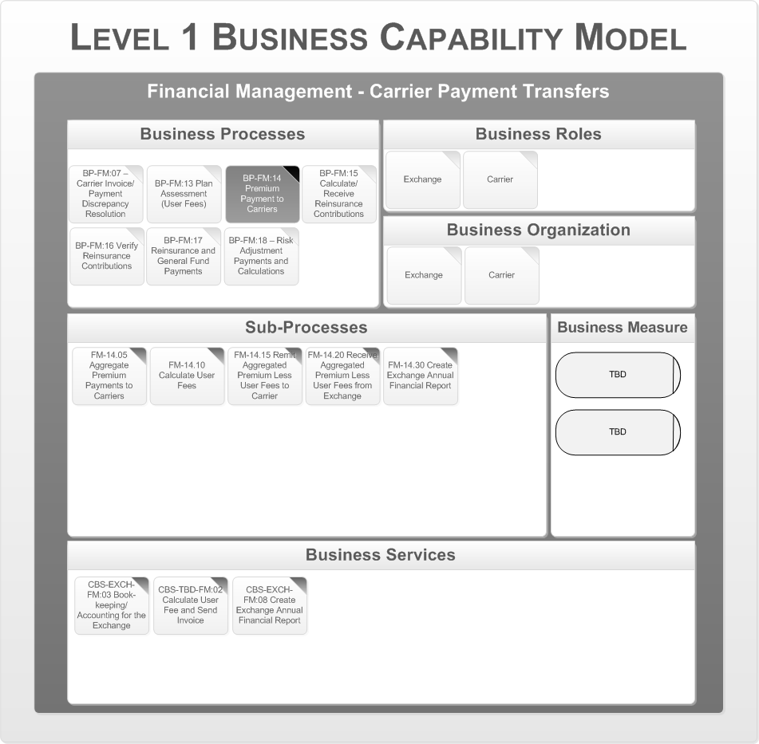

Figure 58 – BP-FM:14 – Aggregated Premium Payment to Issuers and User Fee Collection

This process includes the aggregated payment of individual and/or SHOP premiums to Issuers after user fees are deducted from the premiums received.

States may elect to deduct the user fees from SHOP and/or individual premium payments handled by The Health Benefits Exchange. Each State will determine the user fee formula. The Health Benefits Exchange will then calculate the user fee due for Exchange operations, and remit the aggregated premium less user fees to each Issuer. The Health Benefits Exchange also prepares The Health Benefits Exchange Annual Financial Report as required by the State or other authority. **Note:** This process will not be utilized if The Health Benefits Exchange elects to invoice Issuers for user fees from premiums as outlined in BP-FM:13.

The following are the key business organizations that interact during this process:

* + Exchange
  + Insurer

Appendix A – Reference Section lists the CMS Blue Print Documents that contains details on the Business Processes, Business Sub Processes, and Business Services.

#### Calculate/Receive Reinsurance Contributions

The following figure is the Business Capability Model for the Financial Management – Insurer Payment Transfer business area, business process “Premium Payment to Insurers.”

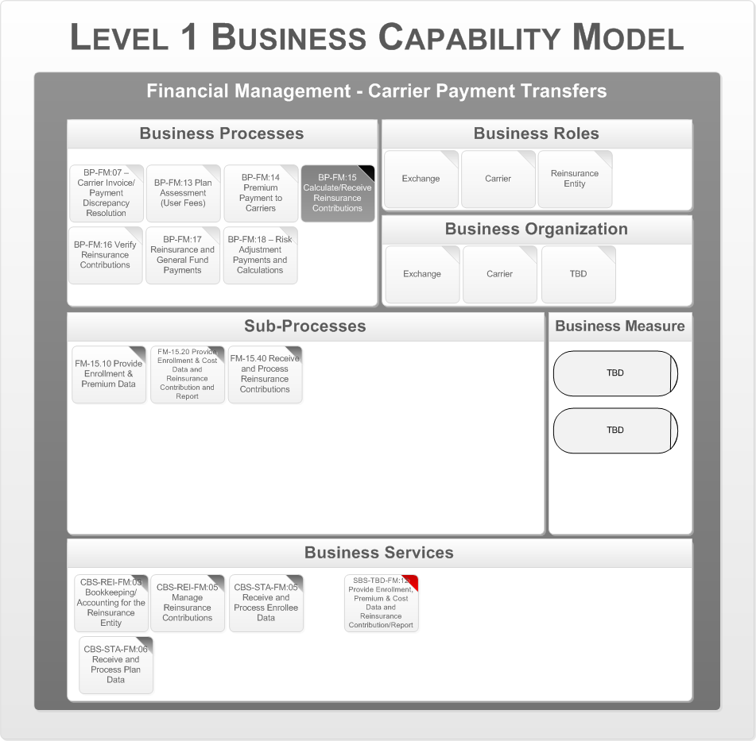

Figure 59 – BP-FM:15 – Reinsurance Contributions

This process supports operations from 2014 through 2016. The process collects and processes reinsurance contributions from all Issuers and TPAs acting on behalf of group health plans. This process applies to all Issuers in all markets (large, small group, individual, non-grandfathered) and TPAs for self-insured entities (contributions go to State where the employee resides). CMS will annually provide the rate for reinsurance contributions. A TBD source will provide the list of Issuers/TPAs operating in the State, along with supporting data, to the Reinsurance Entity. Issuers will provide monthly enrollment and premium data, and the reinsurance contribution payment and report to the Reinsurance Entity. TPAs will provide enrollment data monthly, the total cost of providing benefits, and the reinsurance contribution payment to the Reinsurance Entity. The Reinsurance Entity will receive the data and process the reinsurance contribution payments.

The following are the key business organizations that interact during this process:

* + The Health Benefits Exchange
  + Insurer

Appendix A – Reference Section lists the CMS Blue Print Documents that contains details on the Business Processes, Business Sub Processes, and Business Services.

#### Verify Reinsurance Contributions

The following figure is the Business Capability Model for the Financial Management – Insurer Payment Transfer business area, business process “Verify Reinsurance Contributions.”

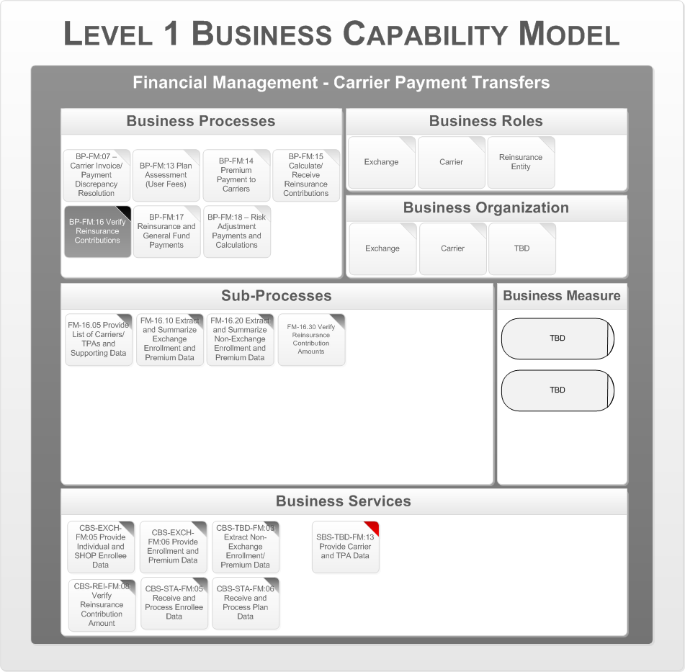

Figure 60 – BP-FM:16 – Reinsurance Contribution Verification

This process supports operations from 2014 through 2016. The process verifies reinsurance contributions from all Issuers and TPAs acting on behalf of group health plans. This process applies to all Issuers in all markets (large, small group, individual, and non-grandfathered) and TPAs for self-insured entities (contributions go to the State where the employee resides).

Reinsurance entities will verify the basis for the calculation of the reinsurance contribution amounts using the enrollment and premium data for Exchange enrollees from Exchanges, as well as non-QHP enrollment and premium data and TPA enrollment, and cost data. The Reinsurance Entity will also verify the contribution amounts using the reinsurance contribution formula.

The following are the key business organizations that interact during this process:

* + The Health Benefits Exchange
  + Insurer

Appendix A – Reference Section lists the CMS Blue Print Documents that contains details on the Business Processes, Business Sub Processes, and Business Services.

#### Reinsurance and General Fund Payments

The following figure is the Business Capability Model for the Financial Management – Insurer Payment Transfer business area, business process “Reinsurance and General Fund Payments”.

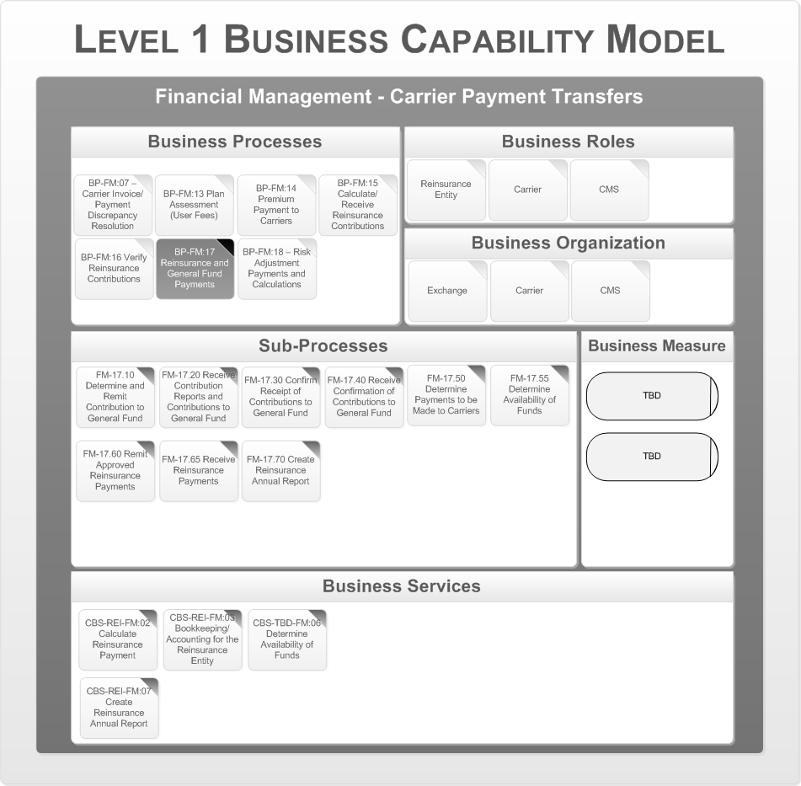

Figure 61 – BP-FM:17 – Reinsurance Financial Transfers

This process collects risk adjustment charges from Issuers and remits risk adjustment payments to Issuers. This process applies to all Issuers in individual and small group markets within the State. The State updates Issuer accounts with Issuer risk adjustment payment and charge data. The State notifies Issuers of the risk adjustment charges (net negative balance issuers), receives payments from those Issuers, and monitors for unpaid risk adjustment charges. The State determines the available funding for risk adjustment payments and remits risk adjustment payments to net positive balance Issuers. The State also generates the annual risk adjustment financial report as required by the State or other authority.

The following are the key business organizations that interact during this process:

* + The Health Benefits Exchange
  + Insurer

Appendix A – Reference Section lists the CMS Blue Print Documents that contains details on the Business Processes, Business Sub Processes, and Business Services.

#### Risk Adjustment Payments and Calculations

The following figure is the Business Capability Model for the Financial Management – Insurer Payment Transfer business area, business process “Risk Adjustment Payments and Calculations.”

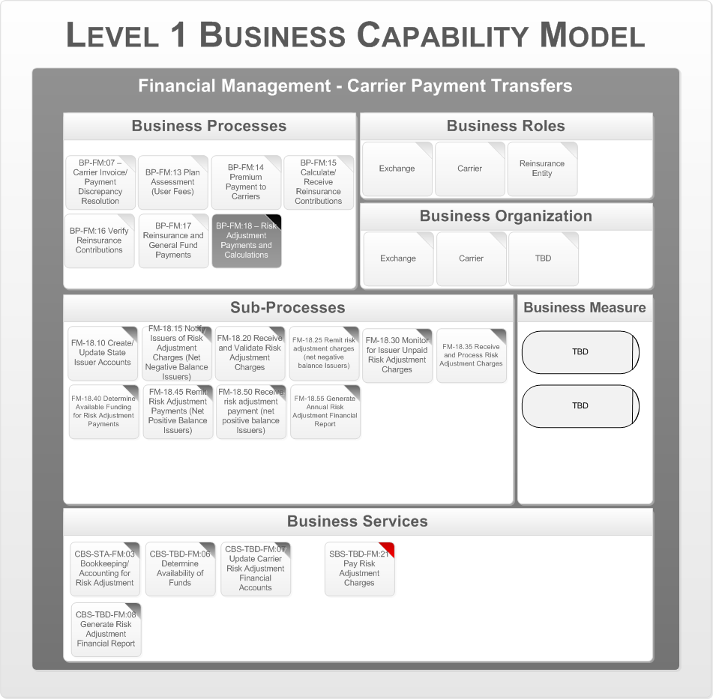

Figure 62 – BP-FM:18 – Risk Adjustment Payment

This process includes the aggregated payment of individual and/or SHOP premiums to Issuers after user fees are deducted from the premiums received.

States may elect to deduct the user fees from SHOP and/or individual premium payments handled by The Health Benefits Exchange. Each State will determine the user fee formula. The Health Benefits Exchange will then calculate the user fee due for Exchange operations, and remit the aggregated premium less user fees to each Issuer. The Health Benefits Exchange also prepares The Health Benefits Exchange Annual Financial Report as required by the State or other authority. This process will not be utilized if The Health Benefits Exchange elects to invoice Issuers for user fees from premiums as outlined in BP-FM:13.

The following are the key business organizations that interact during this process:

* + The Health Benefits Exchange
  + Insurer

Appendix A – Reference Section lists the CMS Blue Print Documents that contains details on the Business Processes, Business Sub Processes, and Business Services.

### Data Collection

This business area encompasses allthe State functions required to collect claims and encounter data from the small group and individual markets for use by the State in risk adjustment calculations. Data collection also includes a function to collect enrollee and rate data from outside The Health Benefits Exchange for use by the State in risk adjustment calculations. This data may also be used to support validation of other business processes, such as risk corridors or reinsurance payments.

This section addresses the business architecture design for the Data Collection business area. This area consists of the following processes:

* + - Non-Exchange Data Collection Plan Assessment
    - Claims/Encounter Data Collection

The following is the series of Level 1 Business Capability Models, one for each business process. The business process in focus for a particular model is depicted in a darkened gray box. The rest of the model is associated with that specific business process. In the Business Services area the Supporting Business Services are indicated with a red tab to distinguish them from the Core Business Services.

#### Non-Exchange Data Collection Plan Assessment

The following figure is the Business Capability Model for the Financial Management – Data Collection business area, business process “Non-Exchange Data Collection Plan Assessment”.

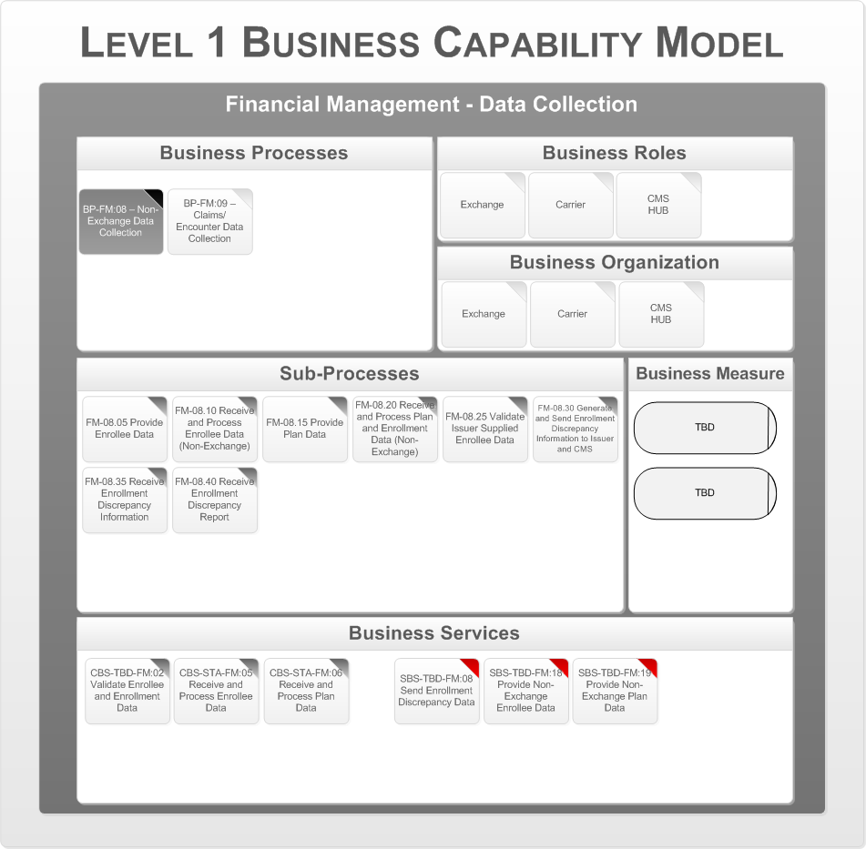

Figure 63 – BP-FM:08 – Non-Exchange Enrollee/ Rate Data Collection

This process receives information on non-exchange enrollees from individual and small group plans outside of The Health Benefits Exchange and receives non-QHP plan data from CMS.

This process receives information on non-exchange enrollees from individual and small non-grandfathered plans outside of The Health Benefits Exchange and receives non-QHP plan and rate setting data from CMS. The State receives enrollee data for plans outside The Health Benefits Exchange from Issuers. In addition, the State receives rate setting data and enrollment counts for plans outside The Health Benefits Exchange from CMS. The State compares the Issuer supplied enrollee data with enrollment data supplied by CMS. If discrepancies are found, enrollment discrepancy reports are issued by the State to the Issuer and CMS. The following are the key business organizations that interact during this process:

* + The Health Benefits Exchange
  + Insurer
  + CMS (HUB)

Appendix A – Reference Section lists the CMS Blue Print Documents that contains details on the Business Processes, Business Sub Processes, and Business Services.

#### Claims/Encounter Data Collection

The following figure is the Business Capability Model for the Financial Management – Data Collection business area, business process “Claims/ Encounter Data Collection.”

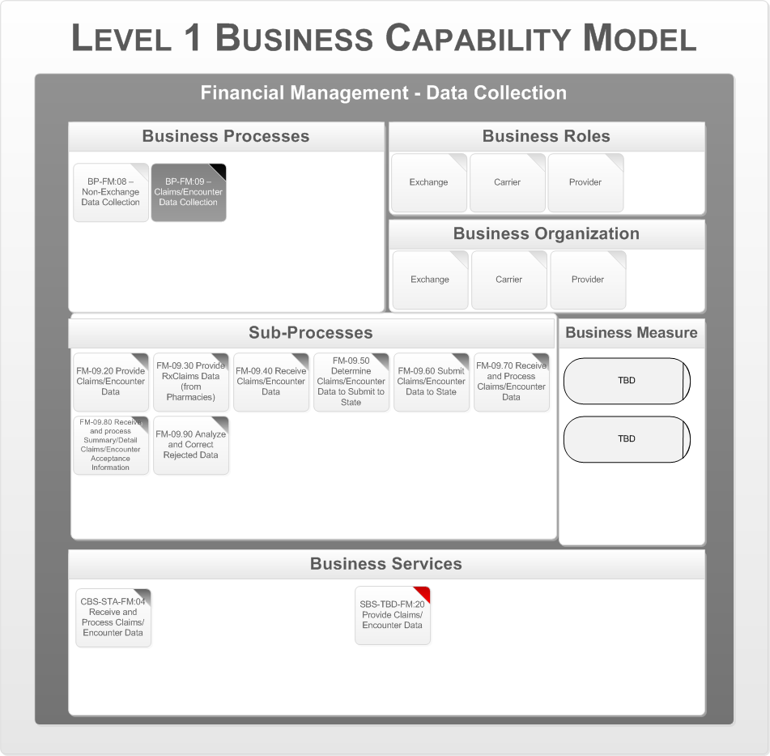

Figure 64 – BP-FM:09 Claims/ Encounter Data Collection

This process receives and processes claims and encounter data from non-grandfathered individual and small group Issuers inside and outside The Health Benefits Exchange.

The State receives claims/encounter and RX utilization data from each Issuer that offers non-grandfathered individual or small group plans in the State. The State returns a detail and summary report to the Issuer regarding what data has been accepted and rejected. The following are the key business organizations that interact during this process:

* The Health Benefits Exchange
* Insurer
* Provider

Appendix A – Reference Section lists the CMS Blue Print Documents that contains details on the Business Processes, Business Sub Processes, and Business Services.

### Premium Processing

This business area encompasses all The Health Benefits Exchange functions required to receive premiums from Vermonters and Employers, aggregate premium receipts and distribute these to Issuers, and resolve invoice discrepancies with Vermonters and Employers.

This section addresses the business architecture design for the Premium Processing business area. This area consists of the following processes:

* + - SHOP Premium Collection
    - Vermonter Premium Collection
    - Employer Premium Discrepancy Resolution
    - Vermonter Premium Discrepancy Resolution

The following is the series of Level 1 Business Capability Models, one for each business process. The business process in focus for a particular model is depicted in a darkened gray box. The rest of the model is associated with that specific business process. In the Business Services area the Supporting Business Services are indicated with a red tab to distinguish them from the Core Business Services.

#### SHOP Premium Collection

The following figure is the Business Capability Model for the Financial Management – Premium Processing business area, business process “SHOP Premium Collection.”

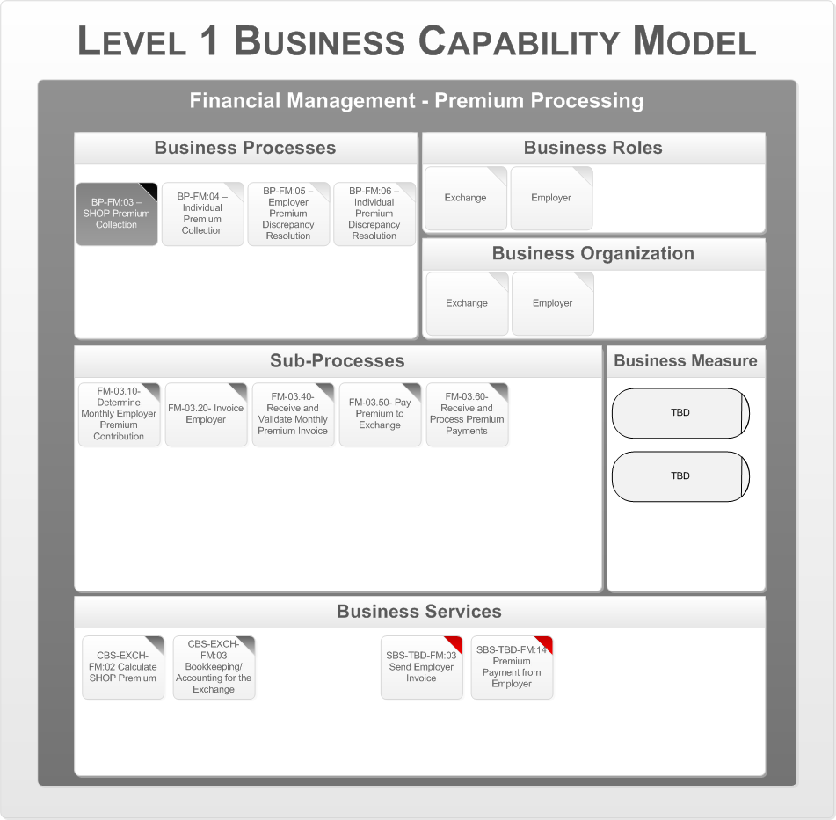

Figure 65 – BP-FM:03 – SHOP Premium Collection

This process consists of SHOP issuance of monthly premium bills to Employers and the receipt of payments from Employers to SHOP. In this process, the SHOP will determine the monthly employer premium contribution based on employee enrollment information. The SHOP will send a monthly premium invoice to the Employer, and process premium payments from the Employer. If the Employer does not make full payments, or believes there is a problem with the invoice, then the Employer Premium Discrepancy Resolution process is activated. The following are the key business organizations that interact during this process:

* The Health Benefits Exchange
* Employer

Appendix A – Reference Section lists the CMS Blue Print Documents that contains details on the Business Processes, Business Sub Processes, and Business Services.

#### Vermonter Premium Collection

The following figure is the Business Capability Model for the Financial Management – Premium Processing business area, business process “Vermonter Premium Collection.”

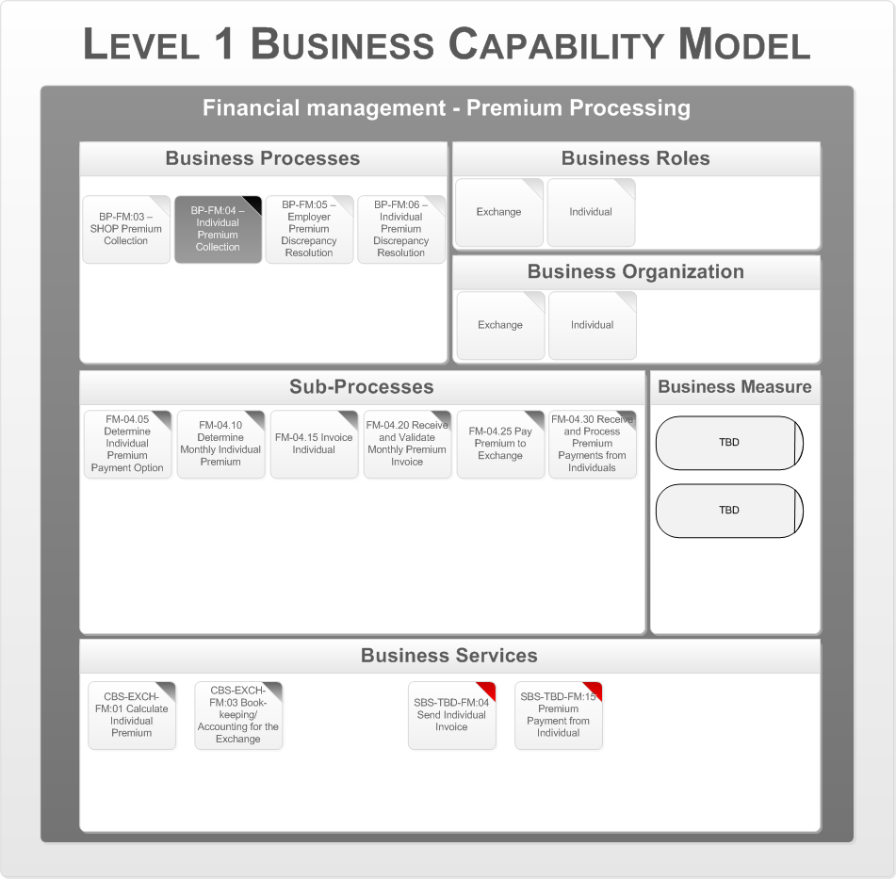

Figure 66 – BP-FM:04 – State Option to Collect Premiums in The Health Benefits Exchange

This optional process consists of The Health Benefits Exchange issuance of monthly premium invoices to individuals and the receipt of payments from individuals to The Health Benefits Exchange. In this process, The Health Benefits Exchange will determine the monthly individual premium contribution based on individual enrollment information. The Health Benefits Exchange will send a monthly premium invoice to the Vermonter, and process premium payments from the Vermonter. If the Vermonter does not make full payments, or believes there is a problem with the invoice, then the Vermonter Premium Discrepancy Resolution process is activated. The following are the key business organizations that interact during this process:

* The Health Benefits Exchange
* Vermonter

Appendix A – Reference Section lists the CMS Blue Print Documents that contains details on the Business Processes, Business Sub Processes, and Business Services.

#### Employer Premium Discrepancy Resolution

The following figure is the Business Capability Model for the Financial Management – Premium Processing business area, business process “Employer Premium Discrepancy Resolution”.

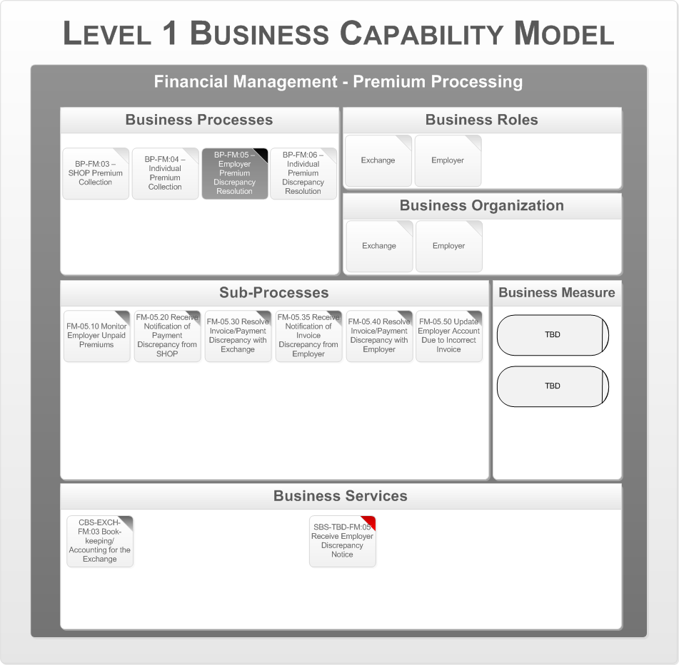

Figure 67 – BP-FM:05 – Employer Premium Discrepancy Resolution

This process resolves employer payment and billing discrepancies in the SHOP Premium Collection process. In this process, the SHOP will monitor for unpaid employer premiums, and notify the Employer of payment discrepancies (either unpaid amounts or incorrect payment amounts). The Employer may also identify an issue with the premium invoice. In either case, the Employer and the SHOP will work together to resolve the discrepancy. Based on the resolution, The Health Benefits Exchange may update the employer account (for an invoice discrepancy), or the Employer may remit the premium payment (for a payment discrepancy).

The following are the key business organizations that interact during this process:

* The Health Benefits Exchange
* Employer

Appendix A – Reference Section lists the CMS Blue Print Documents that contains details on the Business Processes, Business Sub Processes, and Business Services.

#### Vermonter Premium Discrepancy Resolution

The following figure is the Business Capability Model for the Financial Management – Premium Processing business area, business process “Vermonter Premium Discrepancy Resolution”.

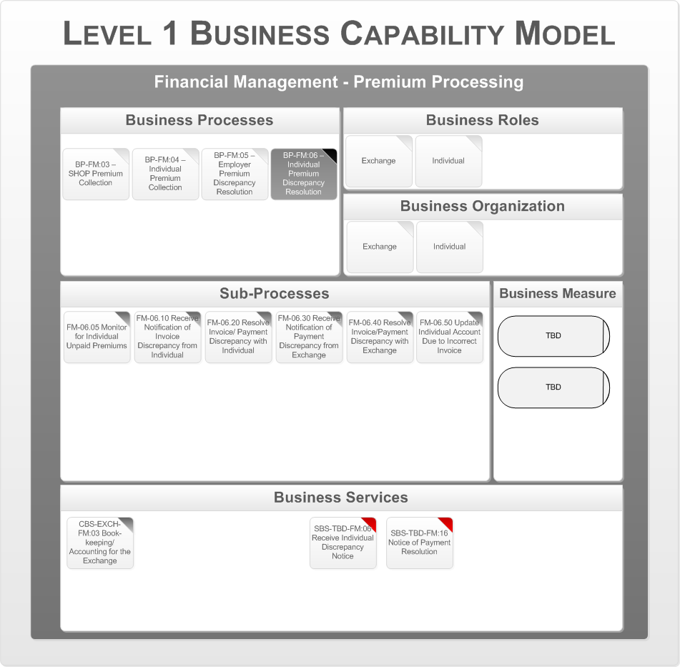

Figure 68 – BP-FM:06 – Vermonter Premium Discrepancy Resolution

This process resolves payment and billing discrepancies in the Vermonter Premium Collection process. This process is applicable when the State elects to collect premiums on the behalf of Issuers. In this process, The Health Benefits Exchange will monitor for unpaid individual premiums, and notify the Vermonter of payment discrepancies (either unpaid amounts or incorrect payment amounts). The Vermonter may also identify an issue with the premium invoice. In either case, the Vermonter and The Health Benefits Exchange will work together to resolve the discrepancy. Based on the resolution, The Health Benefits Exchange may update the individual account (for an invoice discrepancy), or the Vermonter may remit the premium payment (for a payment discrepancy).

The following are the key business organizations that interact during this process:

* The Health Benefits Exchange
* Employer

Appendix A – Reference Section lists the CMS Blue Print Documents that contains details on the Business Processes, Business Sub Processes, and Business Services.

### Risk Spreading Calculations

This process encompasses the State and Exchange functions required to process Exchange and Issuer data through a calculation process for reinsurance payment, risk adjustment, and risk corridors, as well as to determine the payment amounts due from and to Issuers as a result of these calculations.

This section addresses the business architecture design for the Risk Spreading Calculations business area. This area consists of the following processes:

* + - Reinsurance Payment Calculation
    - Risk Adjustment Calculation
    - Risk Corridors Calculation

The following is the series of Level 1 Business Capability Models, one for each business process. The business process in focus for a particular model is depicted in a darkened gray box. The rest of the model is associated with that specific business process. In the Business Services area the Supporting Business Services are indicated with a red tab to distinguish them from the Core Business Services.

#### Reinsurance Payment Calculation

The following figure is the Business Capability Model for the Financial Management – Risk Spreading Calculations business area, business process “Reinsurance Payment Calculation”.

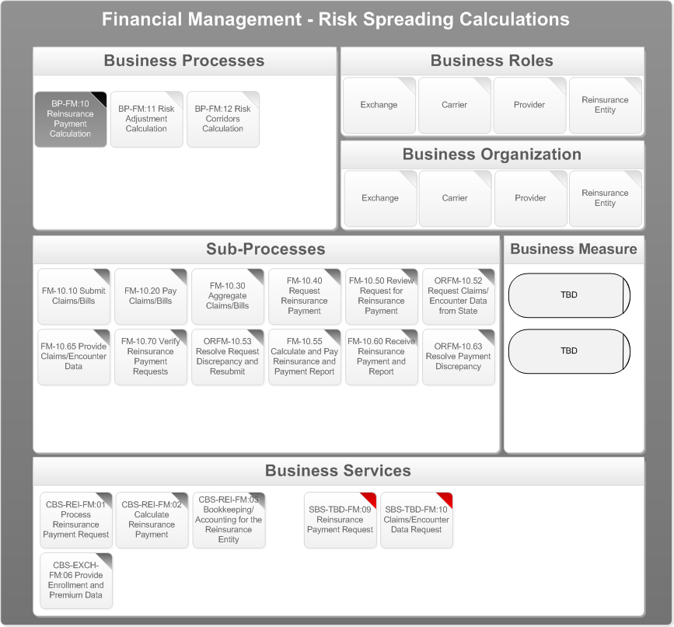

Figure 69 – BP-FM:10 – Reinsurance Payment Calculation

This process operates from 2014 through 2016. The process calculates reinsurance payments to Issuers that cover high-risk individuals in order to help stabilize premiums for coverage. Reinsurance payments apply to Issuers of non-grandfathered individual QHP plans. CMS will provide parameters for payment to the Reinsurance Entity and the Issuer. The State has the flexibility to modify CMS’ parameters for payment for reinsurance payment calculation. When the Issuer requests a reinsurance payment, the Reinsurance Entity reviews the request, and depending on whether discrepancies are found, notifies the Issuer of approval/disapproval. If the request is approved the Reinsurance Entity calculates the reinsurance payment by comparing the new year-to-date total to the previously submitted year-to-date total for each individual and calculating a reinsurance payment. The payment calculation will be based on the product of coinsurance rate and any differential amounts that fall between the attachment point and reinsurance cap. The Reinsurance Entity may also verify the reinsurance payment request using the detail/summary claims/encounter data. The following are the key business organizations that interact during this process:

* The Health Benefits Exchange
* Insurer
* Provider
* Reinsurance Entity

Appendix A – Reference Section lists the CMS Blue Print Documents that contains details on the Business Processes, Business Sub Processes, and Business Services.

#### Risk Adjustment Calculation

The following figure is the Business Capability Model for the Financial Management – Risk Spreading Calculations business area, business process “Risk Adjustment Calculation”.

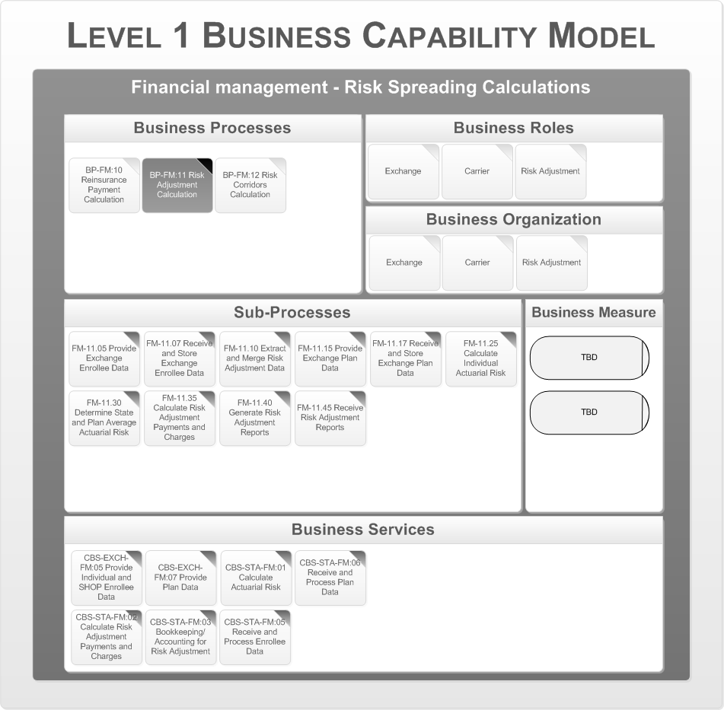

Figure 70 – BP-FM:11 – Risk Adjustment Calculation

This process calculates the risk adjustment payments or charges to Issuers based on the actuarial risk of enrollees within a plan when compared to the State average actuarial risk. The State assesses charges to low actuarial risk plans and makes payments to high actuarial risk plans. This process applies to all Issuers in Vermonter and Small Group Markets within the State. The State receives enrollee data for individual and small group, participating inside The Health Benefits Exchange, from The Health Benefits Exchange. The State collects enrollee data for individual and small group outside of The Health Benefits Exchange. The State extracts and merges claims/encounter data, enrollee data, and rate setting data previously collected. The State calculates State and plan average actuarial risk. The State then calculates risk adjustment payments and charges, and notifies the Issuer.

The following are the key business organizations that interact during this process:

* + The Health Benefits Exchange
  + Insurer
  + Risk Adjustor

Appendix A – Reference Section lists the CMS Blue Print Documents that contains details on the Business Processes, Business Sub Processes, and Business Services.

#### Risk Corridors Calculation

The following figure is the Business Capability Model for the Financial Management – Risk Spreading Calculations business area, business process “Risk Corridors Calculation”.

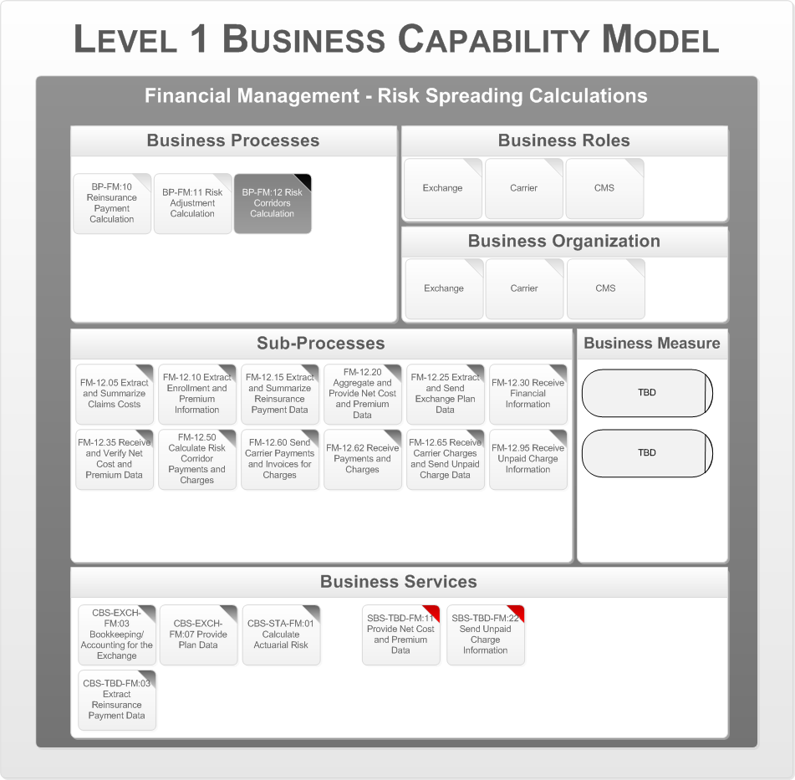

Figure 71 – BP-FM:12 – Risk Corridors

This process supports operations from 2014 through 2016. The risk corridor process allows QHPs and CMS to share in profits or losses based on a statutory formula. This process applies to all individual and small group QHP Issuers.

CMS is the central actor in this process; however, the following data must be provided to CMS: (1) States annually provide claims cost, enrollment, premium and risk adjustment charges/ payments data, (2) each Reinsurance Entity annually provides reinsurance data, and (3) Issuers provide net cost and premium data.

The following are the key business organizations that interact during this process:

* + The Health Benefits Exchange
  + Insurer
  + CMS

Appendix A – Reference Section lists the CMS Blue Print Documents that contains details on the Business Processes, Business Sub Processes, and Business Services.

### Business Process Support Model

The next step is to map the business services to application services and define the key business data objects. This is described by the Business Process Support Model. The following diagram shows the Business Process Support Model for the each “Financial Management” business area.

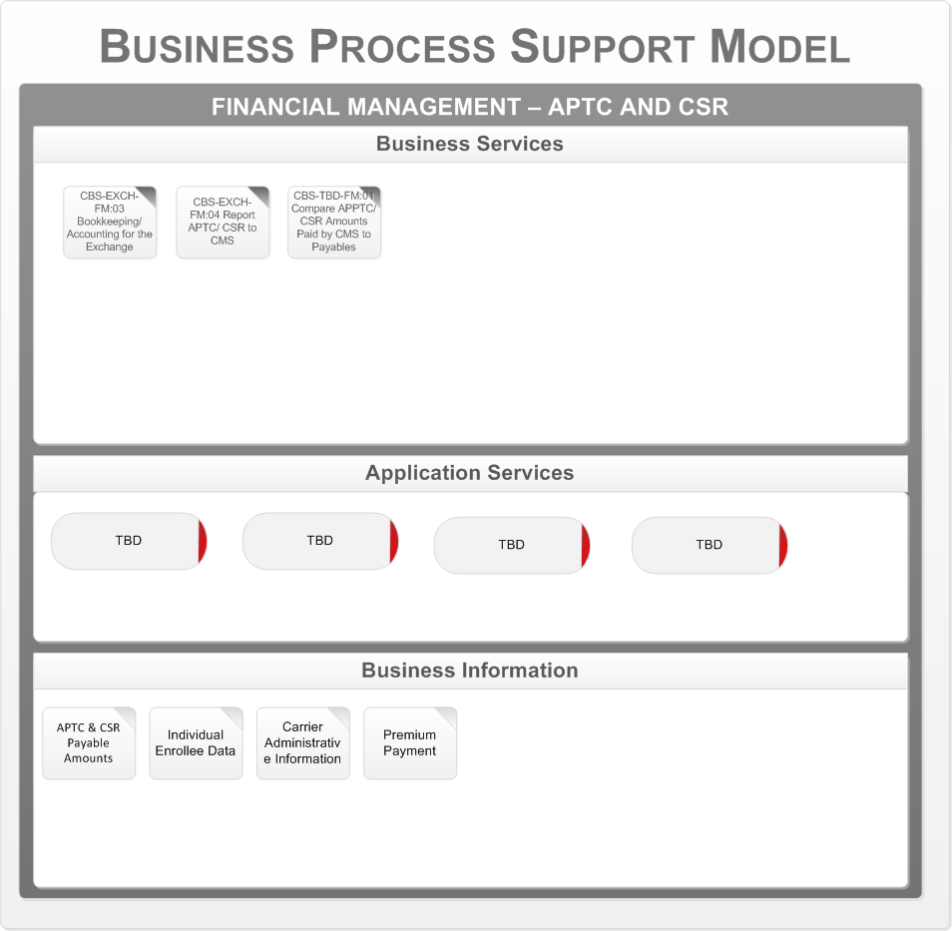

Figure 72 – APTC and CSR Business Process Support Model

The core business services for the APTC and CSR are mapped to the following application services:

* TBD

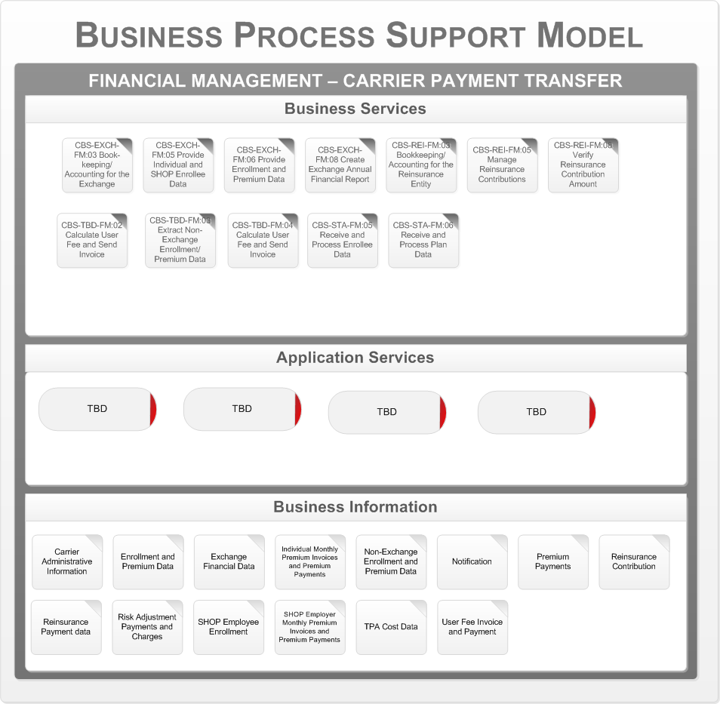

Figure 73 – Insurer Payment Transfer Business Process Support Model

The core business services for the Insurer Payment Transfer are mapped to the following application services:

* + - TBD

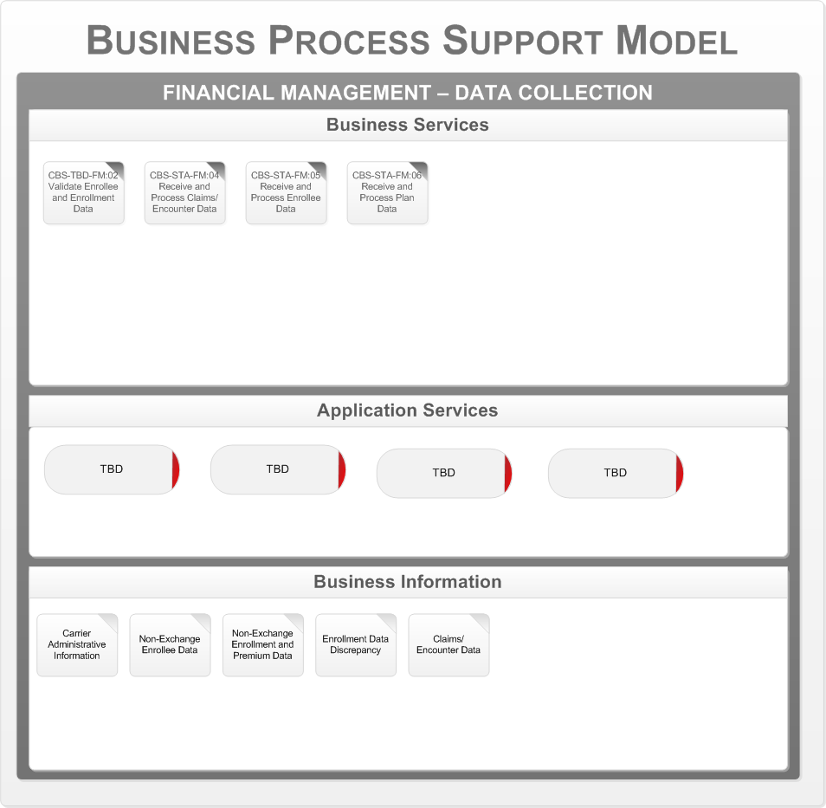

Figure 74 – Data Collection Business Process Support Model

The core business services for the Data Collection are mapped to the following application services:

* + - TBD

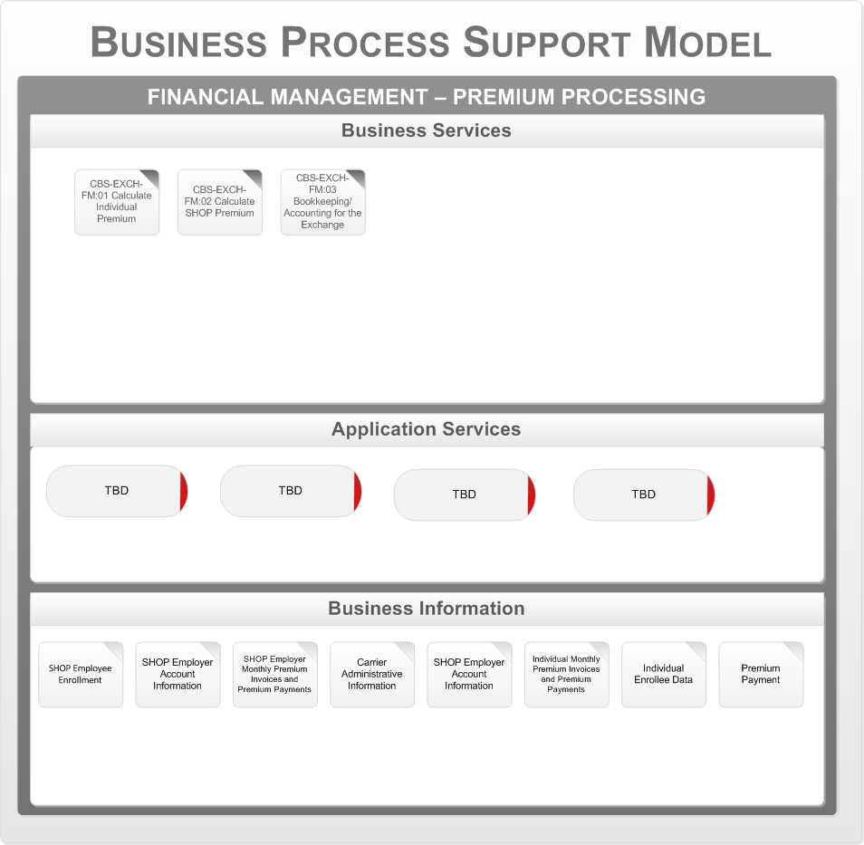

Figure 75 – Premium Processing Business Process Support Model

The core business services for the Premium Processing are mapped to the following application services:

* + TBD

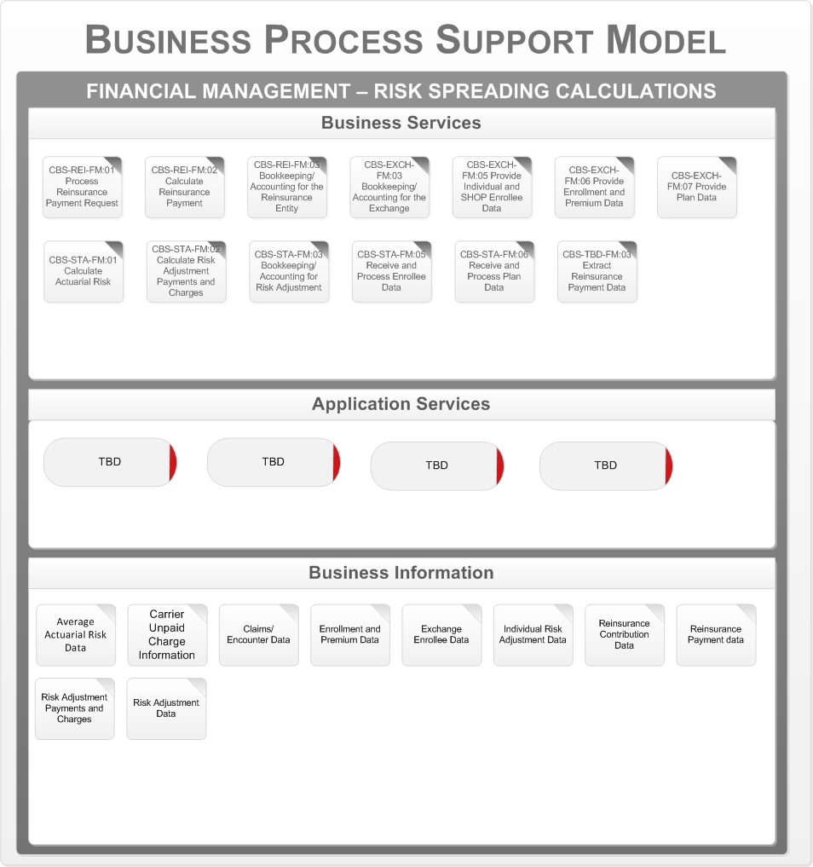

Figure 76 – Risk Spreading Calculations Business Process Support Model

The core business services for the Risk Spreading Calculation are mapped to the following application services:

* + TBD

## Customer Service

The Customer Services business area will define the business processes that support the ability to respond easily and effectively to the vast breadth of inquiries encountered on a daily basis, in real time and across multiple channels of communication; supports registering and managing citizen issues, and problems; and supports rapid case resolution.

**Note:** CMS has not yet released the Customer Service blue print document. The mapping diagrams documented in this section are based on Oracle’s Customer Service Business Processes best practices and Siebel’s Customer Relationship Management Business Process Models.

### Manage Inbound Communication

The following figure is the Business Capability Model for the Customer Service business area, business process “Manage Inbound Communication”.

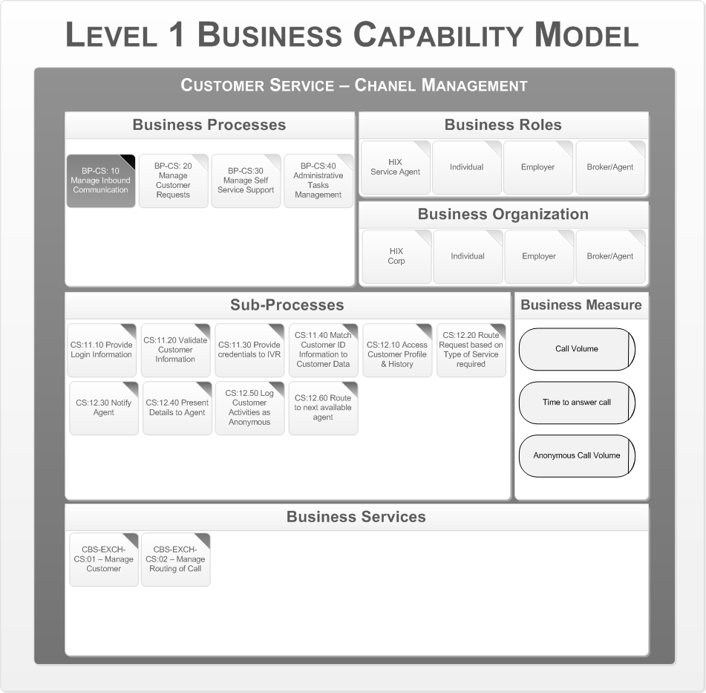

Figure 77 - Manage Inbound Communication

This process flow is performed to collect information from an individual necessary to route the call according to the service required. Request can come through various channels like phone call, web portal or Chat request it need to capture the customer information and route to right service support person for accurate support. The following are the key business organizations that interact during this process:

* + The Health Benefits Exchange
  + Vermonter
  + Employer
  + Broker/Agent

### Manage Customer Requests

The following figure is the Business Capability Model for the Customer Service business area, business process “Manage Customer Request”.

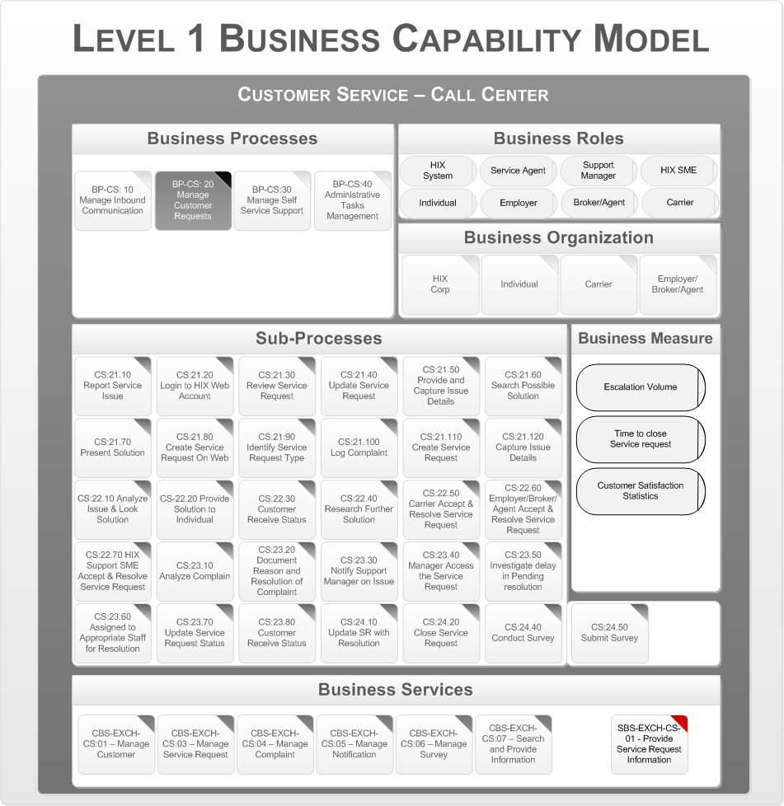

Figure 78 - Manage Customer Request

This process flow is performed to initiate or update the service request. Provides interfaces, and services to document manage the service request life cycle – document details, analyze request, provide solutions, and resolve service request. The following are the key business organizations that interact during this process:

* + The Health Benefits Exchange
  + Vermonter
  + Insurer
  + Employer/Broker/Agent

### Manage Self Service Support

The following figure is the Business Capability Model for the Customer Service business area, business process “Manage Self Service Support”.

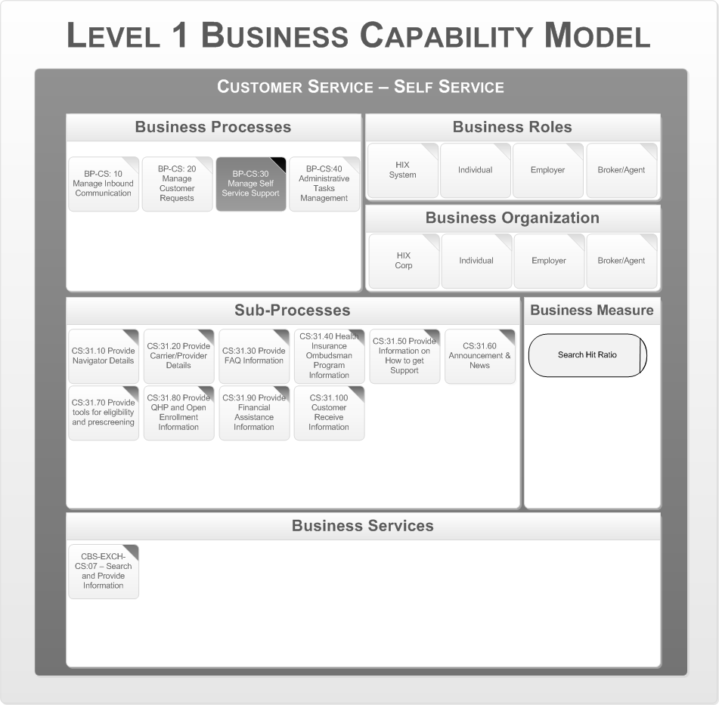

Figure 79 - Manage Self Service Support

This process flow shows overall self service functionality of the web site, where individual can navigate to HBE Portal and browse the current state information on their service request. Customers can also browse all relevant information to browse, compare, price, and select Quality Healthcare Plans (QHP).The following are the key business organizations that interact during this process:

* + The Health Benefits Exchange
  + Vermonter
  + Employer
  + Broker/Agent

### Administrative Tasks Management

The following figure is the Business Capability Model for the Customer Service business area, business process “Administrative Tasks Management”.

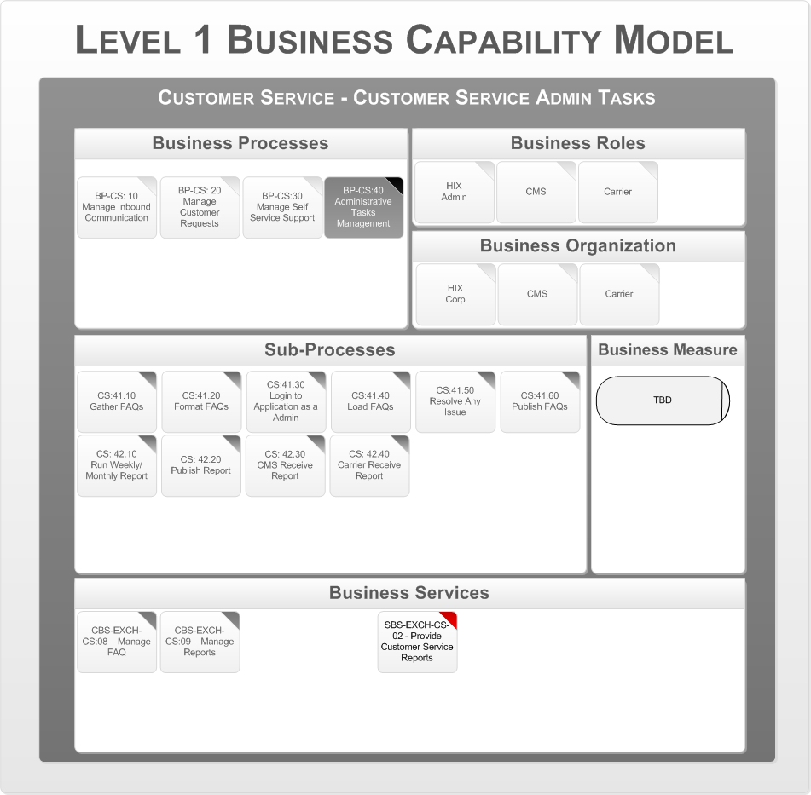

Figure 80 - Administrative Tasks Management

This process flow consists of Admin tasks to load and publish FAQs/ Solutions. The Administrators can access the HBE Portal and get access to any of the Service Request and track current state, assist with service resolution, and measure/report on customer service performance metrics. The following are the key business organizations that interact during this process:

* + The Health Benefits Exchange
  + Vermonter
  + Employer
  + Broker/Agent

## Business Process Support Model

The next step is to map the business services to application services and define the key business data objects. This is described by the Business Process Support Model. The following diagram shows the Business Process Support Model for the “Customer Service” business area.

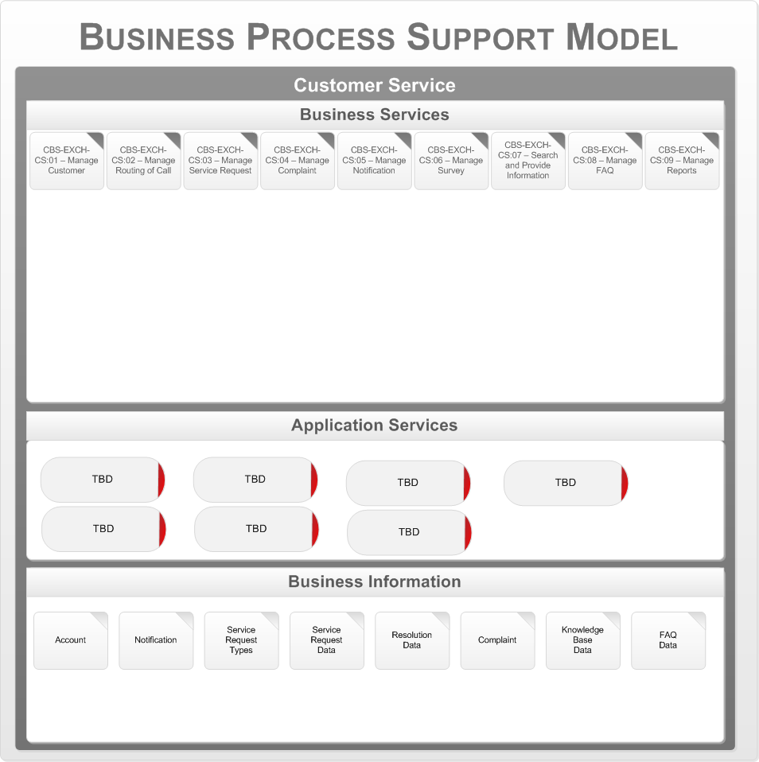

Figure 81 - Customer Service Business Process Support Model

The core business services for Customer Service are mapped to the following application services:

* TBD

## Communications

CMS is currently working on the Communication Business Process blue print. This section will be completed once the CMS Communication print is published.

## Oversight and Reporting

CMS is currently working on the Oversight and Reporting Business Process blue print. This section will be completed once the CMS Oversight and Reporting blue print is published.

# Appendix A

**References**

|  |  |
| --- | --- |
| **Document Name** | **Description** |
| PM BA Supplement draft v1.0 2011-05-03.docx | This *Plan Management Blueprint – Exchange Business Architecture Supplement*, Version 1.0, describes the initial business architecture for the Plan Management business area. It identifies and defines the major Plan Management business functions, processes, and services for use in discussions with the states and federal partners for implementing Exchanges. This blueprint is preliminary and is subject to change. |
| EE BA Supplement draft v1.0 2011-05-03.docx | This *Eligibility and Enrollment Blueprint – Exchange Business Architecture Supplement* describes the initial business architecture for the Eligibility & Enrollment (E&E) business area. It identifies and defines major Eligibility & Enrollment business functions, processes, and services for use in discussions with states and federal partners for implementing Exchanges in support of individual eligibility for and enrollment in a qualified health plan (QHP), advance premium tax credits (APTC), cost-sharing reductions (CSR), and Medicaid, the Children’s Health Insurance Program (CHIP), and the Basic Health Program (BHP). |
| FM BA Supplement DRAFT - 081011.docx | The *Financial Management Blueprint – Business Architecture Supplement* describes the initial business architecture for the Financial Management (FM) business area from the State perspective. It identifies and defines major Financial Management business functions, processes, and services for use in discussions with States. |
|  |  |

# Appendix B

**Glossary**

Table 17 - Glossary

|  |  |
| --- | --- |
| **Glossary** | **Descriptions** |
| APTC | Advanced Premium Tax Credit |
| BHP | Basic Health Program |
| CHIP | Child Health Insurance Program |
| CMS | Center for Medicare and Medicaid Services |
| CSR | Cost Sharing Reduction |
| CTI | Computer Telephony Integration |
| DCBS | Department of Consumer Business Services |
| DHS | Department of Health Services |
| EA | Enterprise Architecture or Eligibility Automation (depends on the Context) |
| HA | High Availability |
| HBE | Health Benefits Exchange (aka HIX) |
| HHS | Human and Health Service |
| HIPAA | Health Insurance Portability and Accountability Act |
| HIX | Healthcare Insurance Exchange |
| IP | Intellectual Property |
| IVR | Interactive Voice Recognition |
| MDM | Master Data Management |
| OEAF | Oracle Enterprise Architecture Framework |
| QHP | Quality Health Plan |
| SHOP | Small Business Health Option Program |
| SME | Subject Matter Expert |
| SOA | Service Oriented Architecture |

**References**

Table 18 - References

|  |  |
| --- | --- |
| **Reference Artifacts** | **Descriptions** |
| EE BA Supplement draft v1.0 2011-05-03.docx | CMS Eligibility and Enrollment Blueprint |
| PM BA Supplement draft v1.0 2011-05-03.docx | CMS Plan Management Blueprint |
| FM BA Supplement DRAFT - 081011.docx | CMS Finance Management Blueprint |
| HBE-IT Project Charter_verx.x.pdf | HBE Project Charter |
| https://www.pcisecuritystandards.org/ | PCI Security Standards Council |
| http://www.hhs.gov/ocr/privacy/ | Health Insurance Privacy - HIPAA |
| https://www.niem.gov/Pages/default.aspx | National Information Exchange Model provides a commonly understood way to connect data that improves government decision making for the greater good. |